Yale GIM “Research in Progress” Meeting
Presented by
Yale School of Medicine’s Department of Internal Medicine
Section of General Internal Medicine

“Incarceration and Cancer Outcomes: A Root Cause of Inequity?”

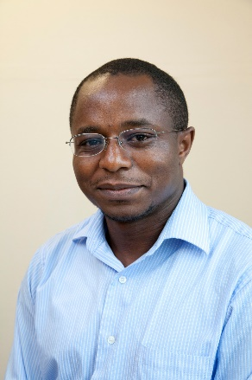

Cary Gross, MD,  Professor of General Medicine and of Epidemiology,  Yale School of Medicine | Oluwadamilola Temilade Oladeru, MD, MA, MBA,  Assistant Professor of Radiation Oncology, University of Florida | Jenerius Aminawung, MD, MPH,  Associate Director, Project Manager,  Data Analyst; COPPER,  Yale School of Medecine

Date: September 29, 2022 12:00pm – 1:00pm

Zoom: https://yale.zoom.us/j/95746029979

Texting code for today’s session: TBA

Course Director/Host: Patrick G. O’Connor, MD, MPH, 203-688-6532
There is no corporate or commercial support for this activity
Program Goal:
1. Improve knowledge about the health impact of incarceration, and its disproportionate impact on minoritized populations.
2. Enhance awareness of the link between incarceration, and cancer incidence & mortality.
3. Identify opportunities for research and stakeholder engagement to achieve health equity for incarcerated individuals with cancer.
Target Audience: Medical Professionals
Financial Disclosure Information: Dr. Aminawung has no relevant financial relationship(s) with ineligible companies to disclose; Dr. Gross discloses Grant or research support-Janssen|Independent Contractor (included contracted research)-Genentech (Relationship has ended)|Grant or research support-AstraZeneca; Dr. Oladeru discloses Grant or research support-Bristol Myers Squibb|Grant or research support-Pfizer.

Dr. O’Connor, course director and faculty member for the Yale General Internal Medicine Faculty Meetings, has no relevant financial relationship(s) with ineligible companies to disclose.

Patti Cavaliere, Vivian DuBrava, Michele Manganello, and Toni Boulay, coordinators/planners for the Yale General Internal Medicine Faculty Meetings, have no relevant financial relationship(s) with ineligible companies to disclose.

Accreditation Statement: Yale School of Medicine is accredited by the Accreditation Council for Continuing Medical Education (ACCME) to provide continuing medical education for physicians.

Designation Statement: Yale School of Medicine designates this Live Activity for a maximum of 1.00 AMA PRA Category 1 Credit(s)™. Physicians should only claim credit commensurate with the extent of their participation in the activity.

