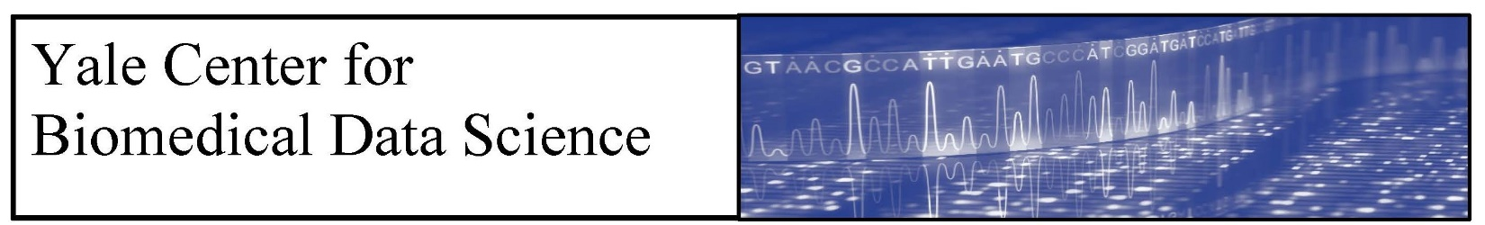
CBDS Seminar Series
“Exploring the ‘Social Network’ within a Human Cell”

Edward Huttlin, PhD
Harvard Medical School
Zoom: https://yale.zoom.us/j/99254481798

Host: Wes Lewis, Seminar Organizing Committee
Wednesday, October 6
4 p.m. to 5 p.m. Seminar
The proteome can be viewed as a community of thousands of proteins that assemble into complexes and signaling networks to support cellular function. Because these interactions are dynamic and organize the proteome according to shared function, the structure of this ‘social network’ within a cell can reveal functions of individual proteins and provide a systems-level view of cellular state. For the past several years, we have been using affinity-purification mass spectrometry to systematically map physical protein interactions in human cells. By immuno-purifying more than 10,000 distinct human proteins – more than half the proteome - in HEK 293T cells, we have created BioPlex, the most comprehensive experimentally-derived model of the human interactome to date. In addition, by repeating these AP-MS experiments in additional cell lines, we are now producing multiple proteome-scale, cell-specific interaction networks to explore how entire interactomes remodel in different cellular contexts. Individually and in combination with other complementary biological data, these networks are powerful tools for discovery. In this talk I will provide an overview of the BioPlex project, emphasizing how computational approaches have provided functional insights for thousands of uncharacterized proteins and deepened our understanding of the systems-level organization of the proteome.

Ed Huttlin has been an Instructor in the Department of Cell Biology at Harvard Medical School since 2015, where he oversees the BioPlex project – a longstanding effort to profile protein-protein interactions in human cells via affinity-purification mass spectrometry (bioplex.hms.harvard.edu). As co-Principal Investigator on the BioPlex project along with Professor Steve Gygi and Professor Wade Harper, Ed oversees a team of 8-10 technicians and postdocs and is directly responsible for quality control and all aspects of data analysis and dissemination. To date, the BioPlex team has completed over 25,000 AP-MS experiments and produced the most comprehensive models of the human interactome to date (Huttlin et al. Cell 2015, Huttlin et al. Nature 2017, Huttlin et al. Cell 2020).

Although his recent work is heavily computational, Ed originally studied chemistry at the University of Minnesota where he completed his Bachelor’s degree and performed undergraduate research focused on bioanalytical applications of capillary electrophoresis. Ed then entered the Biochemistry department at the University of Wisconsin, Madison and earned his PhD working in the lab of Professor Michael Sussman. During graduate school Ed gained experience in all aspects of proteomics, from sample preparation and instrumentation to computational analysis, and produced a dissertation describing quantitative proteomics applications of in vivo ¹⁵N metabolic labeling in organisms ranging from Arabidopsis to mice. He then joined the lab of Steve Gygi at Harvard Medical School where he has taken a leading role developing the lab’s computational infrastructure and biological data mining capabilities. In this capacity he has participated in development of isobaric labeling technology and led an effort to profile protein expression and phosphorylation across nine mouse tissues (Huttlin et al. Cell 2010) prior to assuming responsibility for the BioPlex project.

If you would like to receive email notification of future seminars, please email cbds@yale.edu

