YALE SCHOOL OF MEDICINE
Department of Pathology

2021-22 Research in Progress Series

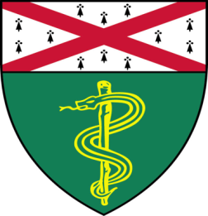

Mamie Wang, (Kleinstein Lab)
Ph.D. Candidate

“High Through-put Single-cell Profiling of B Cell Responses Following Influenza Vaccination in Young and Older Adults”

And
Samuel Kerr, (Katz Lab)
Ph.D. Candidate

“Targeting CXCR5 for T-Cell Lymphomas”

Join Zoom Meeting
https://zoom.us/j/96247765777
Passcode: 889328
Tuesday, October 12th, 9:30-10:30 a.m.

"All the contents are proprietary, unauthorized use of the information is prohibited and unethical".

Questions? Wendy Folsom, Pathology: Wendy.Folsom@yale.edu, LH315, 203-785-3478

