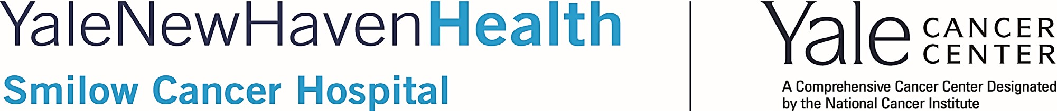

Cancer Genetics and Prevention Program
Educational Seminar

February 25, 2021
2:30-3:30 PM
Zoom Meeting

Meeting ID: 235 849 8262 Password: 667726
Presentation:
“Integrating Parallel Tumor-Normal Sequencing to Inform Cancer Management and Prevention”
Presented by
Zsofia K. Stadler, MD, Memorial Sloan Kettering
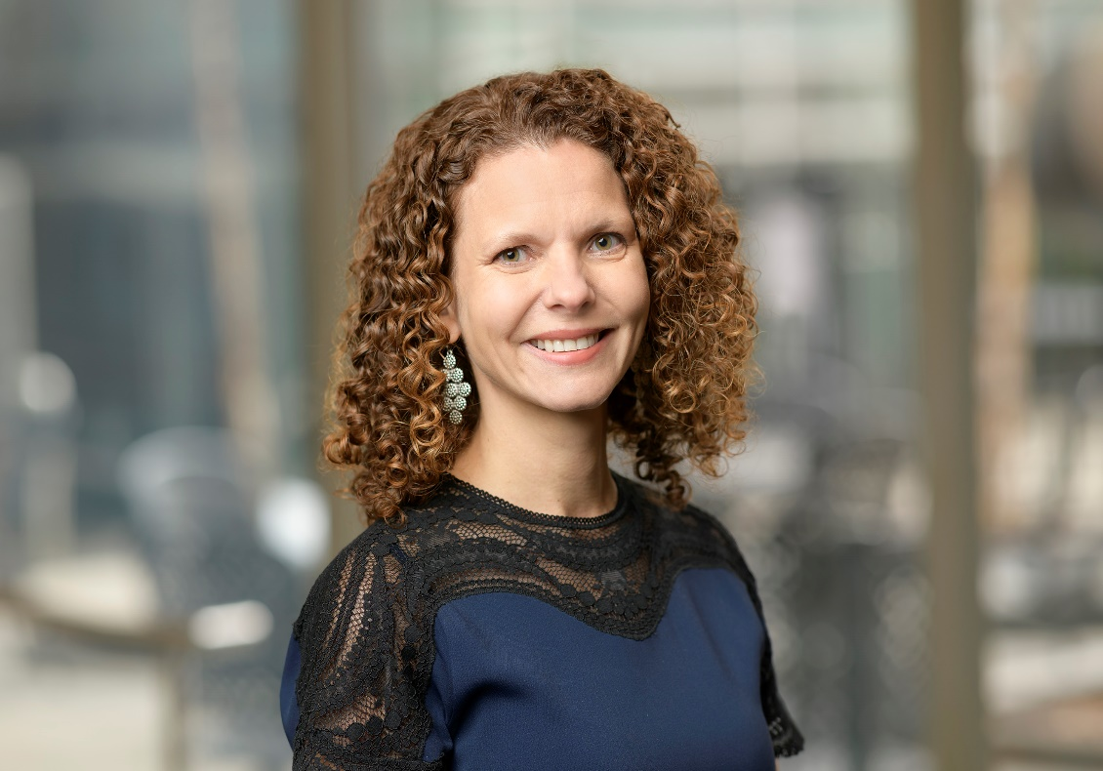

"The National Society of Genetic Counselors (NSGC) has authorized Smilow Cancer Hospital at Yale New Haven Hospital to offer up to 2 CEUs or 20 Category 1 contact hours for the event Smilow Cancer Genetics and Prevention Program Education Series. The American Board of Genetic Counseling (ABGC) will accept CEUs earned at this program for the purposes of genetic counselor certification and recertification. This event is open to those interested in attending. Anyone wishing to claim category 1 CEUs from ABGC will need to submit a payment of $25.”

