YALE SCHOOL OF MEDICINE
Department of Pathology

2020-21 Research in Progress Series

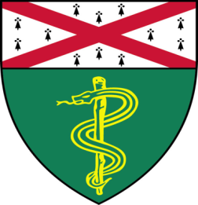
Ioannis (John) Vathiotis, M.D.(Rimm Lab)
Postdoctoral Associate

“Discovery of Biomarkers Associated
with Response to Trastuzumab in HER2
Positive Breast Cancer”

And

Taylor Takasugi, (Chang Lab)
M.D./Ph.D. Candidate

“POT1b and Telomere Length Maintenance”

Join Zoom Meeting
https://zoom.us/j/95032258483
Passcode: 889918

Tuesday, October 6th, 9:30-10:30 a.m.
"All the contents are proprietary, unauthorized use of the information is prohibited and unethical".

Questions? Wendy Folsom, Pathology: Wendy.Folsom@yale.edu, LH315, 203-785-3478

