YALE SCHOOL OF MEDICINE
Department of Pathology

2020-21 Research in Progress Series

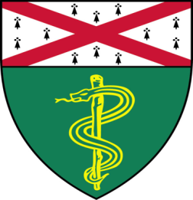
Sabine Lang, Ph.D.(Yan Lab)
Associate Research Scientist

“Targeting KDM5 Histone Demethylases to Overcome Resistance to Trastuzumab+Pertuzumab
Combination Therapy”

And

Vesal Yaghoobi, M.D., MSc (Rimm Lab)
Postdoctoral Associate

“A Comparison of the Tumor Microenvironment between African American’s and Caucasian’s Triple Negative Breast Cancer (TNBC)”

Join Zoom Meeting
https://zoom.us/j/95032258483
Passcode: 889918

Tuesday, January 19th, 9:30-10:30 a.m.

"All the contents are proprietary, unauthorized use of the information is prohibited and unethical".

Questions? Wendy Folsom, Pathology: Wendy.Folsom@yale.edu, LH315, 203-785-3478

