Presented by: Obstetrics, Gynecology and Reproductive Sciences
Weekly Grand Rounds Series (Live Activity and Virtual)
Texting code for this session: 28622

Adolescent PCOS - A Primer for Clinicians

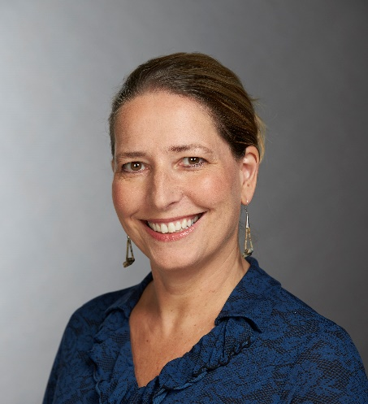
Tania S. Burgert, M.D.
Associate Professor of Pediatrics
University of Missouri Kansas City

May 19, 2022  4:00 - 5:00 pm ▪ Virtual | https://zoom.us/j/94267432468  US: +12034329666  Webinar ID: 942 6743 2468
Needs:  In a recent survey of US-based OBGYN residents, only 55% correctly identified the 3 diagnostic criteria for PCOS | Program Goals:  - Accurately diagnose adolescent PCOS based on the international evidence-based guideline.  - Understand the pathophysiology of PCOS and latest concepts in terms of genetic underpinnings.  - Apply standard and natural treatment paradigms to adolescent PCOS patients.
Target Audience: Ob/Gyn
Financial Disclosure Information:
Tania S. Burgert, M.D., faculty for this educational activity, has no relevant financial relationship(s) with ineligible companies to disclose.

Accreditation Statement: Yale School of Medicine is accredited by the Accreditation Council for Continuing Medical Education (ACCME) to provide continuing medical education for physicians.
Designation Statement: Yale School of Medicine designates this Live Activity for a maximum of 1.00 AMA PRA Category 1 Credit(s)™. Physicians should only claim credit commensurate with the extent of their participation in the activity.

For questions, email: wendy.wojczak@yale.edu

