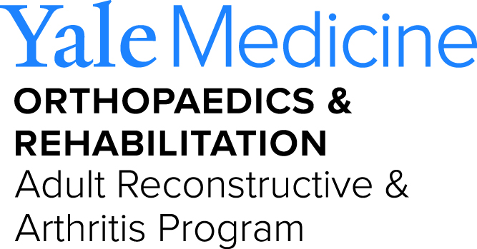
Department of Orthopaedics and Rehabilitation
Yale University School of Medicine
800 Howard Avenue, P.O. Box 208071
New Haven, CT 06520-8071

Phone: (203) 785-2579
Fax: (203) 785-7132

www.Orthopaedics.Yale.edu

For Immediate Release
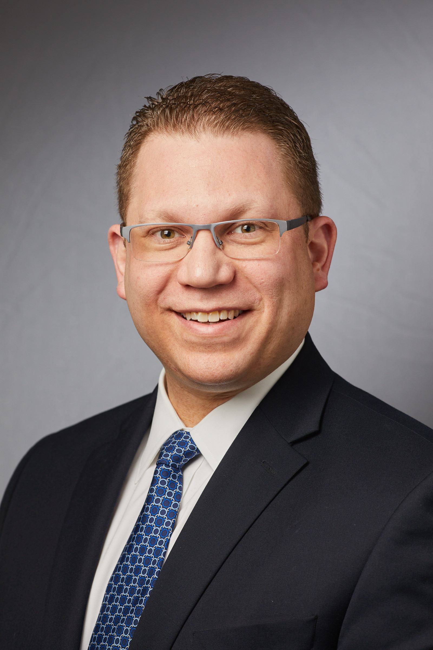

Yale Orthopaedics names
Dr. Lee E. Rubin as Chief of Adult Reconstruction Surgery

Lee E. Rubin, M.D., FAAOS, FAAHKS, FAOA, is an Associate Professor of Orthopaedic Surgery. He was named as Chief of the Division of Adult Reconstruction within the Department of Orthopaedics & Rehabilitation at the Yale School of Medicine (YSM) as of July 1, 2018. Dr. Rubin was appointed as Chief of the Center for Musculoskeletal Care (CMC) Total Joint Replacement Program at YSM and Yale New Haven Hospital (YNHH) following his arrival to New Haven in January 2017.

In these dual Chief roles, he performs over 300 hip and knee joint replacements annually, caring for patients with a wide array of joint pathology and disease complexity, while educating medical students, residents, and fellows. He performs primary and revision surgery, manages peri-prosthetic fractures and prosthetic joint infections, and geriatric fragility fractures. He holds office hours in New Haven, Milford, and Guilford.

At YNHH, Dr. Rubin serves as the Medical Director of the Verdi 4-East CMC floor at the YNHH St. Raphael’s Campus and Co-Chair of the YNHH CMC Surgical Site Infection Reduction Committee. In the first few months following his arrival, he played a central role in helping to establish the first “Tele-Rehabilitation” program in New England at YNHH for selected total joint replacement patients. Most recently, he led the protocol development for the Outpatient Total Joint Replacement Program at the McGivney Advanced Surgery Center, which opened in September 2018.

Currently, Dr. Rubin’s clinical research focuses on risk factor analysis using large healthcare databases and Economic Value Analysis for total joint arthroplasty. He has investigated the role of tranexamic acid in reducing blood loss and blood product utilization, and he routinely publishes on minimally invasive techniques as well as joint replacement surgery in patients with rare disorders.

Nationally, Dr. Rubin serves as an “Elite Reviewer” and Editorial Board Member for the Journal of Arthroplasty, and was a founding Editorial Board Member of both Arthroplasty Today and Reconstructive Review. He is an active member and Fellow of the American Association of Orthopaedic Surgeons (AAOS), the American Association of Hip and Knee Surgeons (AAHKS), and the American Orthopaedic Association (AOA). He is the current Chair of the AAOS Orthopaedic Video Theater Committee, which is responsible for the development and peer-review of digital educational media for orthopaedic surgery community nationally.

Internationally, Dr. Rubin is an eight-time faculty member with the International Congress for Joint Reconstruction’s Annual Anterior Hip Course. At YSM, he is the Program Director of the Keggi Fund for International Orthopaedic Education, which fosters intellectual exchange for global Orthopaedic surgeons with YSM faculty. In the first two years of this new program, Dr. Rubin has hosted visiting surgeons from Turkey, China, Republic of Georgia, Vietnam, and Latvia.

Originally from New Jersey, Dr. Rubin matriculated as an undergraduate Presidential Scholar at Brandeis University in Waltham, Massachusetts and graduated Cum Laude in 2000. He then graduated in 2004 with Alpha Omega Alpha distinction from the Tufts University School of Medicine in Boston. Dr. Rubin completed his Orthopaedic surgery training at Yale University and YNHH in 2009, followed by an Adult Reconstruction (Total Joint Replacement) Fellowship in 2010, focused on the Direct Anterior Approach with Dr. Kristaps J. Keggi and the Keggi Orthopaedic Foundation at the Waterbury Hospital in Connecticut.

Following his early practice and partnership with Dr. Keggi, Dr. Rubin then spent five years in practice with University Orthopedics, Inc. while serving as an Assistant Professor of Orthopaedic Surgery on the Faculty of the Warren Alpert Medical School of Brown University in Providence, Rhode Island. In this role from 2011 to 2016, he became the first surgeon in the 100+ year history of The Miriam Hospital to perform Direct Anterior Hip Replacement, Revision, and Joint Preservation procedures.

In 2013, at age 35, Dr. Rubin was selected and awarded as one of the "Forty Under 40" by the Providence Business News, becoming the first Orthopaedic Surgeon to win this honor in Rhode Island. In 2016, he was invited to serve on the Board of the Yale Orthopaedic Association.

In 2016, Dr. Rubin successfully authored, edited, and published the world's first comprehensive text on anterior hip surgery, entitled "The Direct Anterior Approach to Hip Reconstruction," which has now become the definitive reference for surgeons around the world who are learning and performing hip surgery using this minimally invasive technique. In 2019, he published “Hip Replacement: Experts Answer Your Questions,” which is a concise guide focused on the patient experience surrounding modern hip replacement surgery.

Dr. Rubin now resides in Guilford, Connecticut with his wife Jamie, their two children, and two beagles.

For Additional Information, Please contact:

Mary Henwood, MPH,
Director, Finance and Administration
(203) 785-2542
Mary.henwood@yale.edu

Mina Jabarkhail,
Dr. Rubin’s Administrative Assistant:
(203) 737-4477
Mina.jabarkhail@yale.edu

