Watch a FREE Screening of Dark Waters
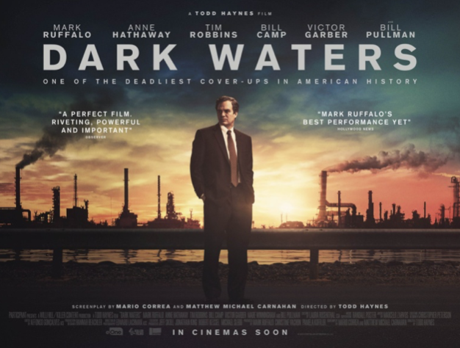
Join us on September 29 for a virtual discussion with Rob Bilott,
the man who inspired the film
Register Today!

We are working with our partners to host a free viewing of the movie Dark Waters— the true story of Attorney Rob Bilott (played by Mark Ruffalo) taking a stand against Dupont to protect public health and expose the damage toxic PFAS chemicals can inflict on our communities.
Register TODAY to receive a link that will allow you to view the movie from the comfort of your own home anytime from September 25th to September 29th. Act soon because spots are limited!
Attend the Virtual Q&A with Rob Bilott
Registering also gets you access to an exclusive virtual town hall on Tuesday, September 29, from 7:00 pm - 8:30 pm. The discussion will feature special guests Rob Bilott, YALE researcher Vasilis Vasiliou, Ph.D., and officials from the CT Dept. of Public Health and Dept. of Energy and Environmental Protection.
We hope you’ll join us to learn about the health and environmental impacts of PFAS chemicals nationwide, and to find out what’s being done to address the problem in Connecticut.

When: Film Screening: September 25 – September 29 (anytime that works for you!)
Virtual Town Hall Discussion: September 29, 7:00pm – 8:30pm

RSVP for this unique opportunity to view Dark Waters from your home for free and then participate in a virtual event. Don’t delay, RSVP today!

Thank you for joining us. Together we make a difference!
Sincerely,
Your friends at CCE
Click here to view web version

