SEMINAR
Climate, Air Pollution, and Covid-19, An Environmental Health Perspective
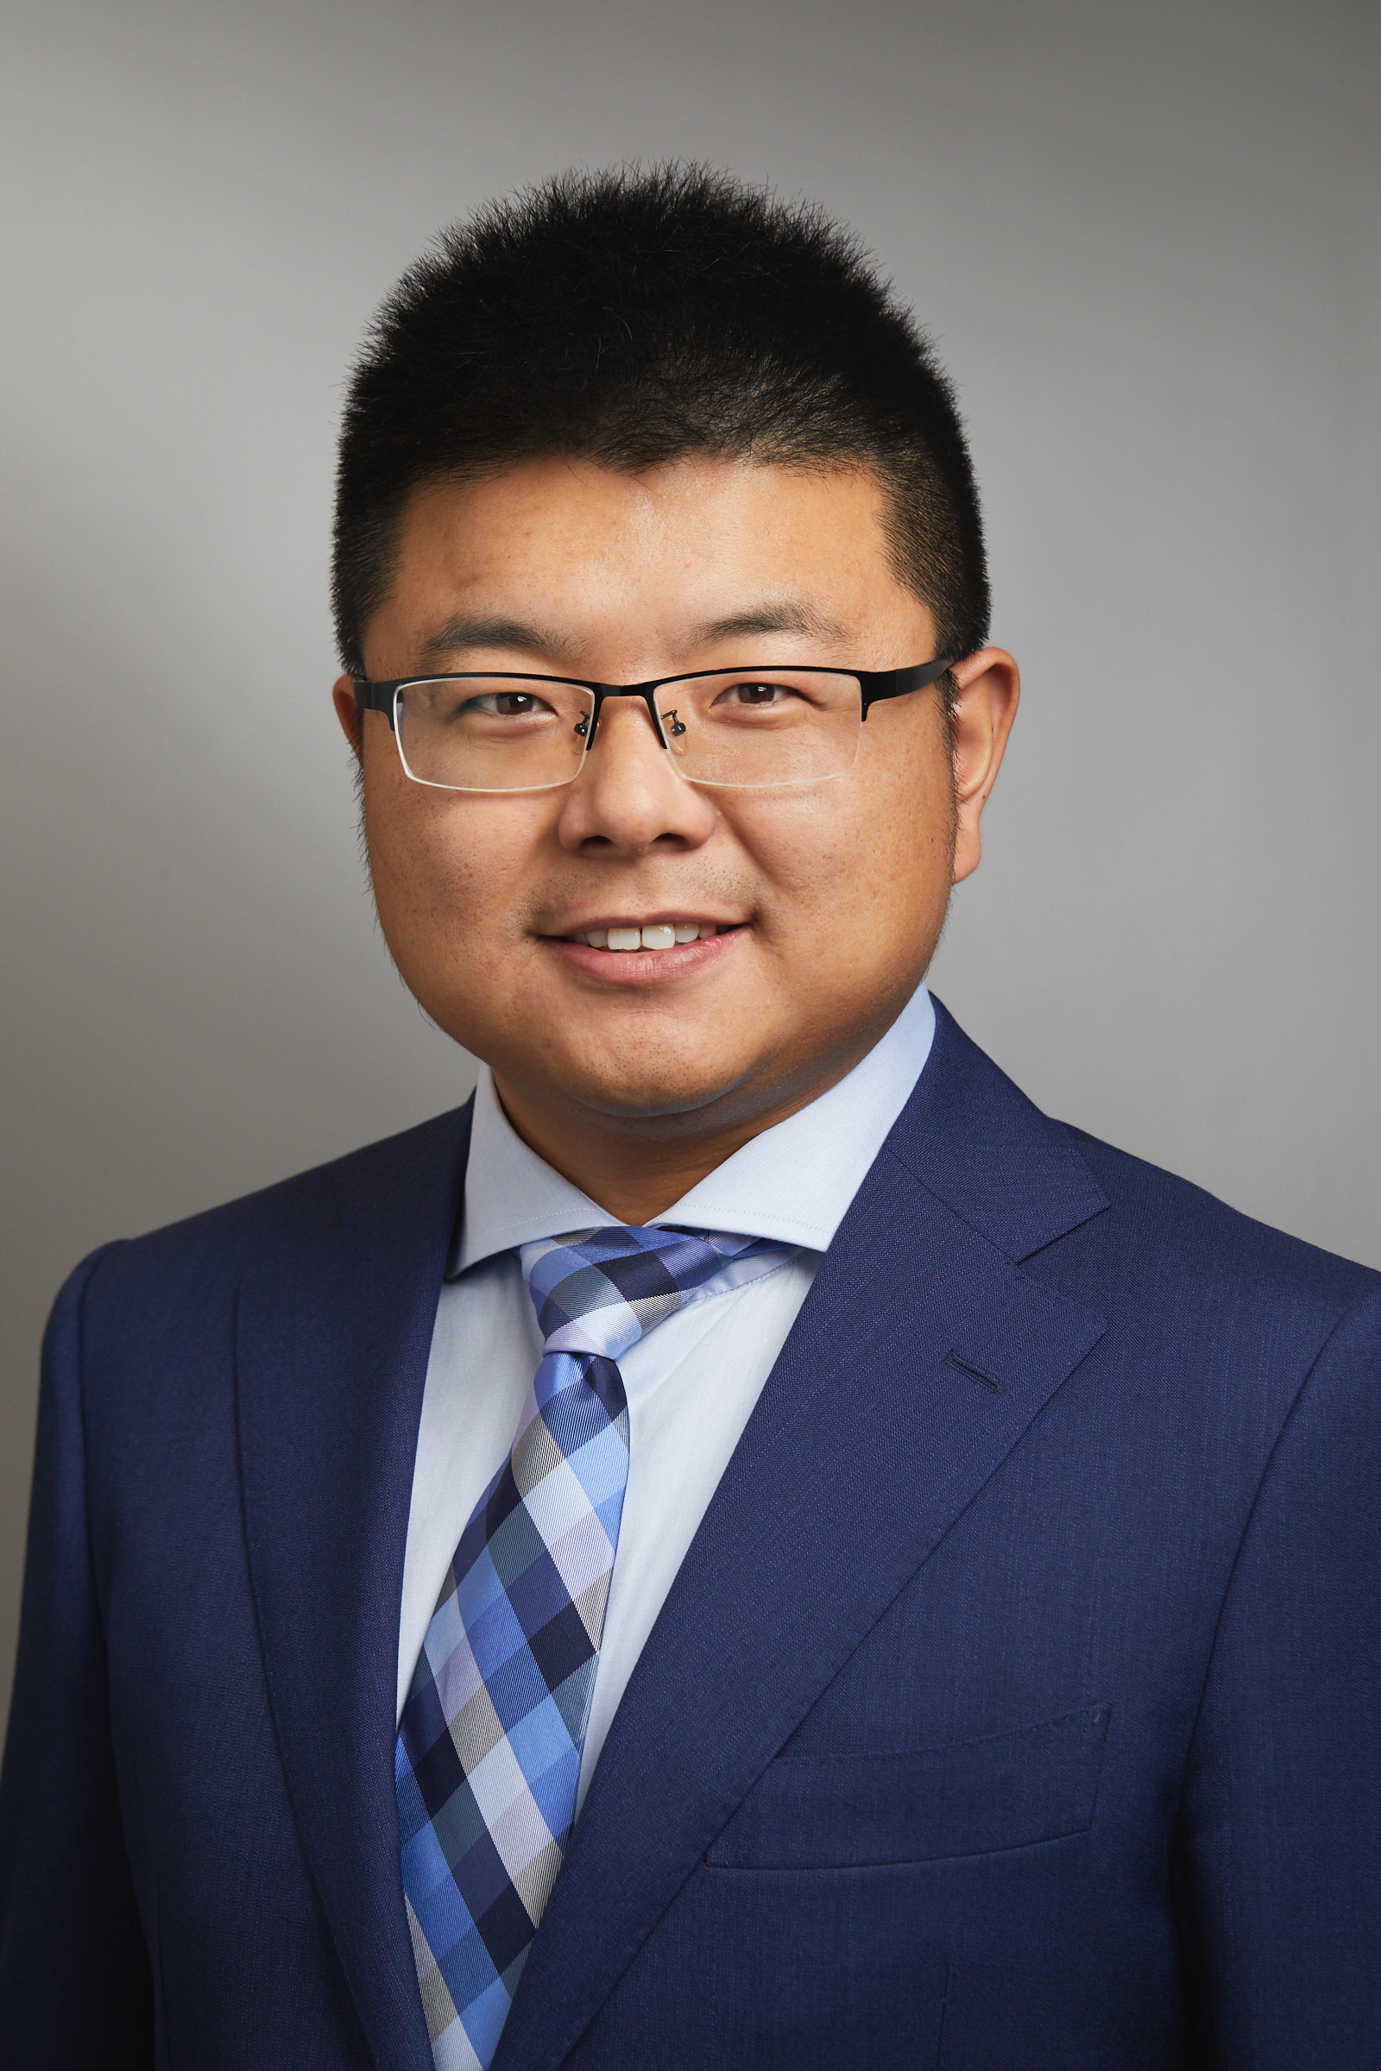
Kai Chen, PhD
Assistant Professor
Department of Environmental Health Sciences
Yale School of Public Health
Dr. Kai Chen received his Ph.D. in Environmental Science and Engineering in 2016 from Nanjing University in China. Prior to joining the Yale School of Public Health faculty in July 2019, Dr. Chen was an Alexander von Humboldt Postdoc Fellow at the Helmholtz Zentrum München-German Center for Environmental Health. Dr. Chen’s research focuses on the intersection of climate change, air pollution, and human health. His work involves applying multidisciplinary approaches in climate and air pollution sciences, exposure assessment, and environmental epidemiology to investigate how climate change may impact human health. His recent work examines the role of meteorological factors (temperature, humidity, and UV radiation) in the transmission of SARS-CoV-2 in the United States and the potential health benefits of air pollution reductions during the COVID-19 lockdown. Dr. Chen is the Director of Research at the Yale Center on Climate Change and Health.

12-1 p.m. EST. Wednesday, September 15, 2021,
LEPH 101, 60 College Street
Lunch Provided

