YALE SCHOOL OF MEDICINE
Department of Pathology

2021-22 Research in Progress Series

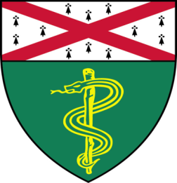

Kiran Patel, (Nguyen Lab)
Postdoctoral Associate
“KDM2A Maintains Redox Homeostasis
to Drive Lung Cancer Metastasis”

And
Zhuoyue Chen, (Kyriakides Lab)
Postdoctoral Associate

“Decellularized Bone Extracellular Matrix (ECM) Hydrogel for Tissue Repair”

Join Zoom Meeting

https://zoom.us/j/96247765777
Passcode: 889328

Tuesday, December 7th, 9:30-10:30 a.m.
"All the contents are proprietary, unauthorized use of the information is prohibited and unethical".

Questions? Wendy Folsom, Pathology: Wendy.Folsom@yale.edu, LH315, 203-785-3478

