Neuroinflammation Seminar Series

Speaker
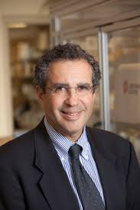

David A. Hafler, MD, FANA
William S. and Lois Stiles Edgerly Professor of Neurology and Professor of Immunobiology; Chair, Department of Neurology; Neurologist-in-Chief, Yale New Haven Hospital

Presents:
“Single-Cell Reconstruction of Homeostatic Immune Cell Adaptation in Human Brain”
- - - - - - - -

Tuesday, November 26, 2019
1:00-2:00 PM
Jane Ellen Hope (HOPE110- Lect Hall)
Upon entering the Hope Building at 315 Cedar Street, walk up a set of steps. H-110 is on the top of the stairs on your right.
For further information, please contact Alisha Cosgrove (alisha.cosgrove@yale.edu)

Pizza will be served

Sponsored by:

