Yale GIM “Educational Strategies & Faculty Development” Meeting
Presented by
Yale School of Medicine’s Department of Internal Medicine
Section of General Internal Medicine

“Teaching Health Professionals to Address Mass Incarceration”

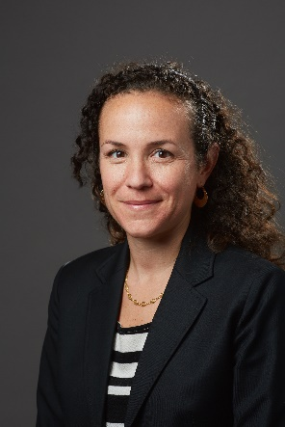

Lisa Puglisi, MD

Assistant Professor,
Director of Education for
The SEICHE Center for Health and Justice,
Yale School of Medicine

Date: September 15, 2022 12:00pm – 1:00pm

Zoom: https://yale.zoom.us/j/95746029979

Texting code for today’s session: TBD

Course Director/Host: Patrick G. O’Connor, MD, MPH, 203-688-6532
There is no corporate or commercial support for this activity

Program Goal:
1. Recognize approaches to education for caring for marginalized populations
2. Appreciate value added to clinical competency by multidisciplinary clinical emersion
3. Identify ways to engage trainees in policy and advocacy
Target Audience: Medical Professionals

Financial Disclosure Information: Dr. Puglisi has no relevant financial relationship(s) with ineligible companies to disclose.

Dr. O’Connor, course director and faculty member for the Yale General Internal Medicine Faculty Meetings, has no relevant financial relationship(s) with ineligible companies to disclose.

Patti Cavaliere, Vivian DuBrava, Michele Manganello, and Toni Boulay, coordinators/planners for the Yale General Internal Medicine Faculty Meetings, have no relevant financial relationship(s) with ineligible companies to disclose.

Accreditation Statement: Yale School of Medicine is accredited by the Accreditation Council for Continuing Medical Education (ACCME) to provide continuing medical education for physicians.

Designation Statement: Yale School of Medicine designates this Live Activity for a maximum of 1.00 AMA PRA Category 1 Credit(s)™. Physicians should only claim credit commensurate with the extent of their participation in the activity.

