Yale Section of Rheumatology, Allergy & Immunology

Research in Progress
Monique Hinchcliff, MD, MS
Associate Professor; Director of Yale Scleroderma Program

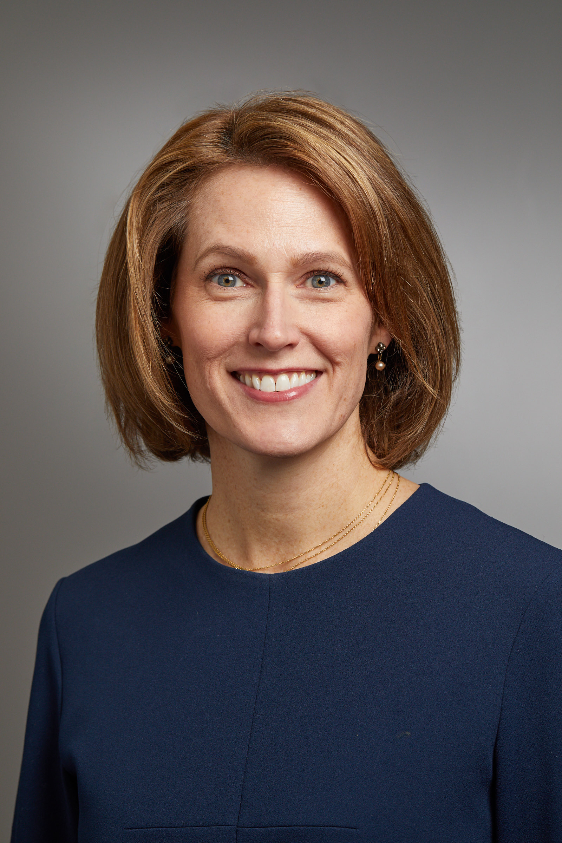

“Ongoing patient-focused research in SSc”

Wednesday, October 19, 2022
9:45am -10:45am
TAC N-107

