YALE SCHOOL OF MEDICINE
Department of Pathology

2021-22 Research in Progress Series

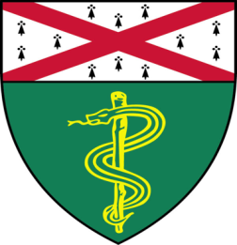

Peter Niimi, (M. Levine Lab)
PhD Candidate

“Mechanisms of Epigenetic Rejuvenation
with Oct4, Sox2, and Klf4”

And
Niki Gavrielatou, (Rimm Lab)
Postdoctoral Associate

“Uncovering Biomarkers of Immunotherapy Outcomes in Head and Neck Squamous Cell Carcinoma Using Digital Spatial Profiling”

Join Zoom Meeting

https://zoom.us/j/96247765777
Passcode: 889328
Tuesday, January 18th, 9:30-10:30 a.m.
"All the contents are proprietary, unauthorized use of the information is prohibited and unethical".

Questions? Wendy Folsom, Pathology: Wendy.Folsom@yale.edu, LH315, 203-785-3478

