YALE SCHOOL OF MEDICINE
Department of Pathology

2019-20 Research in Progress Series

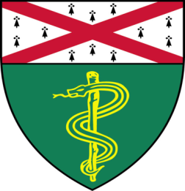

John Vathiotis, MD (Rimm Lab)
Postdoctoral Associate

“CD200/CD200R in Lung Cancer”

And

Paul Stabach, (Braddock Lab)
Research Associate II
“Enzyme Replacement Therapy;
From ENPP1 to DNase1L3”

Tuesday, October 15th, 2019
9:30 to 10:30 a.m.
TAC Auditorium, N-107, 300 Cedar Street

Coffee & refreshments beforehand- TAC Lobby

Questions? Wendy Folsom, Pathology: Wendy.Folsom@yale.edu, LH315, 785-3478

