Yale GIM's Research in Progress Meeting
Presented by
Yale School of Medicine’s Department of Internal Medicine
Section of General Internal Medicine

“Repurposing Medications for Unhealthy Alcohol Use:
Is the Glass Half Full?”

David Fiellin, M.D.
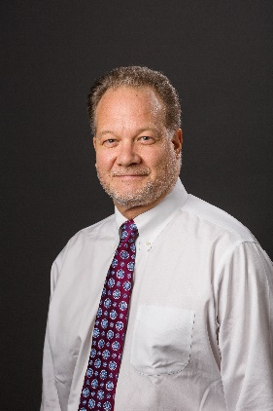

Professor of Medicine,
of Emergency Medicine, and of Public Health

Vice Chief of Faculty Affairs,
General Internal Medicine.

Director, Program in Addiction Medicine
Yale School of Medicine
Date: November 3, 2022 12:00pm – 1:00pm

Zoom: https://yale.zoom.us/j/95746029979

Texting code for today’s session: TBA

Course Director/Host: Patrick G. O’Connor, MD, MPH, 203-688-6532
There is no corporate or commercial support for this activity

Program Goal:
1. Describe the spectrum of unhealthy alcohol use
2. Discuss the neuroscience behind unhealthy alcohol use
3.Explain the potential rationale for using commonly prescribed medications to treat unhealthy alcohol use
Target Audience: Medical Professionals

Financial Disclosure Information: David Fiellin has no relevant financial relationship(s) with ineligible companies to disclose.

Dr. O’Connor, course director and faculty member for the Yale General Internal Medicine Faculty Meetings, has no relevant financial relationship(s) with ineligible companies to disclose.

Patti Cavaliere, Vivian DuBrava, Michele Manganello, and Toni Boulay, coordinators/planners for the Yale General Internal Medicine Faculty Meetings, have no relevant financial relationship(s) with ineligible companies to disclose

Accreditation Statement: Yale School of Medicine is accredited by the Accreditation Council for Continuing Medical Education (ACCME) to provide continuing medical education for physicians.

Designation Statement: Yale School of Medicine designates this Live Activity for a maximum of 1.00 AMA PRA Category 1 Credit(s)™. Physicians should only claim credit commensurate with the extent of their participation in the activity.

