***Special Seminar***

***Department of Immunobiology***

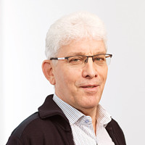

***MEINRAD BUSSLINGER, Ph.D.***

*Senior Scientist/Deputy Director Science,*

*Research Institute of Molecular Pathology (IMP)*

*Vienna Biocenter*

***“****The role of chromatin loop extrusion*

*in generating a diverse*

*antibody repertoire****”***

**Monday, April 20, 2020**

**11:00 A.M.**

**TAC N107 Auditorium**

Host: Richard A. Flavell

*For further information, please contact Caroline Lieber at caroline.lieber@yale.edu*