YALE SCHOOL OF MEDICINE
Department of Pathology

2021-22 Research in Progress Series

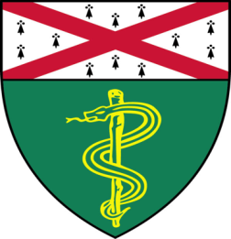

Aileen Fernandez, Ph.D.(Rimm Lab)
Postdoctoral Fellow
“Closed System qRT-PCR for Predicting Patient Response to Immunotherapies”

And

Miguel Lopez de Rodas Gregorio, M.D. (Schalper Lab)
Postdoctoral Associate

“Spatial Analysis and Clinical Significance of Tumor Infiltrating Lymphocytes in Sensitivity to PD-1 Axis Blockers in Non-Small Cell Lung Cancer”

Join TAC Auditorium, N-107, 300 Cedar Street
Coffee & refreshments beforehand- TAC Lobby

or
Join Zoom Meeting

https://zoom.us/j/ 96247765777 Passcode: 889328

Tuesday, April 26th, 9:30-10:30 a.m.

"All the contents are proprietary, unauthorized use of the information is prohibited and unethical".

Questions? Wendy Folsom, Pathology: Wendy.Folsom@yale.edu, LH315, 203-785-3478

