Yale University School of Medicine

1st HARP PILOT INTERVENTION

HARP PILOT INTERVENTIONS Training Manual

Amy C. Justice, MD, PhD, Julie Womack, MSN, PhD, Evelyn Hsieh, MD, PhD, E. Jennifer Edelman, MD, MHS, Steve Maisto, PhD, Adelyn I. Garcia, BA, Micaela M. Leblanc, PharmD, BCPS, Annette Sager, PharmD, Lauren Zaets, PharmD, BCPS, and the Risk Communication Core of HARP from the STEP Trials,¹ Project ED Health II INTERVENTION Training Manual ^{2,3}

Version 2.0
Date: 12/17/2022

TABLE OF CONTENTS

- Overview of the Manual | 4
- Background Information | 4
- Overview of the Intervention | 6
- Components of the Intervention | 7
- Study Protocol | 12
- Script and Tools for Each Step of the Intervention | 17
- Script for the Follow-up Booster Session | 38
- Additional Motivational Strategies | 39
- Common Challenging Scenarios | 40
- Surveys | 42
- Figures and Tables | 74
- References | 78

I. Overview of the Manual

This manual is designed to provide the clinical pharmacist with the necessary skills to perform the first HIV and Alcohol Research center focused on Polypharmacy (HARP) Intervention P1 Pilot easily, effectively, and consistently. This pilot intervention will consist of a brief intervention for participants with HIV who take 5 or more medications and currently (within the past month) consume alcohol. The focus of this pilot will be on bothersome symptoms and the impact of alcohol use and medications on these symptoms. The rationale is that any alcohol use may interact with medications in serious ways leading to adverse outcomes, including bothersome symptoms. This is especially true in those aging with HIV who take many medications and experience substantial physiologic frailty which likely makes them more susceptible to adverse effects of both alcohol and polypharmacy. Because those with moderate to severe alcohol use disorder (AUD) likely also require medications to help them stop drinking, we are excluding anyone with known AUD or who meets criteria for AUD based on a score of four or more with the Alcohol Symptom Checklist. We plan a separate set of pilots for these individuals that will include provision of medication to address alcohol cravings.

The sections in this manual provide background information, outline the goals of the study, and describe the critical components of the HARP Pilot Intervention. An easy to follow, step-by-step approach for delivering the intervention is also included. The study protocol is provided along with motivational and troubleshooting strategies. While the manual gives the reader a critical overview of the intervention, participation in a 20-hour training course, followed by successful completion of several test cases is also required prior to pharmacists delivering the intervention to study participants. The actual intervention sessions will be digitally recorded. A random subset of these recordings will be reviewed for fidelity to the intervention model, with periodic feedback by the trainers to the clinical pharmacists to ensure consistent delivery. We will retrain the clinical pharmacists using additional practice cases and feedback if there is evidence of poor fidelity.

II. Background Information

Introduction
Unhealthy alcohol use⁴ is a major preventable public health problem globally.⁵ The effects of unhealthy alcohol use have far-reaching implications not only for the individual who consumes alcohol, but also for the family, workplace, community, and the health care system. Polypharmacy – defined as being on five or more medications at one time -- is also a growing problem, especially for people aging with HIV (PAH).⁶⁻⁸ Due to physiologic frailty, polypharmacy starting at early ages, and continued alcohol use, PAH experience substantial excess harm from the combined impact of alcohol and polypharmacy.⁷ Yet, risk of harm from alcohol and polypharmacy (AP risks) are rarely tackled together.

Alcohol Impact in PAH
Among patients with HIV, alcohol use is associated with poor adherence to ART medications in a dose-dependent fashion.⁹⁻¹⁴ While ART adherence in this population ranges from 60% to 70%,^{15,16} estimates for adherence in individuals with at-risk alcohol use with HIV is significantly lower (42%).¹⁷ The risk for non-adherence has been shown to increase with increasing levels of alcohol consumption. One study revealed a 2.7 times increase in non-adherence in individuals with frequent heavy drinking (defined below).¹⁸ A Veteran’s Aging Cohort Study (VACS) analysis found that medication adherence was lower on days when patients drank heavily and also on the following day.¹⁹ Alcohol consumption was the most significant predictor of ART medication adherence. Heavy drinking in patients with HIV is also associated with poor treatment response as evidenced by lower CD4 lymphocyte counts and higher HIV RNA.^{12,13} In turn, it has been shown that individuals who have stopped or cut back on frequency of drinking have an improved response to HIV therapy.¹²

Spectrum of Alcohol Use/Terminology
PAH represent the entire spectrum of unhealthy alcohol use as described in scientific guidelines from the National Institute of Alcohol Abuse and Alcoholism (NIAAA).²⁰ This includes individuals with at-risk alcohol use who are at risk for injury and illness because they drink any alcohol all the way up to AUD. For individuals taking 5 or more medications, any alcohol use can be problematic given risk of medication-alcohol interactions and potential increased risk of adverse health outcomes. The HARP Pilot Interventions that you will provide focus on individuals currently consuming alcohol (but not currently meeting criteria for moderate to severe AUD) and taking at least 5 medications. Study participants not eligible for this pilot who meet criteria for moderate to severe AUD may be enrolled in a separate pilot study that includes provision of a medication to address AUD. If a study participant qualifies for a diagnosis of AUD, you will also need to notify their HIV clinician to help facilitate appropriate care.

Impact of Alcohol Combined with Polypharmacy in PAH
We have found that patients and clinicians have limited awareness of alcohol exposure and its associated risk.^{21,22} But both patients and clinicians are concerned about polypharmacy.²³ Our guiding hypothesis is that participants will be more receptive to feedback regarding polypharmacy risks, and that we can more effectively intervene on medical harms from alcohol among PAH by addressing the combined risks of alcohol and polypharmacy, especially because alcohol interacts with a long list of medications.
Once ART has been initiated, many non-ART medications are prescribed to address symptoms and to treat or prevent comorbid disease. An estimated 15% to 39% of PAH are exposed to polypharmacy,²⁴⁻²⁹ with higher rates among older individuals.³⁰ Polypharmacy is often measured as a threshold (e.g., concurrent receipt of five or more medications) but medication count must also be considered as each additional medication contributes risk. A conceptual model of harm from polypharmacy for PAH includes independent and interacting effects of physiologic frailty, medication burden, the prescription of potentially inappropriate medications and omission of indicated medications, and a host of known and unknown medication interactions. PAH are exposed to polypharmacy a decade earlier than the general population and it presents unique management issues in this population.³¹⁻³³ ART interacts with many non-ART medications³⁴ and PAH may be more susceptible to side effects due to increased physiologic frailty. Polypharmacy itself may decrease ART adherence, threatening the patient’s ability to maintain viral suppression. Increasing polypharmacy adds to medication burden and increases the probability of significant two-way and higher order interactions as well as medication-gene and medication-alcohol use interactions. Physiologic frailty reflects the degree to which organ system reserve capacity is lost, allowing a relatively minor injury to result in disproportionate harm.³⁵ Increasing physiologic frailty is associated with increasing polypharmacy and vice-versa. These mechanisms contribute to a host of adverse health events.
Many commonly used medications have the potential to interact with alcohol (A-PIMS). These interactions may alter metabolism (pharmacokinetics) or effects (pharmacodynamics) of alcohol and/or the medication.³⁶ Some interactions can occur with ANY alcohol consumption, whereas others follow a dose-response pattern³⁷ and still others are genetically determined.³⁸ When an older adult combines medications with alcohol, they experience an increased risk of medical complications including hypoglycemia, hypotension, sedation/confusion, gastrointestinal bleeding, and liver damage.^{36,39-41} These concerns are heightened for PAH as they have greater physiologic frailty,²⁶ making them more liable to injury. Further, several ART medications directly (e.g., ritonavir and efavirenz) interact with alcohol.⁴²⁻⁴⁴

Brief Interventions can successfully decrease alcohol consumption
There is compelling evidence in the literature that brief interventions are efficacious in reducing alcohol consumption and associated consequences.⁴⁵ Multiple studies have demonstrated the efficacy of brief interventions in a variety of settings, including general populations, primary care, emergency departments and in-in-patient trauma care units. In addition, a prior meta-analysis including seven studies on the efficacy of non-physician brief interventions in primary care settings in 2633 participants⁴⁶ found that participants who participated in non-physician interventions consumed one- and one-half fewer drinks per week compared to participants who did not receive such an intervention. While some PWH do respond to interventions to decrease their alcohol use, many do not.^{47,48} Further, to our knowledge, there is a current lack of brief counseling interventions to address alcohol use for PWH that: 1) focus specifically on the subset of PWH receiving polypharmacy, 2) are designed to be delivered by clinical pharmacists, and 3) integrate highly personalized risk messages based on alcohol-polypharmacy associated risks.

III. Overview of the Intervention

The pilot intervention consists of two provider contacts via Microsoft TEAMS, and two participant contacts via telephone. The first provider contact will confirm the participant’s medications that can be discontinued or modified, and the second provider contact will confirm the medications that the participant has agreed to discontinue or modify. The first participant contact by telephone will be an approximately one hour long, counseling session that incorporates brief feedback and advice with motivational enhancement techniques to assist the participant in changing their behaviors with respect to alcohol consumption and/or problematic polypharmacy, particularly if those medications interact with alcohol.³ In some cases this means reducing alcohol consumption to lower-risk limits (i.e., below at-risk levels) or eliminating it altogether. In others it may mean reducing the number of medications that they take or stopping specific medications that likely interact with alcohol to cause or exacerbate symptoms that the participant finds bothersome. The second participant contact will consist of a follow-up booster session approximately two weeks after the first intervention session. A subset of participants will be contacted to participate in in-depth interviews to share their feedback on the different components of the intervention. The pilot is participant-centered and utilizes the Information, Motivation, and Behavioral Skills (IMB) model to help participants make the changes recommended to support their health and well-being.
The primary goals of the pilot intervention are to help increase understanding of AP risks in order to obtain the participant’s agreement to: 1) reduce or eliminate alcohol consumption and/or 2) stop, taper, or change medications that are likely contributing to bothersome symptoms based on pharmacologic expertise once the HIV clinician’s approval has been obtained. The clinical pharmacist and participant will determine a plan through a process of providing personalized feedback and negotiation described in the following section. Given the personalized risk information that is being provided as part of this intervention and the need to have a thorough discussion with participants, it is expected that the first intervention session will last approximately 60 minutes and the follow up booster session will be approximately 30 minutes.

Prior to the intervention, participants will complete a set of pre-intervention questionnaires and a self-collected blood spot phosphatidylethanol (PEth) test. Immediately after the first intervention session, participants will be sent a copy of the participant agreement form and the HARP Alcohol Use, Medications and Symptom Monitoring Worksheet. Immediately after the booster session, participants will be sent a post-intervention survey to complete. Approximately 30 days after the booster session, participants will be sent and asked to complete the final post-intervention survey and another PEth test. The intervention is intended to be helpful to diverse participant populations of PAH. For the in-depth interviews, we aim to talk with individuals from a range of ages, race/ethnicities, and genders. We will also select people who represent the five stages of readiness to change.⁴⁹

IV. Components of the Intervention
- Initial Screening Contact: (Clinical pharmacists will do this):
- Let the participant know that because they participated in MASH and VACS, they are eligible for this study.
- Briefly explain the purpose of the study, e.g.: The purpose of this study is to help us understand how best to help individuals who drink alcohol and take 5 or more medications reduce their alcohol intake and/or reduce the number of medications that they take, especially medications that likely interact with alcohol to cause bothersome symptoms. By reducing alcohol intake and/or the number of medications that they take, participants will be able to reduce the number and/or frequency of the unpleasant symptoms that they experience.
- Obtain verbal consent to record the call and screen the participant with the Alcohol Symptom Checklist (Table 1): To start off we have a few screening questions regarding your experiences with alcohol use to determine if you are eligible for the study. We have a cutoff score for eligibility. If you exceed our cutoff, you will not be eligible and we will notify your provider online that you exceeded the cutoff.
- Verify eligibility by administering the Alcohol Symptom Checklist. To be eligible for the study, the person must have a score of less than 4 on the Alcohol Symptom Checklist. If they are eligible for the pilot, obtain verbal consent. If they are NOT eligible (a score of 4 or more on the Alcohol Symptom Checklist), let them know that they are not eligible for this study, but that you will be reaching out when another study for which they are eligible becomes available. You will also need to notify their VA HIV clinician via Teams that the participant screened positive for AUD.

- HARP IRB Approved Verbal Consent
Research Study Summary
- We are asking you to join a research study.
- Approximately 50 subjects will be asked to participate.
- The purpose is to learn how to help people who take 5 or more medications, and drink alcohol decrease their use of alcohol and or medications to decrease their bothersome symptoms. We are also interested in learning how to communicate personal health risks associated with alcohol and medication use.
- Study activities include:
  - Completing a fingerstick blood test on your own, which we will provide instructions for, that measures recent alcohol use. This may take up to 20 minutes.
  - Completing a survey regarding bothersome symptoms, alcohol and current medication use. This should take 5-10 minutes.
  - Participating in a first telephone call with the clinical pharmacist, who will briefly review your medications and discuss possible associations between your bothersome symptoms and your use of alcohol and medications. This may last up to 45 minutes.
  - Keep track of changes in your alcohol consumption, medications, and bothersome symptoms using a worksheet that we provide.
  - Participate in a second follow-up telephone call two weeks after the first call to discuss how things are going. This should last no longer than 30 minutes.
  - After the follow up telephone call, complete a brief follow up survey. This should take 5-10 minutes.
  - 30 days after the follow-up telephone call, complete another fingerstick blood test and follow up survey. This should take no longer than 30 minutes.
  - Finally, we MAY recontact you to participate in a final interview with one of our colleagues to speak with you about your experience with the study. This interview will take approximately 30 minutes.
- Without the final interview, your involvement will require approximately 2.5 hours. If you are chosen and participate in the final interview, the total time will be 3 hours.
- There may be some risks from participating in this study.
  - You may experience some discomfort from the fingerstick.
  - You may feel emotional discomfort as a result of completing the surveys.
  - The clinical pharmacist will be speaking with your VA HIV clinician prior to her phone call with you regarding:
    - Any of your medications that have significant interactions with each other or with alcohol.
    - Symptoms that you may have consistent with alcohol use disorder.
  - There is also the possible risk of loss of confidentiality.
- The study may have no direct benefits to you. Nevertheless, we hope that through the intervention, you will experience some relief from bothersome symptoms related to your alcohol and/or medication use. We also hope that the tools and skills we discuss will help you decrease your alcohol consumption and talk with your provider about your medications. We hope to benefit others by better understanding how to communicate with participants about their health risks.
- You do not give up any of your legal rights by giving your verbal agreement to participate.
- You will be paid for taking part in this study:
- Prior to the first telephone call with the clinical pharmacist:
  - You will receive a $25 gift card for returning an adequate first fingerstick blood test.
  - You will receive a $25 gift card once you return the first survey.
- After the second telephone call with the clinical pharmacist, we will ask you to complete and return a follow up survey. You will receive a $25 gift card when we receive this survey.
- 30 days after the follow up telephone call with the pharmacist, we will ask you to complete and return another follow up survey and blood spot test. You will receive a $25 gift card for returning the survey and another $25 gift card for returning an adequate second blood spot test.
- If you complete all the activities above, the total value of the gift cards that you receive for this study will add up to $125.
- In addition, if you are selected and agree to participate in the final interview, you will receive an additional $50 gift card, meaning the total value of the gift cards that you receive for this study will add up to $175.
- You are responsible for paying local, state, and federal taxes for the payments you receive for this study. Taxes are not withheld from your payment.
- Taking part in this study is your choice. You can choose to take part, or you can choose to not take part in this study. You also can change your mind at any time. Whatever choice you make will not have any effect on your relationship with the VA and your provider. You do not give up any of your legal rights by giving your verbal agreement to participate.
If you are still interested in participating, I can tell you more. Be sure to ask me questions about anything you do not understand.
Shall I continue? Yes No
What information will you collect and how will you keep it safe and private
The information we will collect is called “Protected Health Information.” It is protected by a federal law called the Privacy Rule of the Health Insurance Portability and Accountability Act (HIPAA). This law means that we cannot use or share your health information for research without your permission. If you want, we can give you more information about the Privacy Rule. Also, you can speak with the VA Privacy Officer at 932-5711 ext 4109 or 6391.
The specific information that we will collect, use, and share, includes:
- Your entire medical record from the VA
- Sex
- Date of birth
- Research study records
- Records about phone calls made as part of this research
- Records about your study visits
All of your responses will be held in confidence. Only the researchers involved in the study and those responsible for research oversight will have access to any information that could identify you. These individuals are all required to keep all information confidential and include:
- The Principal Investigator, the study coordinator, and members of the research team
- The US Department of Health and Human Services agencies
- Representatives from - the - Human Research Protection Program and the Institutional Review Board (the committee that reviews, approves, and monitors research on human participants) responsible for ensuring research compliance.
- Health care providers who provide services to you in connection with this study.
- Laboratories and other individuals and organizations that analyze your health information in connection with this study.
- Data and Safety Monitoring Boards and others authorized to monitor the study
We have obtained a Certificate of Confidentiality from the Federal Government. This protects your privacy by allowing us not to release your name or other information outside of the research study, even by a court order. The Certificate of Confidentiality will not be used to prevent disclosures to local authorities of child abuse or neglect, or harm to self or others. The Certificate does not prevent you or a member of your family from releasing data about yourself or your involvement in this study.
All research information will be secured in locked files (hardcopy) or on a secure server (digital). We may share information about you with other researchers for future studies, but we will not use your name or any personal identifiers.
We will do our best to make sure your information stays private. If we share information with people who do not have to follow the Privacy Rule, agreements are in place with these individuals and/or companies that require that they keep your information confidential. Let us know if you have questions about this.
Why must I agree to the use of my information?
By giving us permission to use your health information, you will allow researchers to use and disclose your information for the purposes of this research study. This is to ensure that the information related to this research is available to all parties who may need it for research purposes. You have the right to review and copy your health information in your medical record.
What if I change my mind?
The authorization to use and disclose the health information collected during this study will never expire. However, you may withdraw or take away your permission at any time. You can do this by telling the study staff or by writing to Amy C. Justice, MD, PhD VA Connecticut Medical Center 950 Campbell Ave West Haven Ct 06516.
If you withdraw your permission, you will not be able to stay in this study, but the care you get from your regular healthcare provider will not change. No new health information identifying you will be gathered after the date you withdraw. Information that has already been collected may still be used and given to others until the end of the research study to ensure the integrity of the study and/or study oversight.
The study doctors also have the right to end your participation in this study for any of the following reasons: 1) if it would be dangerous for you to continue, 2) if you do not follow study procedures, or 3) if the sponsor funding the study decides to end the study.
Will I hear about New Findings?
We may learn things during the study that you may need to know. We can also learn things that might make you want to stop participating. If so, you will be notified.
How may my data be used in the future?
Identifiers will be removed from the private information and biospecimens that are collected. After those identifiers have been removed, the information and biospecimens could be used for future research studies or could be distributed to another investigator for future research without additional informed consent from you or your legally authorized representative

What if I am Injured?
If you are injured as a result of this study, the VA will provide necessary medical treatment at no cost to you unless the injury is due to non-compliance with study procedures. Emergency and ongoing medical treatment will be provided as needed.
Who should I contact if I have questions?
If you have questions or if you have a research-related problem, you can call the Principal Investigator at 203-932-5711 x3541. If you have any questions about your rights as a subject, you may contact the Chairman of the Human Studies Subcommittee at 203-932-5711, extension 3350. If you have any complaints, concerns or pertinent questions regarding the conduct of this study, or if you have any questions about compensation for injury, you may contact the Human Studies Coordinator in the Research Office at 203-937-3830.
Do you consent to participate in the study? Yes No
Do we have permission to contact you for the additional interview? Yes No
Do we have your permission to recontact you for future studies? Yes No

- For those who are eligible and consent to participate:
- Verify contact information including cell phone number where texts may be received.
- Determine whether the participant wants verbal assistance with completing the blood spot. Text them the link to the video instructions.
- Request an enrollment packet be sent to the participant from the Coordinating Center. These packets contain a self-completed pre-intervention survey and PEth blood spot kit.
- Schedule intervention call 4 weeks ahead
- First Provider Contact: After reviewing the participant’s medications on CPRS and their list of bothersome symptoms, the pharmacist will request permission from the participant’s provider (via Microsoft TEAMS) to stop or taper medications that may be potentially inappropriate due to the participant’s bothersome symptoms and their current use of alcohol. The pharmacist will offer to discuss these changes with the participant, and if the participant agrees, confirm with the provider that they should be changed.

- First Intervention Session: Details of each step are provided on pages 17 through 31. Prior to detailing the actual procedure, it is important for the clinical pharmacist to be aware of the full study protocol and how the intervention fits within this protocol. A sample of the dialogue appears in the Appendix. Four major steps are involved:
GOAL: To strengthen
the participant’s…

Personalized Risk INFORMATION

MOTIVATION

- Raise the Subject
  - Establish rapport
  - Raise the general subject of alcohol use, polypharmacy, and alcohol interactive medications
- Provide Informational Feedback
  - Review participant’s bothersome symptoms, drinking and polypharmacy (rapid medication reconciliation)
  - Go over the information in the HARP Personalized Feedback Form
- Enhance Motivation
  - Assess global readiness to change, and specifically importance and confidence.
  - Serve as a source of social support for the participant to change their drinking and polypharmacy behavior.
  - If applicable, discuss with the participant the difference between their perception of their drinking and the symptoms that they experience. For example, if the participant does not feel that their drinking is a concern, discuss possible connections between their symptoms, their alcohol use, and the medications that they take.

and BEHAVIORAL
SKILLS

…regarding changing alcohol use and polypharmacy behaviors

- Strengthen Behavioral Skills, Advise Regarding Resources, and Negotiate Goals
  - Discuss participant use of existing supports the participant may have and suggest potential referrals to new resources and services that can help participants change their drinking and medication use and/or meet their personal goals. Encourage the participant to discuss with their HIV clinician the possibility of meeting with a Social Worker or with a clinical pharmacist from the local VA. Other services/ resources could also be considered based on individualized symptoms, behaviors or conditions that are perceived to be drivers of alcohol use or polypharmacy. These may include exercise/physical therapy, nutritional counseling, stress management, and support groups/resources for any major underlying conditions the participant may be coping with, etc., based on what is locally available as part of VA-based care. Again, encourage the participant to discuss appropriate options with their HIV clinician.
  - Negotiate goals with respect to alcohol and polypharmacy and discuss how to achieve them.
  - Review the concept of self-monitoring and how to use Alcohol Use, Medications and Symptom Monitoring Worksheet (Figure 7).
  - Summarize and document agreement, contacting HIV clinicians when indicated

- Second Provider Contact: If the participant agreed to medication changes, the pharmacist will request that the provider approve these changes and enter them in CPRS. Ask the provider to approve the change agreed upon by the participant and pharmacist, and to enter the appropriate information into CPRS. The pharmacist will notify the participant via text when the provider has approved the changes discussed during the intervention call.

- Follow Up Booster Session: 14 days (up to 28 days) after the intervention, the clinical pharmacist will contact the participant again by telephone and ask about alcohol intake, medication changes, and the Alcohol Use, Medications and Symptom Monitoring Worksheet. Verbal support will also be offered for completing the 30-day post-intervention PEth test and the 30-day post-intervention survey (see next step).

- Thirty-day post-intervention assessments: Thirty days after the booster call, the participant will receive another package by mail and be asked to provide another blood spot for PEth testing and complete the post-intervention survey again.

- Debrief: A subset of participants will be contacted for in-depth interviews after completion of the intervention. For the interviews, we aim to talk with individuals from a range of ages, race/ethnicities, and genders. We will also select people who represent the five stages of readiness to change.⁴⁹

All the information collected, including the PEth tests, self-administered surveys, electronic health record data, and (in a subset of participants) semi-structured interviews, will allow us to determine initial efficacy of the pilot intervention. The intervention is intended to be helpful to diverse participant populations of PAH.

V. Study Protocol as Submitted to IRB

Study Period and Target Population
This study will be conducted among all participants enrolled in VACS, including those at VA sites that participated in the MASH study (Atlanta, Bronx, Houston, Los Angeles, Manhattan/Brooklyn, Washington DC, and Nashville).

Inclusion Criteria (all 3 criteria required)
- HIV diagnosis
- A positive PEth (8+ ng/mL) or self-reported current alcohol use in past 30 days based on most recent AUDIT C (AUDIT-C >0 (from EHR))
- Currently taking 5 or more prescription medications from VA

Exclusion Criteria (any of these criteria results in exclusion)
- AUD in the past 2 years based on diagnostic codes in VA EHR
OR
- Meet criteria for moderate to severe AUD based on a score of 4 or more on the Alcohol Symptom Checklist administrated as part of the initial contact (below, 4 or more yes responses are consistent with AUD)

Overall Study Plan
Overview. The Veterans Aging Cohort Study (VACS) survey protocol enrolled 4,502 participants from October 2012 to October 2020 and the Medications, Alcohol, Substance Use in HIV Study (MASH) protocol, which is nested within VACS, has enrolled over 550 veteran participants nationwide and both groups have consented for recontact. MASH included a research coordinator who collected a blood spot sample for PEth analyses. We have the PEth results. The clinical pharmacists will recontact VACS and MASH participants to conduct pilot intervention studies assessing readiness to change and actual changes in levels of alcohol use and polypharmacy. This study is based on the Information, Motivation, Behavioral skills (IMB) model and uses Motivational Interviewing (MI) techniques. The IMB-MI approach assumes that enhancements are needed in critical participant information, motivation, and behavioral skills for sustained participant change in health-related behaviors. If the critical participant weaknesses in information/motivation/behavioral skills needed for alcohol use and polypharmacy behavior change can be identified and remediated through an intervention, significant and sustained health behavior change will occur.
Eligible Participants. Based on data already available in VACS and MASH (including EHR data, prior biomarker analyses, and survey data), we will identify participants who are prescribed five or more medications AND who either have a positive PEth value (8+) or a self-reported AUDIT-C value consistent with current alcohol use (score >0). Because participants diagnosed with active moderate to severe AUD may require medication in addition to counseling, those with an AUD diagnosis in the past two years or who test positive for AUD on the Alcohol Symptom Checklist for moderate or severe AUD (score of 4 or more) will be excluded. The Alcohol Symptom Checklist will be administered as a screen during the first contact by the coordinator or the clinical pharmacist with the participant.
Enrollment. VA clinical pharmacists will be responsible for recruitment, obtaining consent, and administering the intervention. MASH participants will be familiar with these clinical pharmacists as they spoke with them as part of the MASH study.
Participants will be contacted by phone by the clinical pharmacist who will administer the Alcohol Symptom Checklist and obtain verbal consent from them for the study and verify their contact information. The clinical pharmacist will request that a home test kit for PEth and the initial survey be sent to the participant from the West Haven Coordinating Center. The clinical pharmacist will ask about the participant’s comfort with self-administering the blood spot test for PEth and offer video or audio support to facilitate this test if needed. If needed, the clinical pharmacist will schedule a separate, pre-intervention, session to support the participant completing the blood spot and survey. The fingerstick blood test may take up to 20 minutes. Once completed, the participant will be asked to put the questionnaire in the self-addressed, stamped envelope and mail it back to the West Haven Coordinating Center. A separate envelope will be provided to send the blood spot directly to the analytic lab (USTDL) for rapid analysis.
- Initial surveys will include:
  - Pre-Intervention Baseline Data (5 minutes): AUDIT-C, lifetime drinking history (LDHx), and the HIV symptom index.
  - Pre-Intervention IMB-MI assessment (10 minutes): A series of 5-point Likert scale items to assess pre-intervention levels of participant alcohol- and medication-relevant information, motivation, behavioral skills, readiness to change, as well as behavioral intentions with respect to changing behavior. (Surveys included in this packet). As an indicator of participants’ current readiness to change their drinking and polypharmacy behaviors, we will measure “How important is it for them to decrease their (unhealthy alcohol or polypharmacy use),” and “How confident they are that they can decrease their use,” each on 10-point scales.
- Participants will be sent a $25 gift card for a completed survey and a $25 gift card once the results for the PEth are back confirming an adequate sample. Participants who return the survey but do not have an adequate PEth sample will be recontacted and offered a second sampling kit with additional instruction.
- Once PEth results are available (approximately 1 week after the blood spot is mailed to USTDL), the Coordinating Center will update the participant’s medications from the EHR and provide the clinical pharmacist with the participant’s personalized feedback form that will be shared with the participant during the intervention. The clinical pharmacist will call the participant and schedule the first intervention session. In addition, participants will receive text/phone reminders from the clinical pharmacist 1 day before and the morning of the scheduled session.
- Prior to the scheduled session, and after reviewing the participant’s medications on CPRS and their list of bothersome symptoms, the pharmacist will request the provider’s permission to stop or taper medications that may be potentially inappropriate due to the participant’s symptoms and their current use of alcohol. The pharmacist will offer to discuss these changes with the participant, and if the participant agrees, confirm with the provider that they should be changed. The medication use-related goal of this intervention is to help participants stop medications when it is safe to do so, not to substitute one medication for another.
- The HARP pilot intervention will be conducted by clinical pharmacists trained in IMB-MI procedures ⁵⁰⁻⁵² (described below) following a manualized approach and trained to criterion standard. The intervention will be digitally recorded to allow us to monitor fidelity. These recordings will be stored on our servers behind the VA firewall. Only those who are monitoring intervention fidelity will have access to these recordings. Where necessary, intervenor retraining will be implemented. The intervention will include the following components:
  - Brief review and verification of medications (5 minutes). Routine for clinical pharmacists.
  - Presentation of the first intervention session (45 minutes). This pilot intervention will be delivered by the clinical pharmacist employing the IMB model and motivational interviewing (MI) techniques. The clinical pharmacist will employ MI in informational participant-centered discussions in which the clinical pharmacist and the participant collaboratively discuss the harms of drinking and polypharmacy (specifically alcohol interactive medications), symptoms associated with alcohol and with specific medications, and how to mitigate these harms. Motivational elements will include messages highlighting the participant’s personal risk of bothersome symptoms from their use of alcohol and level of polypharmacy, attitude change elements to improve their attitudes toward the intended behavior change, and social normative support for the intended behavior change. Behavioral skills content will include instruction in participant self-monitoring of alcohol and polypharmacy use and bothersome symptoms, and in the identification and mobilization of people who can support the participant in the behavior change process. It will also include a menu of options for referrals for further skills building (e.g., Social Work, meeting with the clinical pharmacist at their clinic, follow-up with the HIV clinician, and alcohol-reduction programs, based on what is locally available as part of VA-based care).
  - The clinical pharmacist and participant will jointly develop a plan for the participant to change alcohol and polypharmacy use, review the concept of self-monitoring and how to use a worksheet to self-monitor alcohol use behavior, medications of concern, and symptoms, and obtain any additional resources needed.
  - Documentation. Immediately after completing the interview, the clinical pharmacist will complete, record, and the Coordinating Center will mail to the participant their final HARP Personalized Feedback Form, and the HARP Agreement Form outlining the agreed-upon plan to reduce alcohol use and polypharmacy, and the personalized HARP Alcohol Use, Medications, and Symptom Monitoring Checklist.
  - Follow up with provider: If the participant agrees to medication changes, the pharmacist will request that the provider approve these changes and enter them into CPRS. Once the provider has entered these changes, the pharmacist will notify the participant via text that the provider has approved the changes discussed during the intervention call. While responses from the clinicians will be analyzed as part of the study; no clinician identifying information will be included.
  - Follow-up Booster Session (two weeks after the first intervention session). The booster session will focus on providing encouragement and helping to address any problems the participant may have had enacting the planned behavior changes. We expect that these calls will last 15-30 minutes.
  - Reassessment (10 minutes). At the end of the follow up booster session, the clinical pharmacist will then remind the participant that they will receive a post-intervention survey (which assesses relevant information, motivation, behavioral skills, importance of change, and confidence in their ability to change, as well as behavioral intentions to change) immediately after the booster session, and another package by mail in 30 days with a repeat survey and PEth test. The participant will be encouraged to complete all of these assessments in a timely manner and return them to the West Haven Coordinating Center in the enclosed self-addressed, postage-paid envelope. The clinical pharmacist will emphasize that they will not see the results of the survey.
- After Receipt of the Immediate Post Intervention Assessment, a $25 gift card will be sent to the participant.
- 30-Day Post Intervention Follow-up and Measurement (30 minutes): 30 days after the follow up booster session, participants will be sent a second PEth home test kit to measure changes in alcohol consumption with a return envelope and recontacted by phone by the clinical pharmacist to discuss any changes in alcohol consumption or use of medication. They will also be asked to complete a paper and pencil survey reporting any changes in their alcohol or prescription drug use. We will also check VA EHR pharmacy data.
- Upon Receipt of the 2nd PEth test and survey, participants will be sent a payment of $50. Participants who fail to return an adequate PEth sample will be recontacted and offered an additional test kit and additional instruction. If they are unable to provide a PEth test, they will receive $25.
- After Completion of the Intervention Study--Qualitative, semi-structured interview (30 minutes): Finally, we will recontact a subset of participants for qualitative interviews that will elicit their feedback on the intervention. This information includes but is not limited to asking how difficult they found self-administering the PEth test, assessing whether their personalized risk estimate influenced their thinking on their alcohol or medication use, their views on how clearly the clinical pharmacists were able to communicate risk information, how well they liked receiving the intervention from a clinical pharmacist, and the usefulness of the intervention provided to reduce polypharmacy, alcohol and other substance use. These interviews will be targeted to occur within one week after the 30-day follow-up, but we will allow up to 1 month. We will conduct these interviews by telephone or Microsoft Teams. These conversations will be recorded.
- Participants participating in the semi-structured interview will receive an additional $50.
Training: Clinical pharmacists will be trained to criterion standards established in our training manual by a team including expertise in behavioral psychology (Dr. Maisto) and HIV clinical care (Drs. E. Jennifer Edelman, Julie Womack, and Evelyn Hsieh). The manual will be designed to provide the clinical pharmacists with the necessary skills to perform the pilot intervention easily and effectively. The manual will provide background information and study goals and describe the critical components of the IMB-MI model and the HARP pilot interventions. An easy to follow, step-by-step approach to performing the intervention will be included. The study protocol to be followed by the clinical pharmacists will be included in the manual along with additional motivational and troubleshooting strategies. While the manual gives the reader a critical overview of the intervention, clinical pharmacist participation in a 2-hour training course, followed by successful completion of a test case will be required to be ready to begin enrollment. Systematic feedback regarding intervention fidelity will be provided by the Evaluation Team (Drs. Justice, Maisto, Edelman, Satre, Womack and Hsieh). Booster sessions will be offered over the course of the study to ensure effective and consistent performance.

PEth test: All participants will perform two PEth tests over the course of the pilot intervention. PEth is a red cell membrane phospholipid formed exclusively in the presence of ethanol. Its levels correlate with the amount of alcohol consumed over the past 21 days and it can be measured using dried blood spots facilitating easy sampling, shipping and storage.⁵³⁻⁵⁸ A recent population-based nested care-referent study conducted in Sweden demonstrated that PEth was strongly and independently associated with risk of intracranial hemorrhage whereas self-report was not.⁵⁹ Similarly, among participants with HIV, we have found that those who report no alcohol consumption, but test positive on PEth are at the greatest risk of mortality.⁶⁰

VI. Script and Tools for each step of the Intervention

KEY POINTS BEFORE BEGINNING THE INTERVENTION
- Review the information in the participant’s tailored risk report and updated medication list before speaking with the participant. If needed, review the medical record.
- Perform the first pilot intervention session within 2 weeks (preferably 1 week if possible) of receiving the participant’s HARP Personalized Feedback Form and PEth results
- Perform the follow up booster session 14 days (up to maximum of 28 days) after the first intervention session.
- Adhere to the script
- Be comfortable with the web-based resources and possible referrals to strengthen behavioral skills
- Ensure quality digital recording via Microsoft Teams of the intervention; keep recorder near conversation area

KEY POINTS AFTER THE INTERVENTION
- Discuss any operational problems with Principal Investigator/Project Director
- Document agreed changes regarding alcohol use and polypharmacy in the HARP Agreement Form, which will also be saved in RedCap.
- Communicate with the HIV clinician regarding any medications the participant wishes to discontinue via Microsoft TEAMS and keep a record of all communications
- Discuss with the participant any referrals that they may wish to discuss with their HIV clinician (e.g., social work to address alcohol consumption and stressors, physical therapy to address symptoms in lieu of medications) that will help strengthen behavioral skills.
- 30 days after the entire intervention (first intervention session + follow up booster session) participants will receive a second PEth blood spot test and the final post intervention survey

Before going to our step-by-step description of the intervention, it is important to emphasize that the intervention uses the IMB model of behavior change and techniques of motivational interviewing (MI) to increase participants’ likelihood of changing behavior (in our case, alcohol use, prescribed medication use, or both). MI may be seen as a general style of communication that clinicians may use when working with their participants. In this last section before describing the intervention, we describe the basics of MI communication that along with the IMB model, facilitate behavior change. In this regard, there are eight MI techniques that can help to shift the participant’s propensity to change. Reviewing and practicing these eight techniques will enhance the clinical pharmacist’s skill in delivering the HARP intervention. Examples within this section pertain to alcohol use but of course can be adapted to whatever behavior change is in question.
- Eliciting Self-Motivational Statements
This first technique refers simply to having participants generate statements themselves that can lead toward change. This may involve, for example, expressing an openness to information about the risks of their alcohol consumption and expressing a need or desire to change. In essence, the idea is to get people to “tell themselves” that change makes sense for them, rather than having therapists or other professionals tell them. The words are viewed as being more persuasive to the individual if they come from them than from somebody else.

Several methods have been suggested to help elicit self-motivational statements from individuals in discussion of modification of their drinking. It may be useful to begin eliciting self-motivational statements from participants by use of general questions, such as, “You may have some concerns or questions about your use of alcohol and the number of medications that you are prescribed.” “Could you tell me what some of your concerns are?” Another possibility is, “What is the biggest risk to you from your current drinking and the current number of medications that you take?”

An important note in applying this technique is that participants may at first be slow to generate self-motivational statements. In such cases, it may be helpful to give specific cues relevant to alcohol and risk, particularly regarding health. In this pilot intervention, our focus is on how stopping/reducing alcohol consumption and the number of medications that a person takes can reduce bothersome symptoms. For example, the clinical pharmacist might say, “Alcohol is known to affect the body in a lot of ways. For example, how tired we feel, upset stomachs, our ability to sleep, and our thinking can be affected by alcohol (INCLUDE INFORMATION HERE ABOUT THE SPECIFIC SYMPTOMS THE PARTICIPANT IS EXPERIENCING). How do these examples compare to your experiences? How worrisome are these symptoms to you?”

We will be assessing both how confident the participant is that they can reduce their alcohol consumption (or the number of medications that they take) and also how confident they are that they can make behavioral changes in alcohol consumption and polypharmacy.

- Listening with Empathy
The elicitation of self-motivational statements, and other responses from participants, likely will be more effective if clinical pharmacists listen empathically to what participants are saying. In MI this therapeutic skill also is called reflection, active listening, or understanding. In this context, empathic listening goes beyond the dictionary meaning; it involves listening to what the participant says, and “reflecting” it back to them, often in a modified or reframed form. Many times, the reflection includes acknowledgement of the participant’s feelings. The reader may recognize the influence of the work of Carl Rogers on the use of reflective listening to build motivation.
An important aspect of reflection is that the clinical pharmacist may reflect selectively, reinforcing certain thoughts or feelings the participant has expressed. Therefore, participants hear themselves say a motivational statement, and immediately hear the therapist say that it was said. In addition, reflective responding often encourages the participant to elaborate on the self-motivational statement. Some examples of reflective responding follow.
Clinical pharmacist (I): What concerns you about your drinking?
Participant (P): I’m not too concerned, but sometimes I wonder if drinking might have something to do with my feeling dragged out all the time.
I: You feel dragged out much of the time.
P: Yeah, like finding it hard to get going in the morning the day after I drink, feeling tired during the day, that sort of thing.
I: You are thinking that your lack of energy might have something to do with how much you’re drinking.
P: Yeah, maybe it does, at least sometimes.
Notice that in this (contrived) example, the clinical pharmacist uses information that the participant has expressed, and through summarizing the content and feelings back to the participant, has encouraged them to elaborate further. Also, notice that the clinical pharmacist gives no direct advice, and asks no direct “why” or similar questions, and in fact is not asking questions at all. Another example of reflective listening follows.
P: I like alcohol, but sometimes I wonder about it.
I: You’re not always sure about how you feel about alcohol.
P: Yeah, that maybe it's not always worth the fun that you have with it.
I: You think that alcohol may not always be just fun.
P: That's right, like it might cause arguments.
I: You think that arguments may happen while drinking that might not take place if you weren't using alcohol.
It is important to note that reflective listening may appear simple, but to do it well takes a clinical pharmacist with specific skills. He or she must be an alert listener who is attuned to their participant, who is able to respond quickly to capture the most compelling thoughts and feelings that the participant is expressing at the moment, and able to summarize them back to the participant in a way that is meaningful to them and that encourages elaboration. Accordingly, the clinical pharmacist makes use of the participant's nonverbal as well as verbal cues in formulating reflections back to them. Notice again that true reflection does not involve giving advice, agreement or disagreement, teaching, or suggestions. Instead, the clinical pharmacist responds to the participant in a way to encourage elaboration of the participant's own thoughts and feelings. To repeat, reflective listening seems easy but takes considerable skill to do well.
Of course, reflection also may involve the clinical pharmacist’s inferring a bit what the participant is feeling. For example,
P: If I stop drinking, then I'll lose all my friends.
I: It's hard for you to imagine having any social life if you stop using alcohol.
Capturing participant fears such as those expressed in this example and reflecting them back cogently is crucial in making MI effective.
Another point about reflection is that participants may express ambivalence or may "counterpoint" your reflection to take the other side of view. For example, in the case of ambivalence, the participant might say,
P: I know that drinking less makes sense, but life just wouldn't be the same.
I: You think it's smart to drink less, but you're afraid life wouldn't be as much fun.
Here the clinical pharmacist is making an inference in part about what the participant is expressing and reflecting back their ambivalence, in a way that encourages the participant to go on with their thoughts. Notice again that the clinical pharmacist does not use the participant's statement as a cue to teach or instruct them that one can still have a good time without drinking or with drinking moderately.
An example of the pendulum of participant viewpoint swinging as a result of a SW reflection,
P: I'm worried about how much I drink.
I: So, you think that you drink enough that it may be a problem for you.
P: Well, not really a problem.
I: There are things you like about drinking but you also have some concerns about it.
In this case the clinical pharmacist goes with the participant's counter-reaction to the first reflection with an attempt to restore "balance" by reflecting the participant's ambivalence.
One final point about reflective listening is that it is not a technique that has specific, circumscribed application in MI, but one that is used throughout its course. Although reflection is not the only way the clinical pharmacist responds to the participant, it is a predominant style of interacting in MI. In practice, this means making an effort to use more reflections than questions, to the extent possible.
- Questioning
This third technique is a style of clinical pharmacist response in MI that, like reflection, may be used throughout the course of MI. It refers to asking participants about their thoughts and feelings, rather than telling them. This style of interaction is based on the idea that the participant is the best source of information about their internal workings. It is important to keep questions open-ended. Open-ended questions are questions that allow the participant to give a free-form answer. In contrast, closed-ended questions can be answered with a “Yes” or a “No,” or they have a limited set of possible answers. For example:
Open-ended:
          - What kinds of difficulties have you experienced when trying to cut back on your drinking in the past?
Vs
Closed-ended
          - Have you had trouble trying to cut back on your drinking in the past?

- Presenting Personal Feedback
In MI-based brief interventions, a major way of making the risks of a participant's drinking salient to them is to present formal, written feedback regarding their alcohol use and its consequences. This feedback may take any form suitable to the context of an intervention. However, the format is standard: written feedback comparing what the participant does or how he or she performs on some standard. Typically, the standard is one of "lower risk" behavior. The goal of giving feedback to the participant is to identify clearly what he or she is doing to place him or her at higher risk for having alcohol-related symptoms, or for developing more severe symptoms. Through such recognition, concerns arise in the participant about their drinking. And it is through raising these concerns that movement toward behavior change happens.
An important part of providing feedback again is how the clinical pharmacist responds to the participant's reactions to the information. Reflection plays a major part in this interaction. For example,
P: I never realized the symptoms I have might be caused by my drinking.
I: This information surprises you.
Another example involves the clinical pharmacist reflecting both sides of the participant's reaction:
P: I drink as much as all of my friends do, but that amount may still be causing me problems.
I: You feel that you really haven't been doing anything too unusual, and yet drinking that much may not be good for you.
It is possible that participants will have little to say, or that they will not show much nonverbal reaction to the feedback. In that case, it works well if the clinical pharmacist asks directly what the participant's reaction is. For example, questions such as, "What do you make of this?", "Does this surprise you?", and "What do you think about this?" help to further the change process. By restating the aim of providing feedback to participants, clinical pharmacists can highlight symptoms they are experiencing that may be due to a pattern of behavior. An awareness of these patterns of behavior may raise concerns for the participant. Such concerns are the bedrock of initiating behavior change. In the HARP Pilot interventions, this feedback will take the form of the “Personalized Feedback Form” (shown later) to provide tailored information regarding the impact alcohol and their medications may be having on their bothersome symptoms.
5. Affirming the Participant
This fifth technique is another style of interacting with the participant that the clinical pharmacist uses throughout MI. It refers to genuinely complimenting and reinforcing the participant for giving effort and time to considering and taking concrete steps to change a given behavior. It’s been hypothesized that therapist affirmation may have several effects that further participant change: it strengthens the working relationship, enhances the participant's attitude of self-responsibility and empowerment, reinforces effort and self-motivational statements, and sustains and increases participant self-esteem. A few examples of clinical pharmacist affirmation statements are, "You've taken a big step in receiving this feedback today, and I respect’ you for it," and "You show a lot of strength going through this feedback and using the information to make some changes"

6. Handling Resistance
Resistance refers to participant failure to comply with the clinical pharmacist’s instructions and is further indicated by these participant behaviors: interrupting, cutting off, or talking over the clinical pharmacist; arguing with or challenging the clinical pharmacist, discounting her views, and showing hostility; sidetracking or changing the subject, not responding, not paying attention; and defensiveness, or minimizing or denying the problem, blaming others, rejecting the clinical pharmacist’s opinion, and so forth.
Resistance may occur at any point in the course of an intervention, and how it is handled makes a difference. Studies have shown that how counselors interact with participants influences the degree and frequency with which resistance occurs. This implies that resistance is at least as much a function of the clinical pharmacist as it is of the participant. This slant differs sharply from the more traditional view, held especially in addictions treatment, that resistance is a product of a participant characteristic, such as "denial" of his or her problem behavior. With this alternative approach, it follows that therapists can learn a style that typically results in a reduction of participant resistance behaviors. Such a style is a matter of not doing certain things, and of doing others.
The available research suggests that clinical pharmacists should not: argue with, disagree with, or challenge the participant; judge, criticize, or blame the participant; warn the participant of dire consequences of his or her behavior; try to persuade the participant by using logical argument or data; interpret the participant's resistance to him or her; confront the participant by pulling authority or "rank" (by virtue of the clinical pharmacist’s expertise); or use sarcasm or disbelief.
Miller and Rollnick (1991) offer several suggestions about what health care providers can do to reduce resistance. First, our major tactic of reflection may be applied. If the resistance is reflected back to the participant, sometimes it results in eliciting the opposite (nonresistant) response from them. Next, the clinical pharmacist might try reflection with amplification. This is an extension of reflection and involves exaggerating what the participant is saying to the point that the participant is likely to adopt the opposite view. For example,
P: I may drink heavy once in a while and have severe side effects from my medications, but so what? It happens all the time, and I haven’t died from it.
I: To you, what you're doing seems perfectly safe.
P: Well, I wouldn't say that; what is perfectly safe after all?
SW: Oh, so you think maybe there is some risk in drinking heavily and taking multiple medications.
It is important to avoid sounding sarcastic when offering an amplified reflection. As Miller and Rollnick say, using this tactic is somewhat risky for the clinical pharmacist, because if it is carried too far or timed poorly it may elicit further hostility from the participant.
Another strategy is to use double-sided reflection. This refers to reflecting back the resistant response along with its opposite. For example,
P: I don't want to think of life without alcohol! All the fun would be gone.
I: You think that stopping drinking would take the fun out of life, but at the same time you see that drinking can make your symptoms worse.
Yet another way that has been proposed to handle resistance is to shift focus, which means that the clinical pharmacist shifts attention away from the concern that is causing the resistance.
P: I can't stop drinking, but that seems to be the only way.
I: I think you may be getting ahead of things here. No one said totally stopping drinking is the only way to improve your symptoms. Let's finish going through this feedback, and later we'll talk about what you might do about things.
The final major method that has been suggested is to "roll" with the resistance, in contrast to opposing it. This method involves the clinical pharmacist’s use of paradox to bring the participant back to the opposite side, as a way to "balance" the interaction.
P: But I can't cut down drinking that much. My life would change in too many ways.
I: I can see your concern, and you may decide when we're through with this that you want to continue drinking the way you are now. Change might be too hard on you. But the choice will be yours to make.
To remind the reader, the purpose of these tactics for handling resistance is to elicit self-motivational statements from participants.

7. Reframing
This technique was made popular by cognitive therapists and involves encouraging participants to examine their perceptions from a different slant or in a reorganized form. This often results in the participant’s discerning new meaning from what is said. Reframing may also result in putting behavior in a more positive light, which may give hope to the participant that a problem is solvable, and that behavior change is possible.
P: Why is everyone always getting on me? My mother's always getting into my life about my drinking.
I: It sounds as if your mother cares about what happens to you.
Another example is,
P: Drinking is a way that my girlfriend and I have a good time. It keeps things relaxed.
I: You've been going along drinking with your girlfriend so that you can keep your relationship peaceful and satisfying. Most people like that kind of relationship. But at the same time, it seems you're uncomfortable with drinking that much.
In this latter example note that the therapist has placed heavy drinking in a positive light for the participant, but concurrently opens a door for the participant to express concerns about her drinking.

8. Summarizing
Part of MI is to summarize periodically during the course of a session, especially toward its end. Most important is to reflect back the participant's self-motivational statements, so they are heard yet another time. It also may be useful in summarizing to include some of the participant-expressed resistance, so as to prevent a counter-reaction from participants that could occur if they hear only a series of motivation to change statements. For example:
Even though you are not totally sure whether you are drinking more than other people your age, you are concerned enough about how alcohol might be interacting with your pain medications that you are willing to cut back.

We’re now ready to go through the HARP intervention step-by-step.

STEP 1: Preparation
- Before contacting the participant, the clinical pharmacist will review the participant’s HARP Personalized Feedback Form (Figure 1), medication list, and, if necessary, the medical record to be clear about the participant’s personalized risks associated with alcohol use and polypharmacy

STEP 2. Raise the Subject
Critical components:
- Be respectful
- Remember: the participant giving you permission to discuss their alcohol use and polypharmacy is an important aspect of the intervention
- Avoid arguing or being confrontational.

OBJECTIVES | ACTION(S) | QUESTIONS/COMMENTS
Establish rapport | - Explain clinical pharmacist ’s role  - Avoid a judgmental stance  - Set the climate | “Hello, I am ____.”
Raise the subject | - Engage the participant | “Thank you for agreeing to participate in this study that will focus on alcohol use and the medications that you take. Is now still a good time to talk?”
Confirm what was heard on the scheduling call | - Re-establish the purpose of today’s phone call | “When we spoke the other day, we discussed that on today’s call we would speak in more detail about your alcohol use and medications you take. Is this consistent with what you recall?”

STEP 3: Provide Informational Feedback
Critical components:
- Review the information on the personalized feedback form (Figure 1)
- Review current drinking patterns and conduct medication reconciliation including review of over-the-counter medications (e.g., PPIs, Tylenol, ASA, antihistamines) and supplements (e.g., calcium, vitamin D)
- Review likely symptoms from alcohol and polypharmacy based on the HARP Personalized Feedback Form provided
- Make the connection between alcohol and polypharmacy, and bothersome symptoms

PREPARATION:
- HARP Personalized Feedback Form (below and in Figure 1) provided by the West Haven Coordinating Center
- PROVIDE INFORMATION

HARP Personalized Feedback Form
Thank you for agreeing to be a part of the HARP study! This includes doing a blood spot test and a survey and our review of your medical record. Based on the results of the blood spot test, what you told us on the survey, and the number of medicines prescribed by your doctor, we have made this report specifically for you.

- You are taking the medicines listed here [list active meds]

- You reported in your survey response that:
  - You drank alcohol in the past month [Never; Less than monthly; Monthly; Weekly; Daily or almost daily].
  - In the past year, you drank [1 or2; 3 or 4; 5 or 6; 7to 9; 10 or more] drinks on a typical day when you drink.
  - Within the past year, you had six or more drinks [Never; Less than monthly; Monthly; Weekly; Daily or almost daily]
  - Your blood spot test for alcohol was [<8 Negative; 8-20 Low to moderate alcohol use; 20-50 Heavy alcohol use; 50> Very heavy alcohol use]
  - Do you have any questions about these results? Is there anything that you would like me to clarify?

Excellent! Now we’ll move to the number of medications that your doctor has prescribed and related information.

- [If participant noted any bothersome symptoms, if not go to #5] You report symptoms that bother you, including: [If 5+ bothersome symptoms noted, list those most associated with alcohol or active medications] * [If <5 bothersome symptoms noted, list all bothersome symptoms]
- You also mentioned some bothersome symptoms that you have been noticing. Based on research and our own clinical experience working with participants, some of the symptoms that you mentioned such as [participant’s symptom(s)] may be worsened by the combination of taking [participant’s medication(s)] and using alcohol at the same time. What are your thoughts about that possible connection? [By each endorsed bothersome symptom listed in 1, list all active medications and alcohol if they contribute to this symptom]. **
- [If no bothersome symptoms] These symptoms may be caused by the alcohol that you drink. The symptoms with the strongest association were: loss of appetite or change in the taste of food; cough or trouble catching your breath; fevers/chills/sweats; feeling nervous or anxious; trouble remembering; feeling sad; difficulty with sleep [“and these medications may also contribute to these symptoms [list medications]”]. Have any of these symptoms bothered you? [If no endorsement even after prompt, say “please consider the possibility that your alcohol use may change the way your medicines work”].

OK, Any questions at all about the effects of the medications and how they might be changed by alcohol?

*A knowledge base will be created using weighted logistic regression analyses of symptoms and their associations with alcohol generated from MASH data.

**A knowledge base will be created listing which of the 19 symptoms from the HIV symptom index are associated with commonly used medications based on UpToDate.

OBJECTIVES | ACTION(S) | QUESTIONS/COMMENTS
Review participant’s  use of alcohol and PEth test results | - Review screening data (Tables 1 & 2, Figure 2)  - Express concern  - Be non-judgmental  - Don’t be confrontational | “We know that drinking can cause problems such as … (refer to symptoms identified or refer to future symptoms that may develop). I am concerned that you drink alcohol while you are taking multiple medications since alcohol can interact with your medications”
Make connections between drinking, medications, HIV and symptoms (if applicable) | - Discuss symptoms | “What connection (if any) do you see between your drinking and your symptoms?  If participant sees connection, use reflection to facilitate their elaboration of what they said.  If participant does not see connection, help them make the connection using knowledge base on symptoms and medications, (e.g., connections between fatigue and opioid use, dizziness and antihypertensives).  Then say,  “I am concerned about your alcohol use given that you are taking [mention alcohol-interactive medications] that may contribute to [dizziness? falls?]”  “Drinking and medications can impair your memory also.”
Give personalized feedback regarding risks from polypharmacy and alcohol | - Discuss specific medications that interact with alcohol.  - Link current symptoms with alcohol use or with specific medications. | “Do you think you have symptoms that could be caused by an interaction between your medications and alcohol including….”

NOTES
This is the opportunity to give personalized risk information and to offer education related to specific participant issues. For example, “We have discussed a possible connection between your drinking – even though you don’t drink much or often – your medications, and the early morning dizziness that you’ve been experiencing.” In your summary try to highlight any connections that the participants made between their alcohol use, their medications, and symptoms, including their wondering whether that is true for them. In addition, highlight any remarks they generated about considering that changing medication use or alcohol use might help them to feel better. After finishing your summary, confirm with the participant that what you said is consistent with their perceptions of the interaction and if they have any remaining comments on the discussion.

Clinical pharmacist says “Given knowledge about your alcohol use, medication use, and how together they could generate your symptoms of XYZ, a next step to take is to consider what can be done to reduce your symptoms. As you might guess, changing alcohol use, medication use, or both are possibilities. Let’s look at where you stand on those options.” First, I’m going to bring back a few questions that we asked you on the survey (last week, a few weeks ago).”

Reminder: For the next two sections, complete the rulers and the enhancing motivation section for MEDICATIONS first, then do the behavioral skills portion for MEDICATIONS (Section 4). Then repeat the enhancing motivation section for ALCOHOL USE and then end with the behavioral skills portion for ALCOHOL USE (Section 5) to help the conversation flow easier.

STEP 4: Enhance Motivation and Strengthen Behavioral Skills for Decreasing Medications

Part I: Enhance Motivation for Decreasing Medications
Critical components:
- Assess readiness to change
- Develop discrepancy between medications and presence of symptoms
- Reflective Listening
- Open-ended questions

PREPARATION:
- Review survey results

OBJECTIVES | ACTION(S) | QUESTIONS/COMMENTS
Assess readiness, importance, and confidence to change (decrease) the number of medications taken | - Review survey results  - Discuss readiness now  - Review discrepancy and rationale  The purpose of the readiness review is to assess motivation if the participant wants to make a change. | “As we discussed on our initial call, we reached out to your provider to talk about the medications you are taking and to review if there were any changes that your provider would be in agreement with making. Your doctor did feel there was an opportunity to make a change if you were interested. *Introduce change here*  Knowing this information, let’s review where you stand on potentially making a medication change”)  1. If your provider felt it was a good idea, how ready are you to decrease your medications?  2. If your provider felt it was a good idea, how important is it for you to decrease your medications?  3. If your provider felt it was a good idea, how confident are you that you can decrease your medications?
Develop discrepancy | - Identify areas to  discuss  - Use reflective  listening | If participant says:  - > 2, ask “Why did you choose that number and not a lower one?” (If use of reflection following ratings immediately above yields ample elaboration and discussion from the participant, then further probing such as indicated here likely is unnecessary. However, if this technique could be useful if use of reflection was less productive than desired.  - 1 or unwilling, ask “Why did you choose a 1, or say you are unwilling to change? What would make  such a change a problem for you? Do you believe that your medications impact the symptoms that you experience? Do you believe that you are able to act on your medication use to improve your symptoms? Or “It seems that in considering what we’ve said so far, you haven’t changed (or decreased?!) your readiness to change your medication use. Could you help me to understand that?”  - Discuss pros and cons of changing the behavior (Figure 4), the main goal of this exchange is to elicit “change talk.” Thus, asking the participant about the possible disadvantages of changing might be emphasized here.  Restate what you think the participant meant by their statement. For example, in the context of discussing taking fewer medications, the statement “It’s difficult”, maybe followed by, “What could you do to make it easier to talk with your provider about taking fewer medications?” A reflection might also be helpful. Something like, “You feel that managing life without taking as many medications might negatively affect your health.”

Suggest a summarizing of the exchange regarding readiness to change and importance of changing, again highlighting any movement toward change that the participant generated, even if considering the knowledge about medication use that was discussed.

NOTES
Participants are often ambivalent about change. Highlighting differences between the participant’s present behavior and their own expressed concerns may tip the scales towards readiness to change. Reflective listening is a way in which to check what the participant meant by a statement. Intonation should turn down at the end of the remark to encourage participant response.

If the participant is not ready to change or is NOT experiencing any symptoms, provide educational information on why we are concerned about any alcohol use in the context of taking a lot of medications. You can use the information on the personalized feedback form here.

Part II: Strengthen Behavioral Skills, Advise Regarding Resources, and Negotiate Goals for Decreasing Medications
Critical components:
- Discuss behavioral changes that could help alleviate symptoms
- Identify existing supports the participant may have to change behaviors
- Advise regarding potential new resources that could help participant change behaviors
- Negotiate goals to cut back on behaviors, and/or reduce bothersome symptoms resulting from medications
- Create the Agreement Form, agree upon and write down the goals concerning decreasing medications

PREPARATION:
- Set goals for medication changes and complete HARP Agreement Form (Figure 6 and noted below) with participant

OBJECTIVES | ACTION(S) | QUESTIONS/COMMENTS
Transition | - Transition from discussing readiness to change, importance, and confidence ratings to what these changes might look like. | “Now that you’ve assessed your readiness to change, importance, and confidence ratings for your medication use, let’s talk about what the changes might be for you. We know from our experience working with participants…the best way to make change happen is by setting specific goals. Let’s make some specific goals for your medication use.  (Collaboration with provider on what we will change if participant agrees)
Discuss possible goals | - Assist participant to identify potential goals  - Avoid being argumentative | Reiterate what participant says and say, “What’s the next step?”
Discuss behaviors that could help to alleviate symptoms | - Help participant identify existing behaviors or supports that could be strengthened to enable behavioral change  - Identify new behaviors or supports that could help to enable behavioral change  - Harm reduction | Follow-up on what was discussed in the previous section and discuss with the participant the behaviors that might help them to relieve their symptoms. Keep asking “And what else?” until the participant has listed a number of behavioral skills that might be helpful. The next steps will help prioritize which behaviors to implement first.  Polypharmacy: “If you make sure to discuss any over-the-counter medications with a clinical pharmacist before starting to take them, you may be able to avoid side effects.”  Always include a statement that although decreasing the number of medications can help reduce certain symptoms and improve health, participants should NEVER stop a medication without receiving confirmation that their HIV clinician approves the discontinuation FIRST. The pharmacist will have spoken with the HIV clinician prior to speaking with the participant to identify possible medication changes that would be acceptable to the provider. If any additional changes are proposed, the pharmacist will first reach out to the HIV clinician to get their approval of the proposed changes. The pharmacist can then contact the participant to confirm approval.
Talk through the HARP Agreement Form (see below) and help participant to complete | - Discuss the HARP Agreement Form with the participant.  - Avoid being argumentative. Don’t push the participant to agree to something they aren’t ready and/or interested in doing.

STEP 5: Enhance Motivation and Behavioral Skills for Reducing Alcohol Use

Part I: Enhance Motivation for Reducing Alcohol Use
Critical components:
- Re-assess readiness to change
- Develop discrepancy between alcohol use/medications and presence of symptoms
- Reflective Listening
- Open-ended questions

PREPARATION:

- Review survey results

OBJECTIVES | ACTION(S) | QUESTIONS/COMMENTS
Assess readiness, importance, and confidence to change (decrease) alcohol use | - Review survey results  - Discuss readiness now  - Review discrepancy and rationale  Purpose of readiness review: to assess motivation if they want to make a change  Purpose of assessing importance: to try and elicit personal value(s)  Purpose of reviewing confidence: to identify obstacles/skills that may impact ability to make a change | Please fill in the circle for the number that most closely matches your response to the following questions regarding alcohol (1= Not at all, 10 = Extremely)  1. How ready are you to decrease how much you drink?  2. How important is it for you to decrease how much you drink?  3. How confident are you that you can decrease how much you drink?
Develop discrepancy | - Identify areas to  discuss  - Use reflective  listening | If participant says:  - > 2, ask “Why did you choose that number and not a lower one?” (If use of reflection following ratings immediately above yields ample elaboration and discussion from the participant, then further probing such as indicated here likely is unnecessary. However, if this technique could be useful if use of reflection was less productive than desired.  - 1 or unwilling, ask “Why did you choose a 1, or say you are unwilling to change? What would make  such a change a problem for you? Do you believe that your medications/alcohol use impact the symptoms that you experience? Do you believe that you are able to act on your alcohol use to improve your symptoms? Or “It seems that in considering what we’ve said so far, you haven’t changed (or decreased?!) your readiness to change your (alcohol use, medication use). Could you help me to understand that?”  - Discuss pros and cons of changing the behavior (Figure 4), though the main goal of this exchange is to elicit “change talk.” Thus, asking the participant about the possible disadvantages of changing might be emphasized here.  Restate what you think the participant meant by their statement. For example, in the context of discussing drinking less with friends, the statement “It’s difficult”, maybe followed by, “What could you do to make it easier to drink less with friends?” A reflection might also be helpful. Something like, “You feel that managing life without alcohol would take a lot away from your social life.”

Suggest a summarizing of the exchange regarding readiness to change and importance of changing, again highlighting any movement toward change that the participant generated, even if considering the knowledge about alcohol use that was discussed.

NOTES
Participants are often ambivalent about change. Highlighting differences between the participant’s present behavior and their own expressed concerns may tip the scales towards readiness to change. Reflective listening is a way in which to check what the participant meant by a statement. Intonation should turn down at the end of the remark to encourage participant response.

If the participant is not ready to change or is NOT experiencing any symptoms, provide educational information on why we are concerned about any alcohol use in the context of taking a lot of medications. You can use the information on the personalized feedback form here.

Part II: Strengthen Behavioral Skills, Advise Regarding Resources, and Negotiate Goals for Reducing Alcohol Use
Critical components:
- Discuss behavioral changes that could help alleviate symptoms
- Identify existing supports the participant may have to change behaviors, and introduce concept of self-monitoring
- Advise regarding potential new resources that could help participant change behaviors
- Negotiate goals to cut back on behaviors, and/or reduce bothersome symptoms resulting from alcohol and medications
- Complete the Agreement Form, agree upon and write down the goals concerning reducing alcohol use

PREPARATION:
- Review Agreement Form (Figure 6 and noted below) provided by West Haven Coordinating Center

OBJECTIVES | ACTION(S) | QUESTIONS/COMMENTS
Transition | Transition from discussing readiness to change, importance, and confidence ratings to what these changes might look like. | “Now that you’ve assessed your readiness to change, importance, and confidence ratings for your alcohol use, let’s talk about what the changes might be for you. We know from our experience working with participants...the best way to make change happen is by setting specific goals.
What changes might look like – setting specific goals | Confirm understanding of “standard drink” | Before we set goals, I want to make sure we are “speaking the same language” on what a standard drink is. Every drink has a different amount of alcohol in it. We included a chart for you on the survey you completed named “What is a Standard Drink?”  Do you have any questions about what a standard drink is?
Setting Goals | - Assist participant to identify potential goals  - Avoid being argumentative | “Let’s start with how often you drink, you initially said you drink alcohol XX days/week. What do you feel would be a reasonable number of days per week to have a drink?”  Next let’s talk about how many drinks you have on the days you drink. You said XX drinks/day on average. What do you feel would be a reasonable number of drinks to have on average days you are drinking alcohol?  Finally, you said you drink 6 or more drinks/day XX times a month. What do you feel would be a reasonable maximum number of drinks to have in a day?  How often do you feel would be a good goal for reaching your maximum number of drinks/day?”  Reiterate what participant says and say, “What’s the next step?”
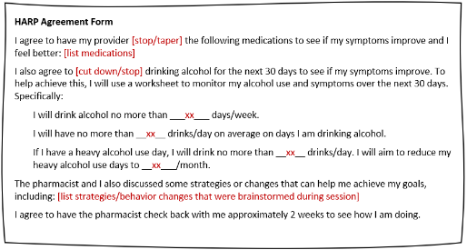
Discuss behaviors that could help to alleviate symptoms | - Help participant identify existing behaviors or supports that could be strengthened to enable behavioral change  - Identify new behaviors or supports that could help to enable behavioral change  - Harm reduction | “You have come up with some really good ideas of how to reduce your alcohol use. What are some of the things you would do to help you make these changes?”  Keep asking “And what else?” until the participant has listed a number of behavioral skills that might be helpful. The next steps will help prioritize which behaviors to implement first.  “If you can stop or limit your drinking you will be less likely to experience (further) symptoms related to alcohol use.”
Web-based resources | - Review web-based resources that may be helpful to participant
Websites that have been produced for Veterans and others, designed to help decrease drinking

http://rethinkingdrinking.niaaa.nih.gov/
https://www.hiv.va.gov/patient/daily/alcohol-drugs/overview.asp
https://vetchange.org/home/index2

Websites that have been produced for Veterans and others, designed to address questions and concerns regarding medications and/or polypharmacy

https://www.fda.gov/drugs/resources-you-drugs/drug-interactions-what-you-should-know
https://www.drugs.com/drug_interactions.html
https://www.agefriendlycare.psu.edu/course/patient/pv-medication/understand-your-medications
https://www.niaaa.nih.gov/publications/brochures-and-fact-sheets/harmful-interactions-mixing-alcohol-with-medicines
https://www.deprescribingnetwork.ca/patients-and-public

Talk through the HARP Agreement Form (see below) and help participant to complete | - Discuss the HARP Agreement Form with the participant.  - Avoid being argumentative. Don’t push the participant to agree to something they aren’t ready and/or interested in doing.

STEP 6. Self-Monitoring
Critical components:
- Introduce concept of self-monitoring
- Walk through each section of the Alcohol Use, Medications, and Symptom Monitoring Worksheet
- Summarize and conclude session

PREPARATION:
- Review Behavior Monitoring Worksheet (Figure 7 and below) provided by West Haven Coordinating Center

Introduce concept of self-monitoring and encourage participant to use a monitoring worksheet | - Introduce concept of behavior monitoring worksheet (Figure 7)  - Participants will be asked to use the worksheet for the two weeks between the intervention and the booster. They are welcome to continue using it after completing the study  - Work through the monitoring worksheet (sent to participant with Agreement Form after intervention) so the participant is clear about how to use this as part of a structured self-monitoring exercise | “An important part of changing your behavior, or breaking a habit, is to monitor your behavior. This includes identifying how you take your medications and when you are most likely to change how you take your medications. This will provide you with information that can help you manage your behavior and make better choices.  You might find it helpful to fill out a monitoring worksheet daily for the next two weeks to help track your bothersome symptoms, and if/how you are taking your most problematic medications. After this call, we will mail you a copy of a monitoring worksheet that you can use. Please have this worksheet available for our next call to help discuss concerns regarding your medications and symptoms. You can also bring this form to your next visit with your HIV clinician to start a conversation about reducing or changing your medications or about your symptoms. This is important for several reasons:  - It gets you in the habit of monitoring your behavior.  - It will make you aware of your what happens when you change how you take your medications  - It will help you identify potential connections between your medications and the bothersome symptoms that you experience.  - It will help you track how frequently each symptom is occurring.  If you get in the habit of tracking your behavior and symptoms, after four weeks, you will be able to look back and see how much you have changed how you take your medications and whether the frequency or quality/quantity of your bothersome symptoms has changed during this period of time.”
Summarize | - Re-summarize goals  - Thank participant for their time. | “This is what I have heard you say… This is how we are going to move forward… This is really an agreement you are making with yourself to improve your health.
Conclude the session | - Schedule follow-up booster session approx. 2 weeks after the initial intervention. The maximum time between the intervention and the booster session is 4 weeks.  - At the end of the booster session, the participant will then be notified that they will receive another PEth test and post-intervention study 30 days after the booster session. | “After this call, we will be sending you a packet which contains 3 items: your personalized feedback form, your HARP agreement form, and the alcohol use and medication monitoring worksheet that we discussed. You can expect to receive these items in the next few days.”

VII. Script for the Follow-up Booster Session

Hello, my name is _______________________________. Thank you again for speaking with me ___ weeks ago about information related to your alcohol use, your medications, and potential bothersome symptoms that may arise from the combination of alcohol and your medications. Today I would like to follow up with you to see how thing have been going since we last spoke.

At the end of our last conversation, we made a simple plan to ____ (refer to the HARP agreement, and the participant’s specific med/alcohol goals that were recorded there) _____. We also provided you with a worksheet to help you track your alcohol use, medications, and symptoms each week.

Since that time, what has it been like trying to follow this plan?
Have any questions come up for you or has any part of the plan been unclear?

MEDICATIONS
In terms of your medications, your goal(s) was(were) to ___ (state the specific goals) ____.
Since our last phone call, have you made any changes to the medications that you take?

- If the participant responds yes: “In what way? What have you done that helped to keep you on track? What made it difficult for you to stay on track/maintain these changes?”
- If the participant responds no: “What were some of the factors that made it hard to change the medications that you take?
NOTE: Based on what the participant says, the interventionist offers reaffirmation and problem solving as needed in response. The same is done for the alcohol goal. The key is to be specific to the goal, and to take one goal at a time if there are multiple.

ALCOHOL USE
In terms of alcohol use, your goals were to ___ (state the specific goals) ____. How has your progress been in reducing the number of days a week that you drank in the last 2 weeks (time since the agreement was completed)? Have you been able to make any changes to the amount of alcohol that you drink?

- If the participant responds yes: “In what way? What have you done that helped to keep you on track? What made it difficult for you to stay on track/maintain these changes?”
- If the participant responds no: “What were some of the factors that made it hard to change the amount that you drink?
NOTE: Based on what the participant says, the interventionist offers reaffirmation and problem solving as needed in response. The key is to be specific to the goal, and to take one goal at a time; note that in the case of alcohol, there are 3 sub-goals in the agreement that should be discussed one at a time.

WORKSHEET
Were you able to use the Alcohol Use, Medications and Symptom Monitoring Worksheet that we sent to you?

- If the participant responds yes: What did you find useful or helpful about it? How many days or weeks did you use the worksheet?
- If the participant responds no: What were some of the factors that made it hard to fill out the form regularly?
Is there anything else that may have changed since our last conversation that may have impacted your alcohol or medication use?

Finally, in the next few days, you will receive a follow up survey along with a self-addressed, pre-paid envelope. Please remember to fill it out and send it back—once it is received by our Coordinating Center, you will be sent a $25 gift card. Then in 30 days you will receive another follow up packet in the mail from our Coordinating Center. This packet will include another follow up survey and PEth test. It is very important that you remember to complete those final study-related tasks and mail them back to us. Once we receive those last materials, the last gift card will be sent to you ($50 if both survey complete and PEth sample adequate, if PEth sample is not adequate a second test kit will be sent to the participant. If second sample is still not adequate, then the participant will receive a $25 gift card for the completed survey).

Thank you once again for your time and participation in this study!

VIII. Additional Motivational Strategies

- Refrain From Directly Countering Resistance Statements

For example, the participant may say “How can I have a drinking
problem when I drink less than all my buddies?” or “Lots of my friends take these medications.” You can reply without insisting that there is a problem per se, but rather an issue that is worthy of further assessment and discussion, within the
context of this brief interview. For example: “Absolutely. I’m not saying that you have a drinking problem. I am concerned because the more alcohol that you drink, given that you’re taking medications that can interact with alcohol, the more it may contribute to your morning dizziness.”

- Focus On the Less Resistant Aspects of the Statement

For example, the above participant may be wondering about how much drinking or how many medications is actually problematic. The response might be to restate his concern and ask about his level of drinking, which is the less resistant part of the statement. “It sounds like you’re wondering about how you could have an issue with your drinking if you drink less than all your friends. Or “It sounds like you’re wondering about how medications can be a problem. Let’s talk about this a bit more.” (And remember, this is a statement NOT a question, so the intonation should turn down at the end of the remark).

- Restate Positive or Motivational Statements

For example, if a participant says: “You know, now that you mention it,
I feel like I have been overdoing it with my drinking lately,” or “You know, I do feel like I take too many medications” the Clinical Pharmacist could say, “You don’t need me to tell you you’ve been drinking a little too much lately, you’ve noticed yourself.”). or “You don’t need me to tell you you’re on an awful lot of medications ……” This serves to reinforce the participant’s motivation-even if the motivational statement is a relatively weak one. If the participant says, “I guess I might have to change my drinking [medications]” this could be restated as “It sounds like you’ve been thinking about changing how much you drink [your medications]”.

- Other Helpful Hints

Encourage participants to think about previous times they have cut back on their drinking or asked their HIV clinician to stop a medication.

Praise participants for their willingness to discuss such sensitive
topics, as well as their willingness to consider change.

View the participant as an active participant in the intervention.

IX. Common Challenging Scenarios

Certain challenges may occur during the course of the intervention:

- Refusal To Engage In The Discussion Of The Topic Of Drinking

Most participants will agree to discuss the topic, because they have already consented to be in the study. In the unlikely event that someone outright refuses to discuss it at all, tell the participant that you will respect their wishes and that all you will be doing is giving them 2 pieces of information:

- You are concerned that their drinking may be interacting with their medications to cause bothersome symptoms.
- You would like them to consider cutting down or stopping drinking to avoid these interactions with their medications.

- Refusal To Engage In The Discussion On The Topic Of Their Medications
Most participants will agree to discuss the topic, because they have already consented to be in the study. In the unlikely event that someone outright refuses to discuss it at all, tell the participant that you will respect their wishes and that all you will be doing is giving them 2 pieces of information:

  - You are concerned that their drinking may be interacting with their medications.
  - You would like them to consider cutting down or stopping certain medications, with the permission of their HIV clinician, that may interact with alcohol and contribute to their bothersome symptoms.

- Refusal To Self-Identify On The Readiness Ruler (Figure 4)

When this happens, it is usually a problem with understanding the numbers. There are several ways of dealing with this:

- Anchor the numbers with descriptors, such as “1” means not ready
at all or 0 percent ready, 5 means that you are kind of ready (you’re getting there, but some things are still standing in the way) and 10 means completely ready or 100% ready to change.

- Not Ready To Change Drinking Patterns

Tell the participant that the best recommendation is to either lower or stop drinking or lower or stop the medications known to interact with alcohol.

X. Surveys

Pre-Intervention Survey 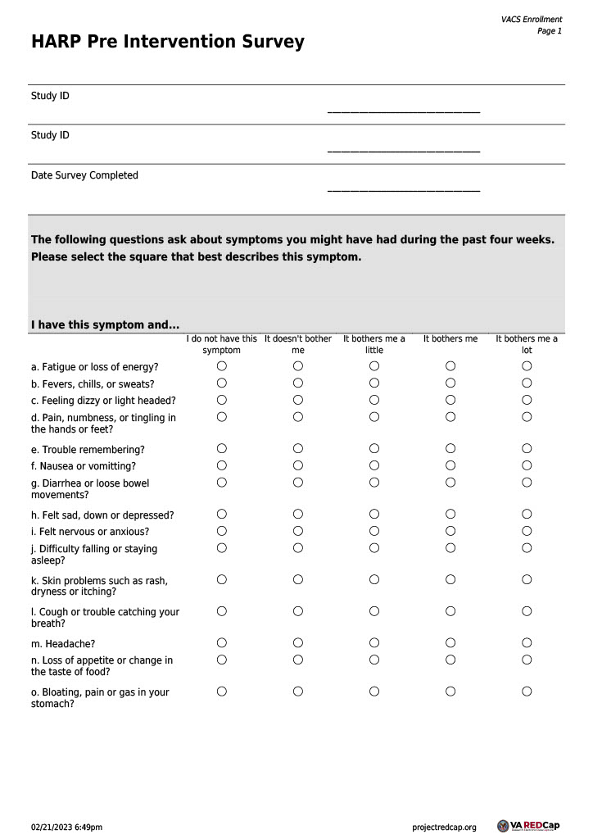
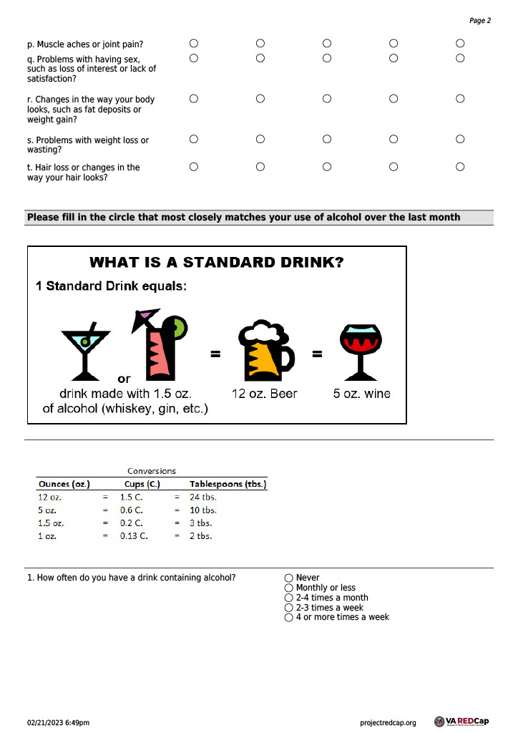

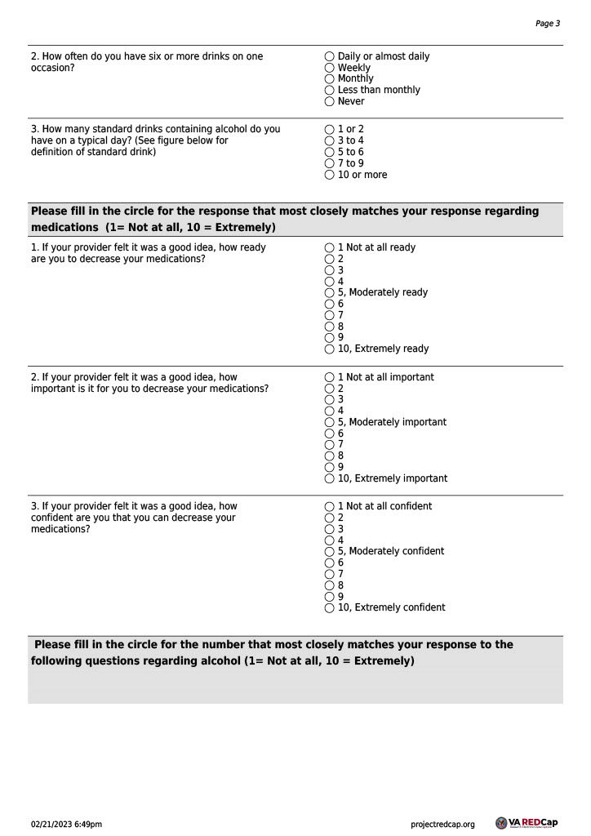

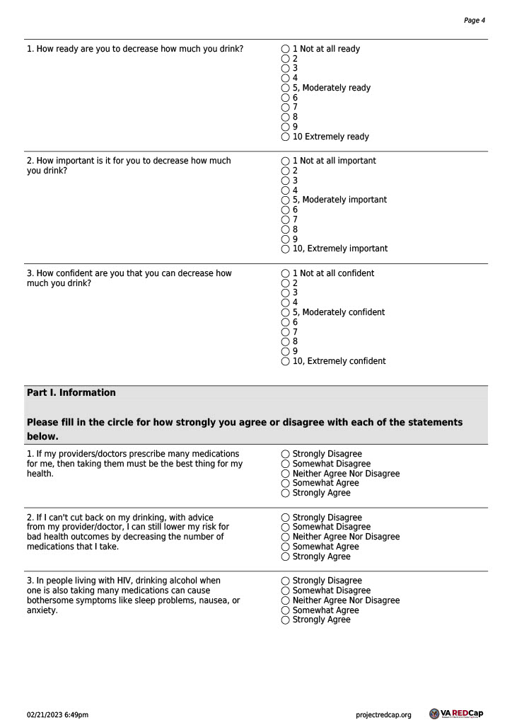

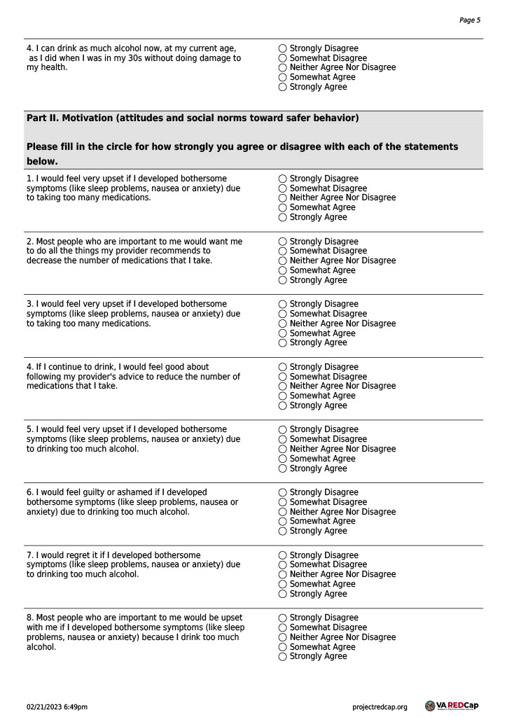

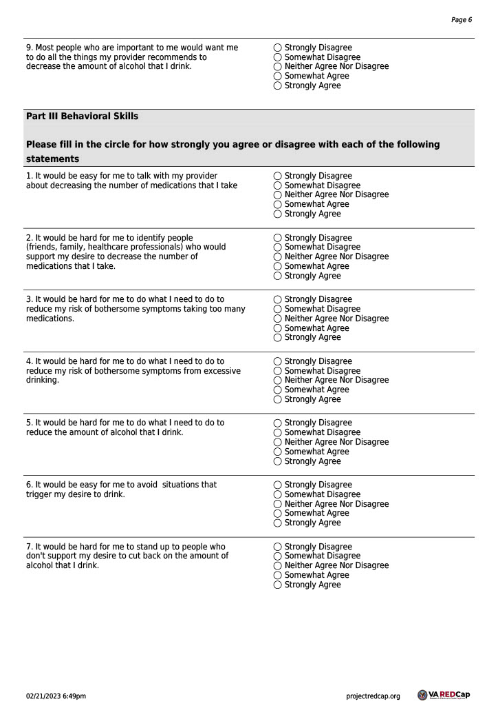

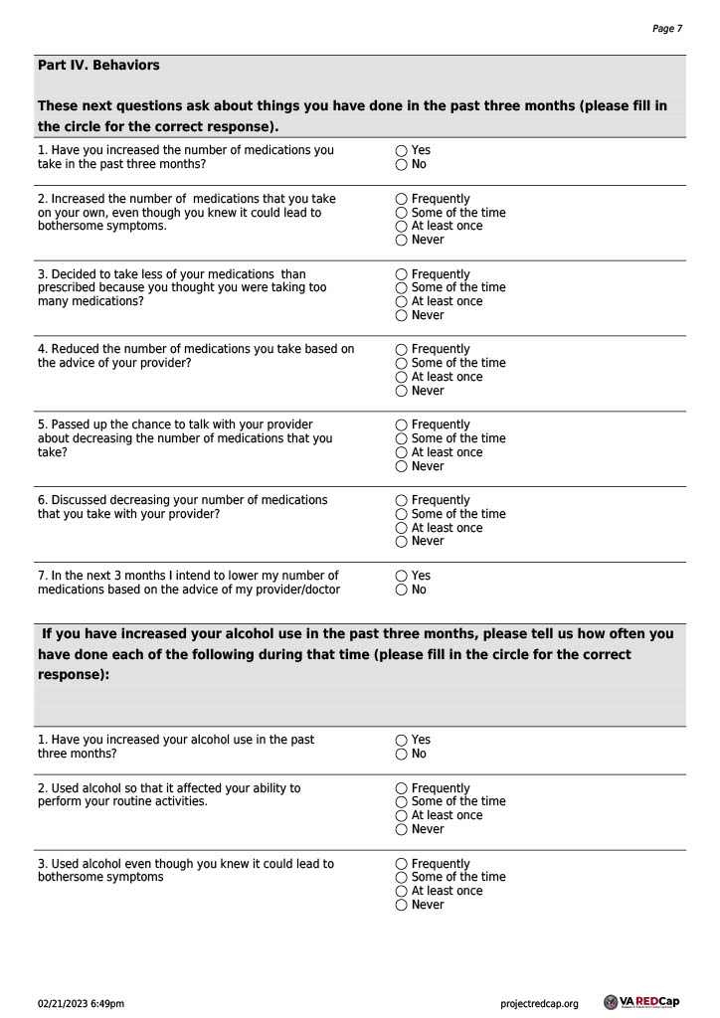

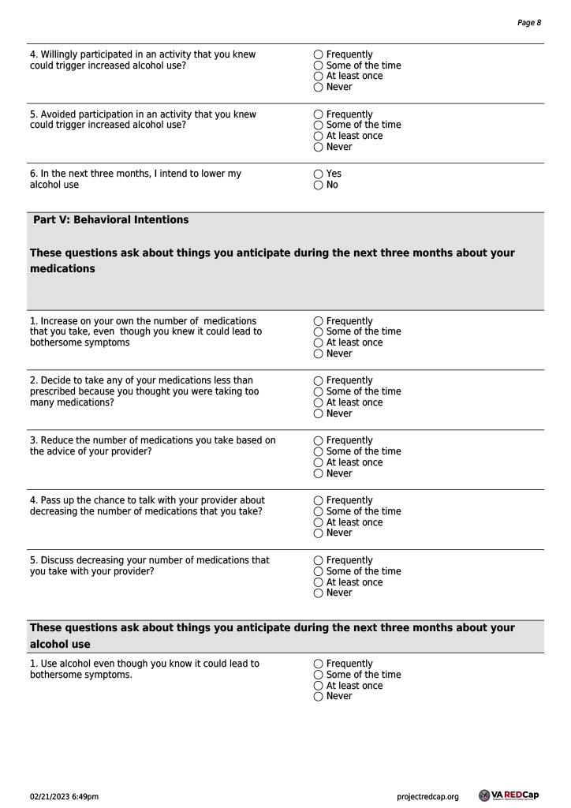

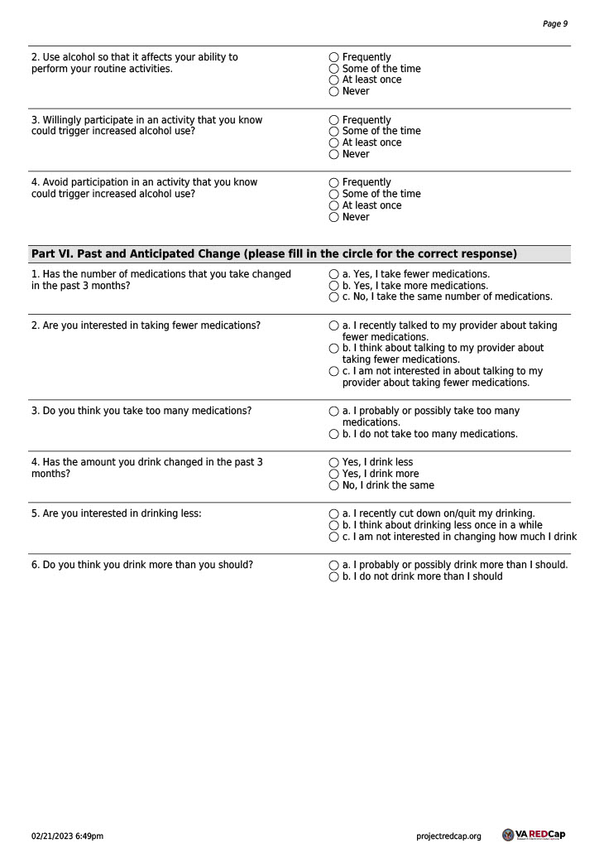

Post-Intervention Survey

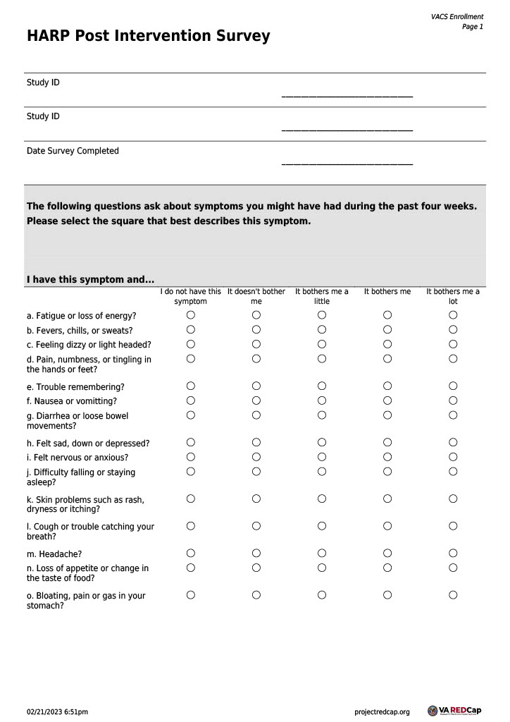

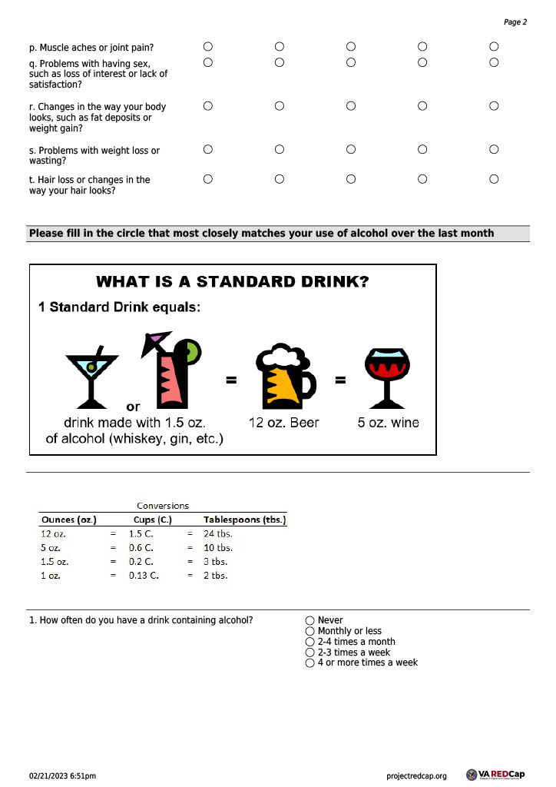

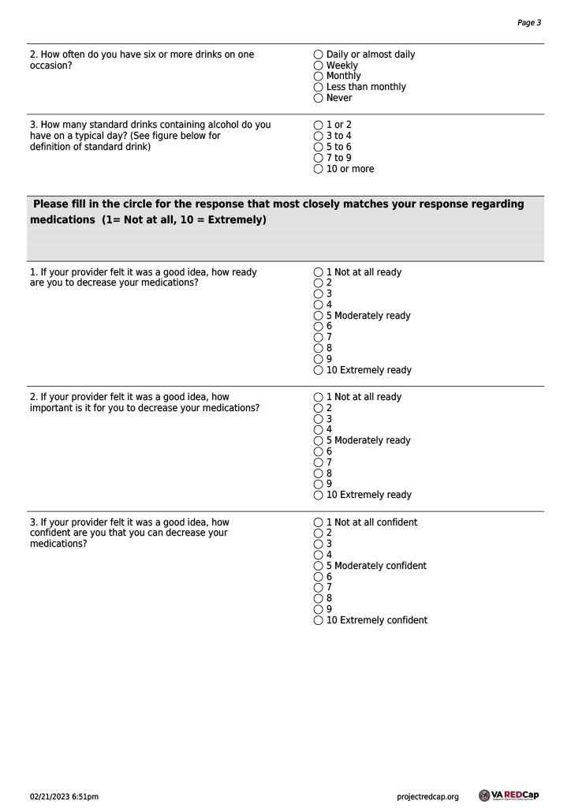

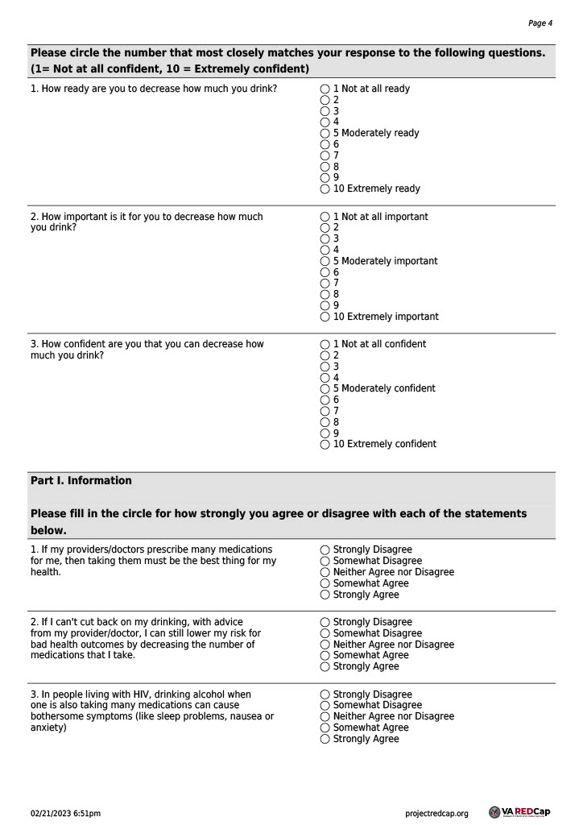

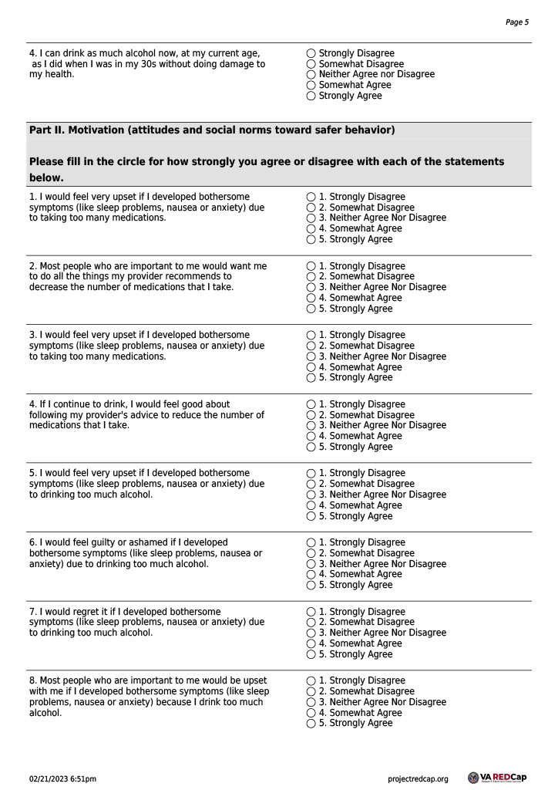

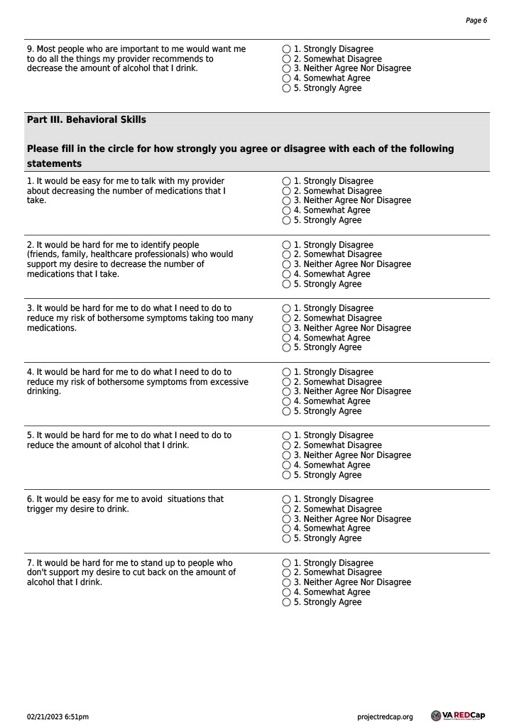
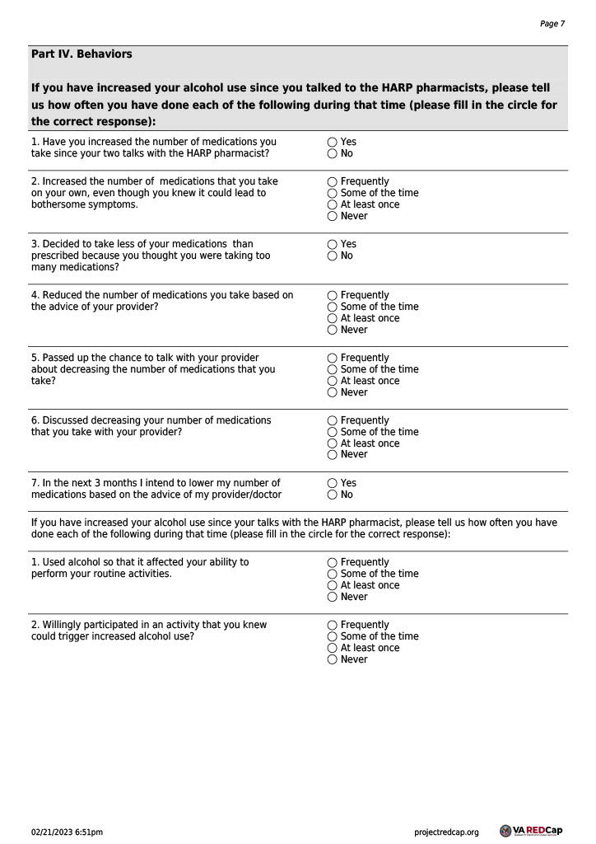

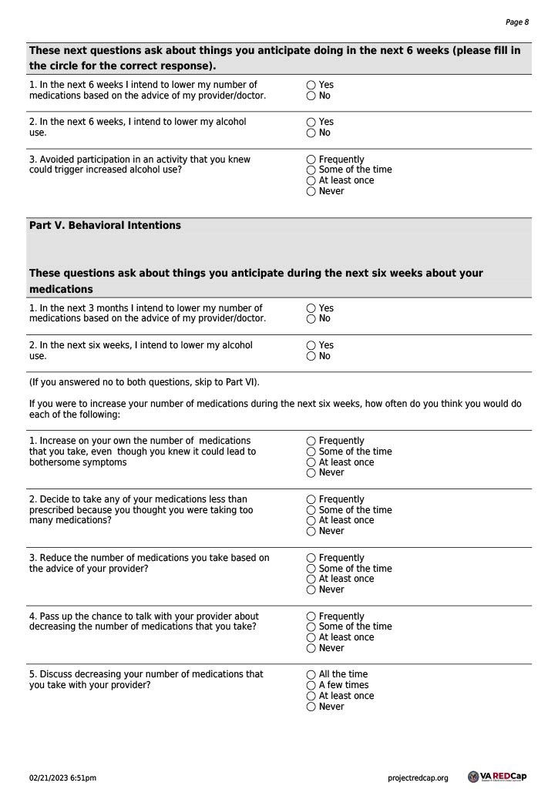

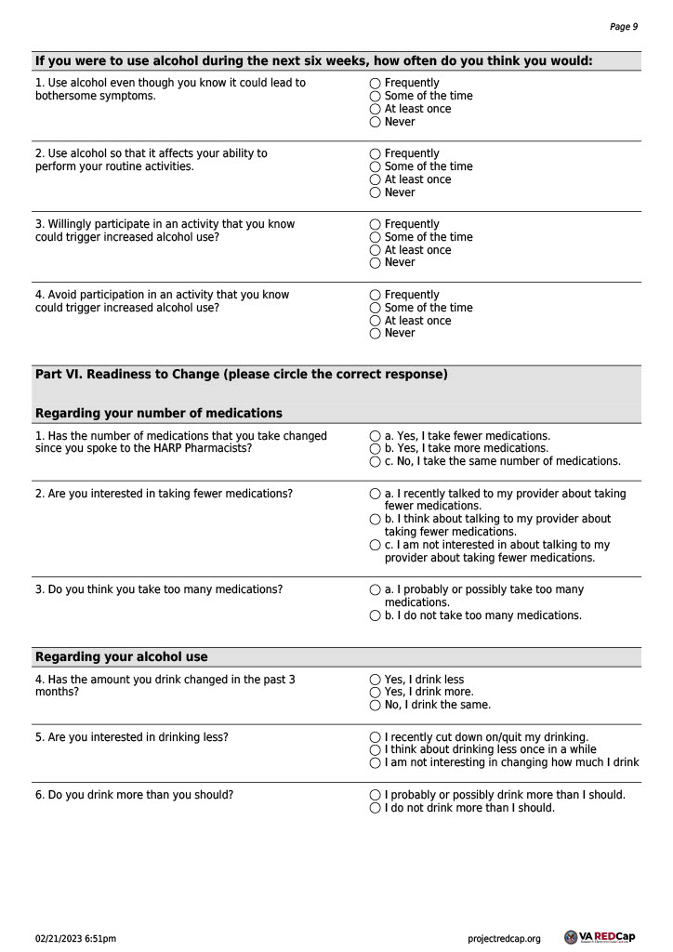

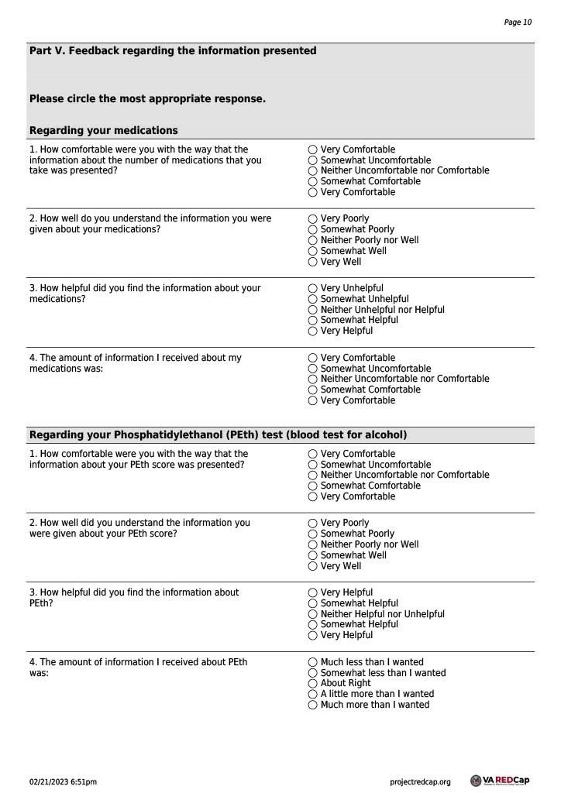

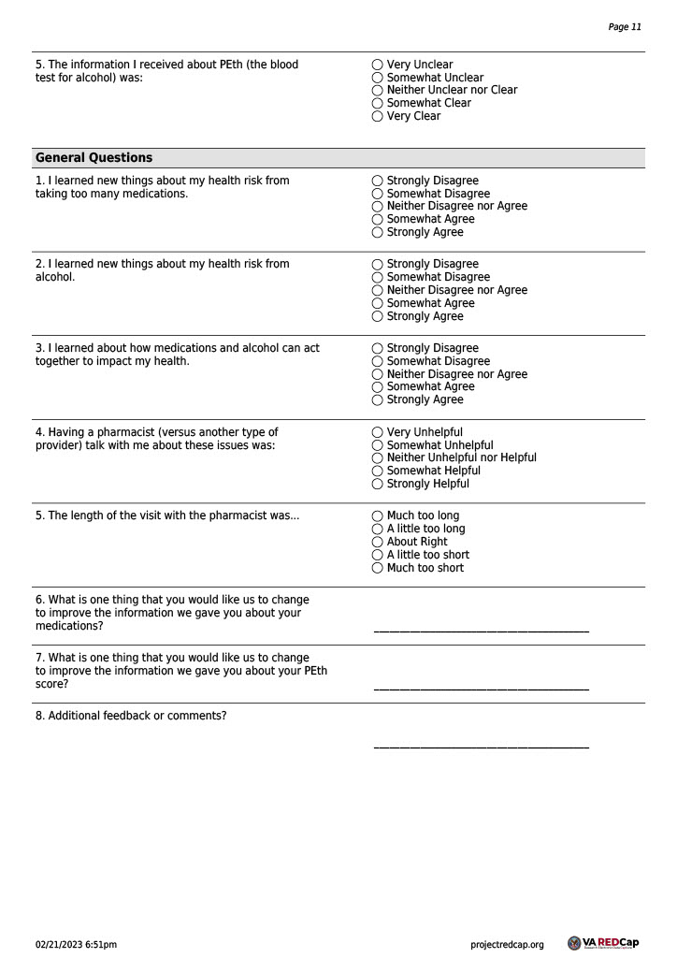



30 Day Post Intervention Survey

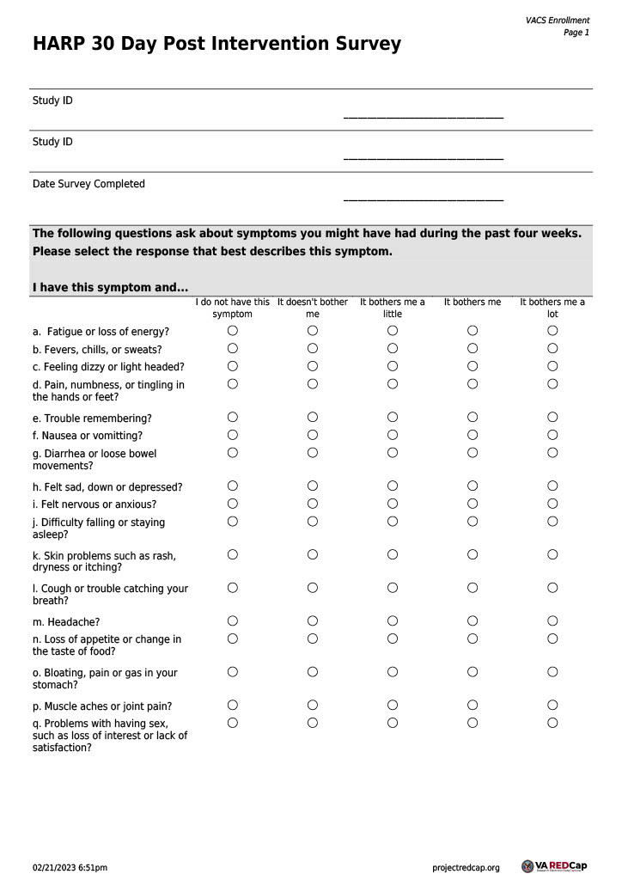

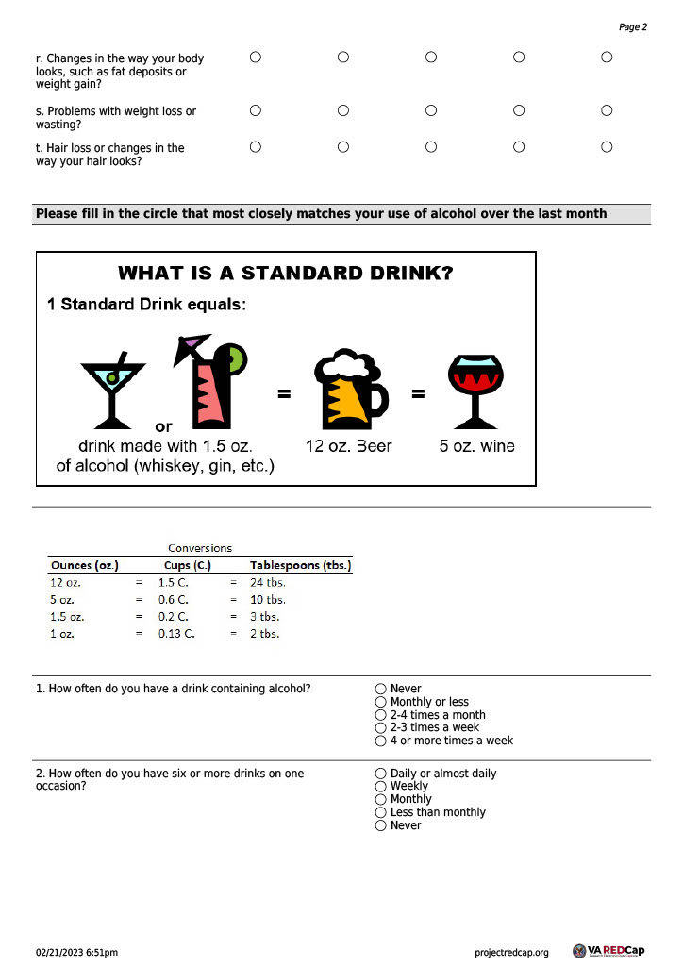

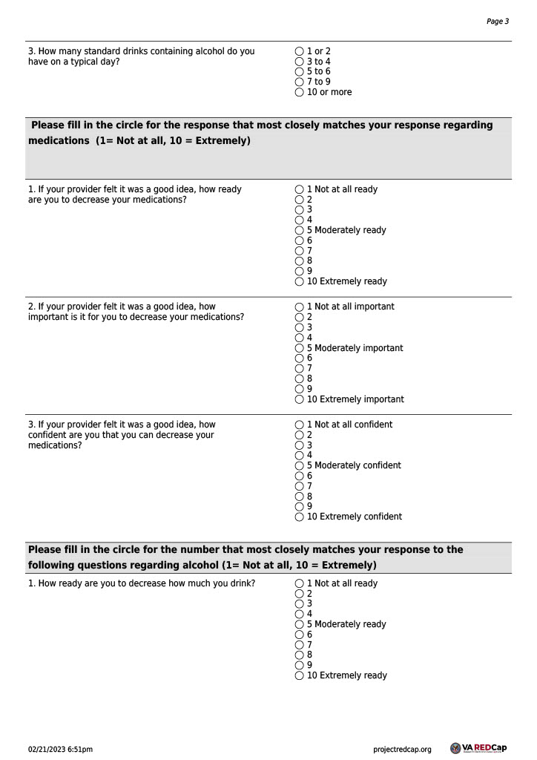

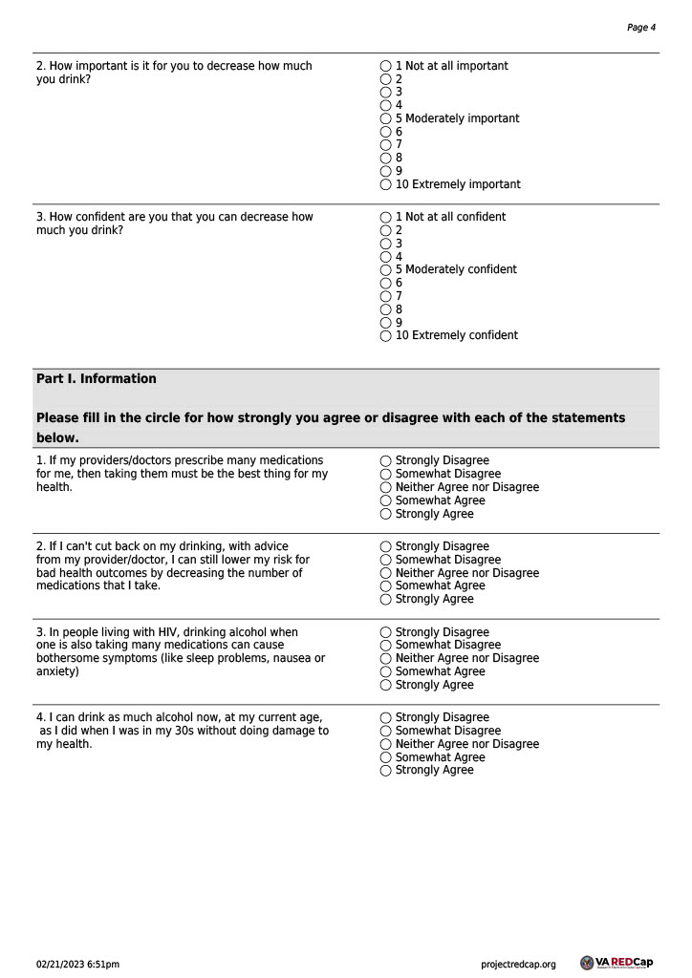

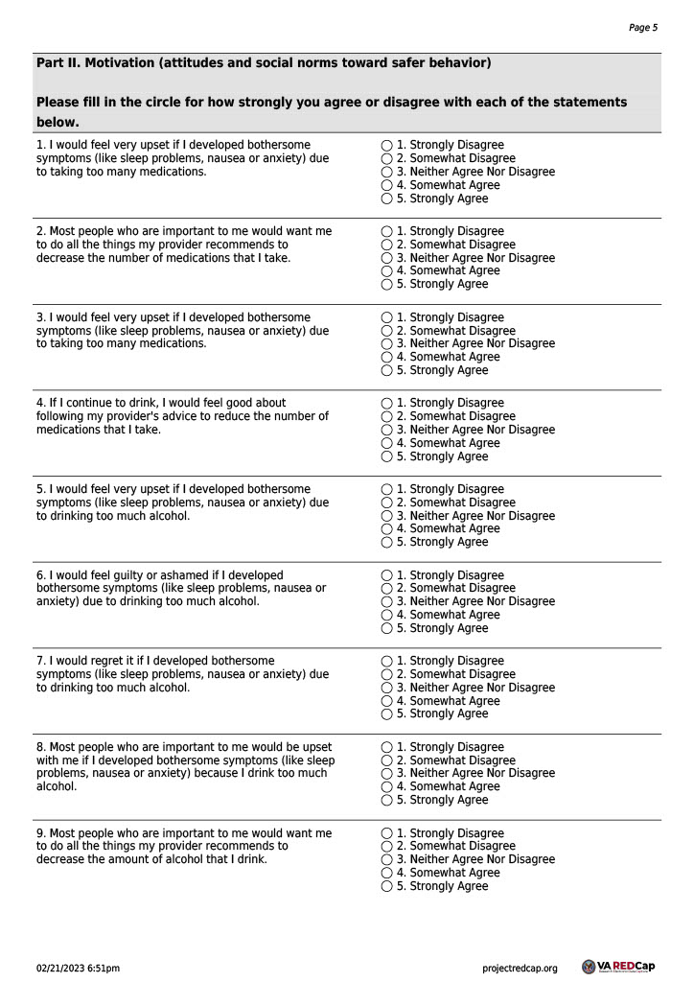

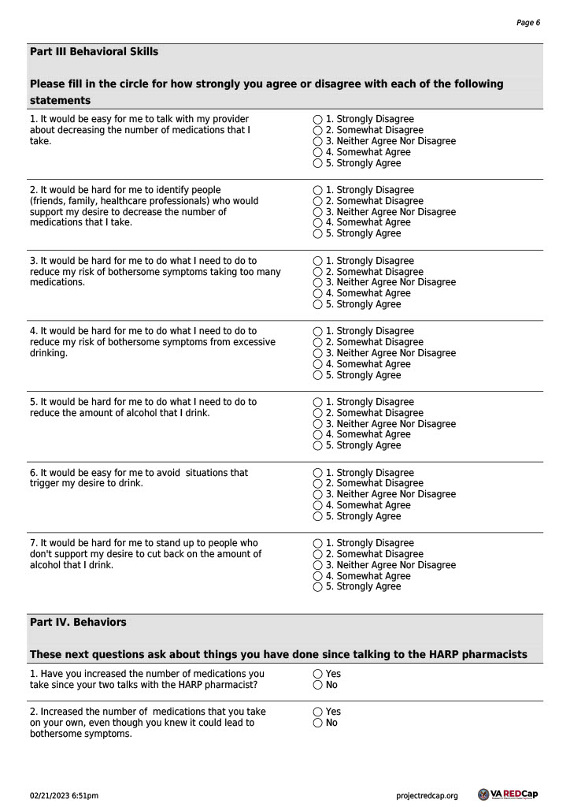

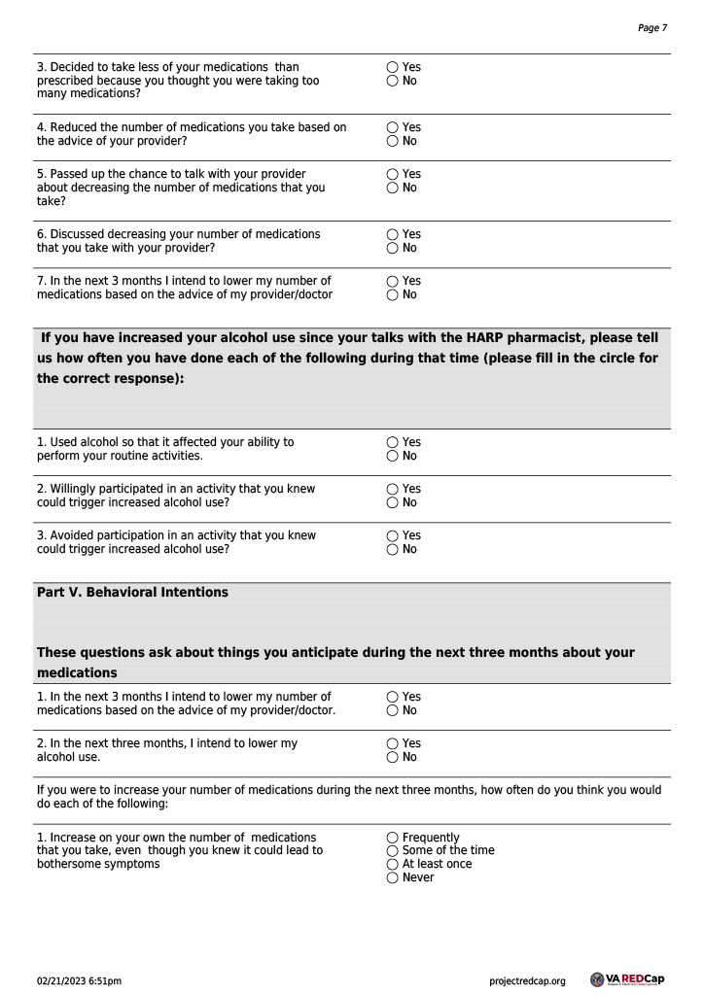

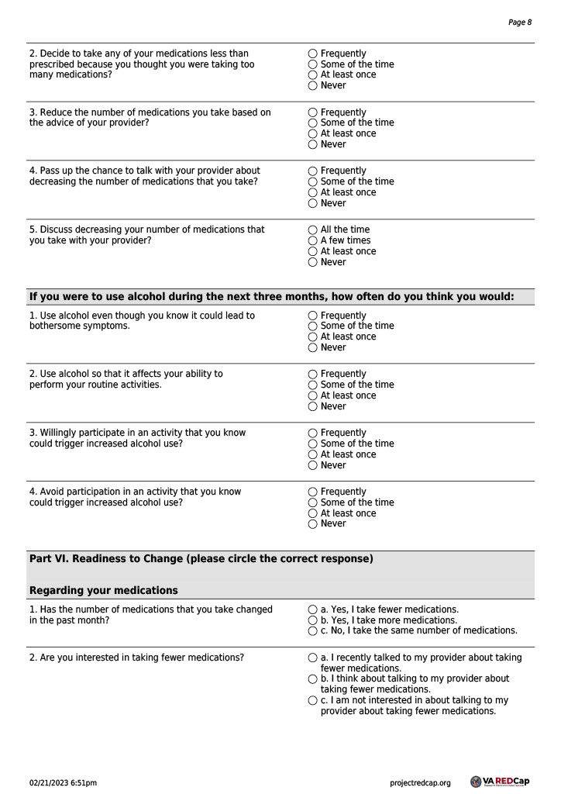

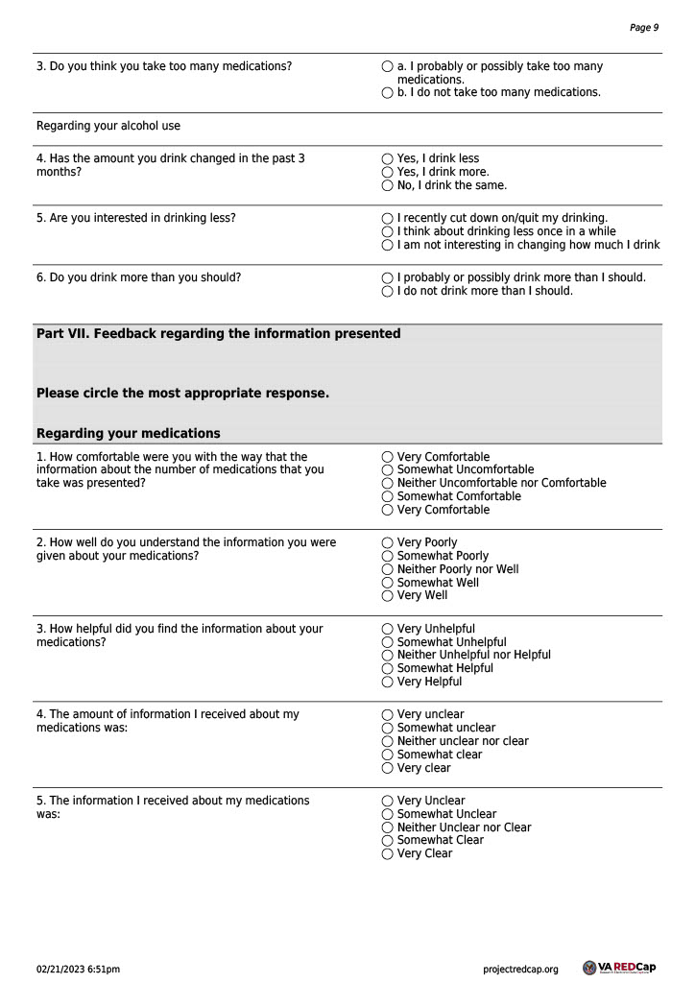

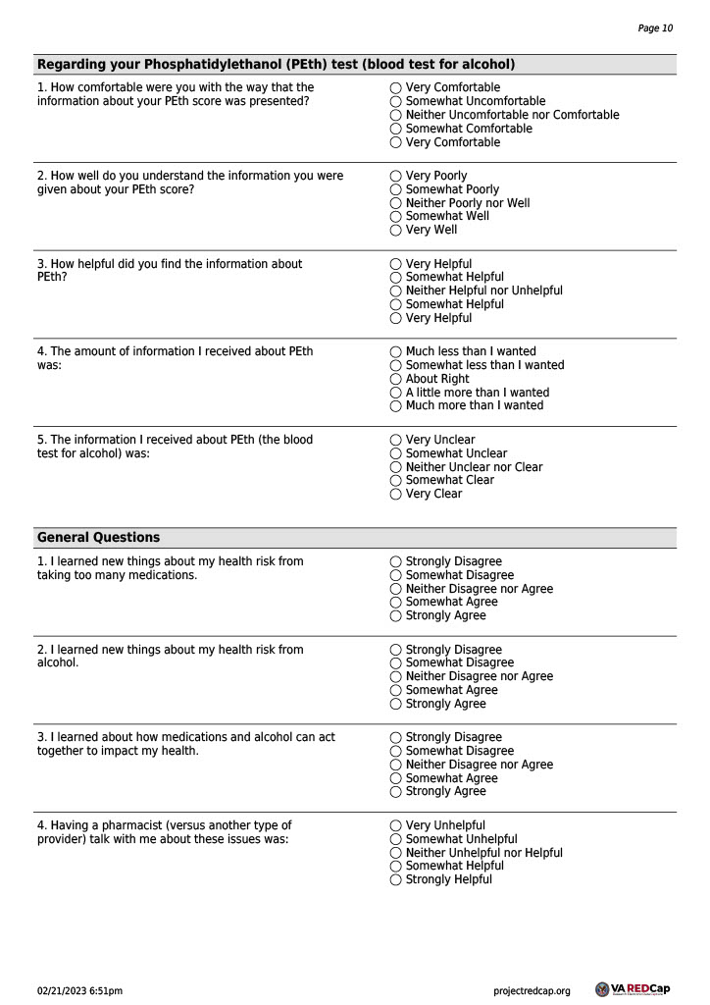

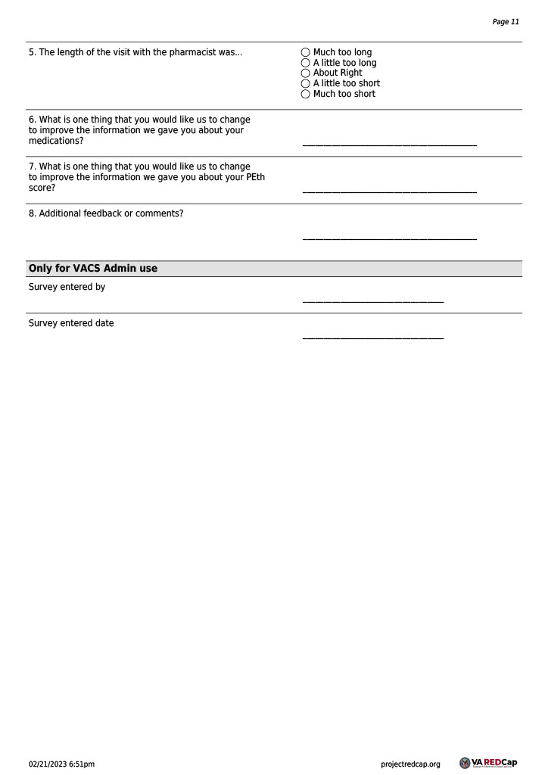

XI. Figures and Tables

FIGURE 1. HARP PILOT INTERVENTION PERSONALIZED FEEDBACK FORM
(For clinical pharmacist’s reference in Steps 1 & 2)

HARP Personalized Feedback Form
Thank you for agreeing to be a part of the HARP study! This includes doing a blood spot test and a survey and our review of your medical record. Based on the results of the blood spot test, what you told us on the survey, and the number of medicines prescribed by your doctor, we have made this report specifically for you.
- You are taking the medicines listed here [list active meds]
- You reported in your survey response that:
  - You drank alcohol in the past year [Monthly; 2-4 times a month; 2-3 times a week; 4 or more times a week].
  - In the past year, you drank [1 or2; 3 or 4; 5 or 6; 7to 9; 10 or more] drinks on a typical day when you drink.
  - Within the past year, you had six or more drinks [Never; Less than monthly; Monthly; Weekly; Daily or almost daily]
- Your blood spot test for alcohol was [low positive (8-10), intermediate positive (11-19), high positive (20+)].
- Do you have any questions about these results? Is there anything that you would like me to clarify?
Excellent! Now we’ll move to the number of medications that your doctor has prescribed and related information.
- [If participant noted any bothersome symptoms, if not go to #5] You report symptoms that bother you, including: [If 5+ bothersome symptoms noted, list those most associated with alcohol or active medications] * [If <5 bothersome symptoms noted, list all bothersome symptoms]
- You also mentioned some bothersome symptoms that you have been noticing. Based research and our own clinical experience working with participants, some of the symptoms that you mentioned such as [participant’s symptom(s)] may be worsened by the combination of taking [participant’s medication(s)] and using alcohol at the same time. What are your thoughts about that possible connection? [By each endorsed bothersome symptom listed in 1, list all active medications and alcohol if they contribute to this symptom]. **
- [If no bothersome symptoms] These symptoms may be caused by the alcohol that you drink [list top 5 most common symptoms associated with alcohol] [if on a medication associated with any of these 5 symptoms, add the following statement, “and these medications may also contribute to these symptoms [list medications]”]. Have any of these symptoms bothered you? [If no endorsement even after prompt, say “please consider the possibility that your alcohol use may change the way your medicines work”].
OK, any questions at all about the effects of the medications and how they might be changed by alcohol?
*A knowledge base will be created using weighted logistic regression analyses of symptoms and their associations with alcohol generated from MASH data.
**A knowledge base will be created listing which of the 19 symptoms from the HIV symptom index are associated with commonly used medications based on UpToDate.

TABLE 1. Categories of Alcohol use
(For clinical pharmacist’s reference)

Abstainers | Drink no alcohol.
Lower risk | Drink within NIAAA guidelines, but may still interact with medications
Hazardous (At Risk) | Exceed NIAAA consumption guidelines. Alcohol use puts them at risk for injury/illness or social problems
Harmful (Problem) | Currently experiencing problems (medical/social) related to alcohol; often exceed NIAAA guidelines for lower-risk drinking.
Alcohol Use Disorder | Meet criteria for AUD based upon assessment criteria such as DSM-5.

PEth Results Interpretation
<8 Negative
8-20 Low to moderate alcohol use
20-50 Heavy alcohol use
50> Very heavy alcohol use

FIGURE 2. WHAT IS A STANDARD DRINK?
(For reference in Steps 5 & 6. Participant will have seen this in the pre-intervention survey. It will also be available on the monitoring worksheet for the patent to reference.)

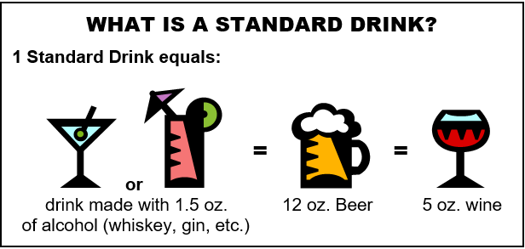

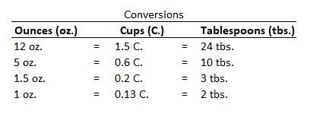
FIGURE 3. PROS AND CONS LISTS
(For clinical pharmacist’s reference in Step 3)
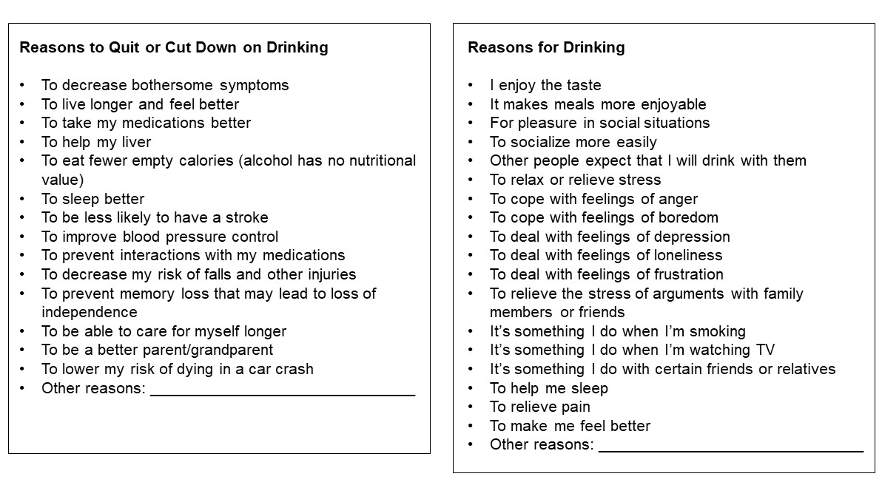
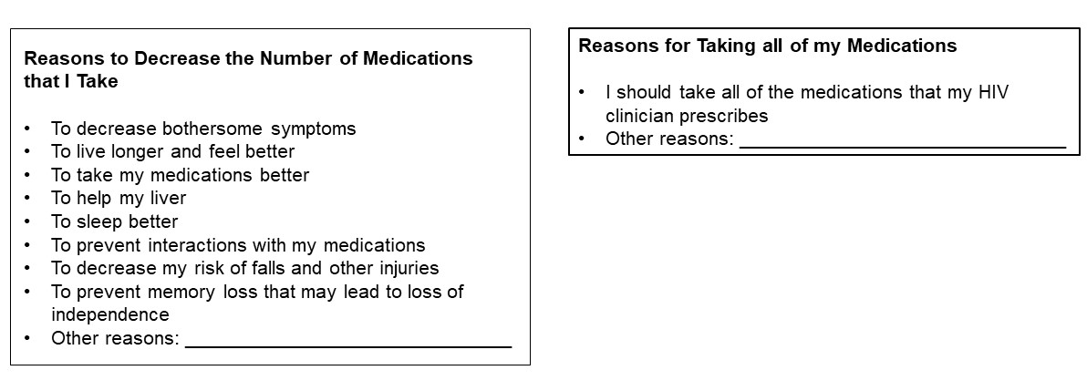

FIGURE 4. DRINKING and MEDICATION AGREEMENT
(For clinical pharmacist’s reference in Step 4)

HARP Agreement Form
I agree to have my provider [stop/taper] the following medications to see if my symptoms improve and I feel better: [list medications]
I also agree to [cut down/stop] drinking alcohol for the next 30 days to see if my symptoms improve. To help achieve this, I will use a worksheet to monitor my alcohol use and symptoms over the next 30 days. Specifically:
I will drink alcohol no more than ___xx___ days/week.
I will have no more than __xx__ drinks/day on average on days I am drinking alcohol.
If I have a heavy alcohol use day, I will drink no more than __xx__ drinks/day. I will aim to reduce my heavy alcohol use days to __xx___/month.
The pharmacist and I also discussed some strategies or changes that can help me achieve my goals, including: [list strategies/behavior changes that were brainstormed during session]
I agree to have the pharmacist check back with me approximately 2 weeks to see how I am doing.

Websites that have been produced for Veterans and others, designed to help decrease drinking

http://rethinkingdrinking.niaaa.nih.gov/
https://www.hiv.va.gov/participant/daily/alcohol-drugs/overview.asp
https://vetchange.org/home/index2

Websites that have been produced for Veterans and others, designed to address questions and concerns regarding medications and/or polypharmacy

https://www.fda.gov/drugs/resources-you-drugs/drug-interactions-what-you-should-know
https://www.drugs.com/drug_interactions.html
https://www.agefriendlycare.psu.edu/course/patient/pv-medication/understand-your-medications
https://www.niaaa.nih.gov/publications/brochures-and-fact-sheets/harmful-interactions-mixing-alcohol-with-medicines
https://www.deprescribingnetwork.ca/patients-and-public

FIGURE 5. SAMPLE BEHAVIOR MONITORING WORKSHEET
(For clinical pharmacist’s reference in Step 6) (next page)

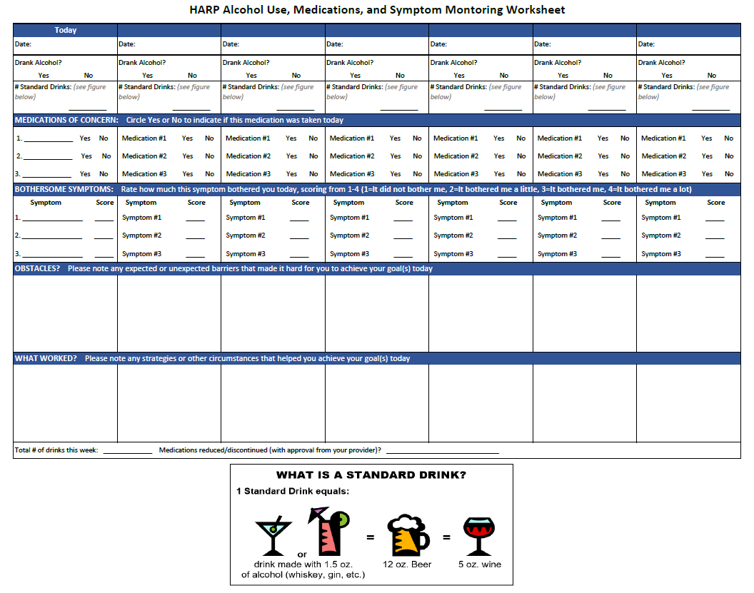
XII. References

1. Edelman EJ, Maisto SA, Hansen NB, et al. The Starting Treatment for Ethanol in Primary care Trials (STEP Trials): Protocol for Three Parallel Multi-Site Stepped Care Effectiveness Studies for Unhealthy Alcohol Use in HIV-Positive Participants. Contemp Clin Trials. Jan 2017;52:80-90.
2. D'Onofrio G, Fiellin DA, Pantalon MV, et al. A Brief Intervention Reduces Hazardous and Harmful Drinking in Emergency Department Participants. Ann Emerg Med. Mar 28 2012.
3. D'Onofrio G, Pantalon MV, Degutis LC, Fiellin DA, O'Connor P G. Development and implementation of an emergency practitioner-performed brief intervention for hazardous and harmful drinkers in the emergency department. Acad Emerg Med. Mar 2005;12(3):249-256.
4. Saitz R. Clinical practice. Unhealthy alcohol use. N Engl J Med. Feb 10 2005;352(6):596-607.
5. Collaborators GBDA. Alcohol use and burden for 195 countries and territories, 1990-2016: a systematic analysis for the Global Burden of Disease Study 2016. Lancet. Aug 23 2018.
6. Justice AC, Gordon KS, Romero J, et al. Polypharmacy-associated risk of hospitalisation among people ageing with and without HIV: an observational study. Lancet Healthy Longev. Oct 2021;2(10):e639-e650.
7. Edelman EJ, Rentsch CT, Justice AC. Polypharmacy in HIV: recent insights and future directions. Curr Opin HIV AIDS. Mar 2020;15(2):126-133.
8. Khawcharoenporn T, Tanslaruk V. Does polypharmacy affect treatment outcomes of people living with HIV starting antiretroviral therapy? Int J STD AIDS. Oct 2020;31(12):1195-1201.
9. Fabris P, Tositti G, Manfrin V, et al. Does alcohol intake affect highly active antiretroviral therapy (HAART) response in HIV-positive participants? J Acquir Immune Defic Syndr. 2000;25:92-93.
10. Cook RL, Sereika SM, Hunt SC, Woodward WC, Erlen JA, Conigliaro J. Problem drinking and medication adherence among persons with HIV infection. J Gen Intern Med. 2001;16:83-88.
11. Galvan FH, Bing EG, Fleishman JA, et al. The prevalence of alcohol consumption and heavy drinking among people with HIV in the United States: results from the HIV Cost and Services Utilization Study. J Stud Alcohol. 2002;63:179-186.
12. Lucas GM, Gebo KA, Chaisson RE, Moore RD. Longitudinal assessment of the effects of drug and alcohol abuse on HIV-1 treatment outcomes in an urban clinic. Aids. 2002;16(5):767-774.
13. Samet JH, Horton NJ, Traphagen ET, Lyon SM, Freedberg KA. Alcohol consumption and HIV disease progression: are they related? Alcoholism: Clinical & Experimental Research. 2003;27(5):862-867.
14. Arnsten JH, Demas PA, Grant RW, et al. Impact of active drug use on antiretroviral therapy adherence and viral suppression in HIV-infected drug users. J Gen Int Med. 2002;17:377-381.
15. Bangsberg DR, Hecht FM, Charlebois ED, et al. Adherence to protease inhibitors, HIV-1 viral load, and development of drug resistance in an indigent population. AIDS. 2000;14(4):357-366.
16. Heckman BD, Catz SL, Heckman TG, Miller JG, Kalichman SC. Adherence to antiretroviral therapy in rural persons living with HIV disease in the United States. AIDS Care. 2004;16(2):219-230.
17. Samet JH, Horton NJ, Meli S, Freedberg KA, Palepu A. Alcohol consumption and antiretroviral adherence among HIV-infected persons with alcohol problems. Alcoholism: Clinical & Experimental Research. 2004;28(4):572-577.
18. Tucker JS, Orlando M, Burnam MA, Sherbourne CD, Kung F-Y, Gifford AL. Psychosocial mediators of antiretroviral nonadherence in HIV-positive adults with substance use and mental health problems. Health Psychology. Jul 2004;23(4):363-370.
19. Braithwaite RS, McGinnis KA, Conigliaro J, et al. A temporal and dose-response association between alcohol consumption and medication adherence among veterans in care. Alcohol Clin. Exp. Res. 7/2005 2005;29(7):1190-1197.
20. National Institute on Alcohol Abuse and Alcoholism. What is heavy drinking? https://www.niaaa.nih.gov/health-professionals-communities/core-resource-on-alcohol/basics-defining-how-much-alcohol-too-much#pub-toc5. Accessed 6.30, 2022.
21. Scheideler JK, Klein WMP. Awareness of the Link between Alcohol Consumption and Cancer across the World: A Review. Cancer Epidemiol Biomarkers Prev. Apr 2018;27(4):429-437.
22. Edelman EJ, Gan G, Dziura J, et al. Readiness to Provide Medications for Addiction Treatment in HIV Clinics: A Multisite Mixed-Methods Formative Evaluation. J Acquir Immune Defic Syndr. Jul 1 2021;87(3):959-970.
23. Womack JA, Novick G, Fried T. The beginning of the end: A qualitative study of falls among HIV+ individuals. PLoS One. 2018;13(11):e0207006.
24. Ware D, Palella FJ, Jr., Chew KW, et al. Prevalence and trends of polypharmacy among HIV-positive and -negative men in the Multicenter AIDS Cohort Study from 2004 to 2016. PLoS One. 2018;13(9):e0203890.
25. Guaraldi G, Malagoli A, Calcagno A, et al. The increasing burden and complexity of multi-morbidity and polypharmacy in geriatric HIV participants: a cross sectional study of people aged 65 - 74 years and more than 75 years. BMC Geriatr. Apr 20 2018;18(1):99.
26. Justice AC, Gordon KS, Skanderson M, et al. Nonantiretroviral polypharmacy and adverse health outcomes among HIV-infected and uninfected individuals. AIDS. Mar 27 2018;32(6):739-749.
27. Milic J, Russwurm M, Cerezales Calvino A, Brañas F, Sánchez-Conde M, Guaraldi G. European cohorts of older HIV adults: POPPY, AGEhIV, GEPPO, COBRA and FUNCFRAIL. European Geriatric Medicine. 2019;10(2):247-257.
28. Ssonko M, Stanaway F, Mayanja HK, et al. Polypharmacy among HIV positive older adults on anti-retroviral therapy attending an urban clinic in Uganda. BMC geriatr. 05 29 2018;18(1):125.
29. Siefried KJ, Mao L, Cysique LA, et al. Concomitant medication polypharmacy, interactions and imperfect adherence are common in Australian adults on suppressive antiretroviral therapy. AIDS. Jan 2 2018;32(1):35-48.
30. Livio F, Marzolini C. Prescribing issues in older adults living with HIV: thinking beyond drug-drug interactions with antiretroviral drugs. Ther Adv Drug Saf. 2019;10:2042098619880122.
31. Edelman EJ, Gordon KS, Glover J, McNicholl IR, Fiellin DA, Justice AC. The next therapeutic challenge in HIV: polypharmacy. Drugs Aging. Aug 2013;30(8):613-628.
32. Department of Health and Human Services. Guidelines for the Use of Antiretroviral Agents in Adults and Adolescents with HIV. 2021.
33. Guaraldi G, Marcotullio S, Maserati R, et al. The Management of Geriatric and Frail HIV Participants. A 2017 Update from the Italian Guidelines for the Use of Antiretroviral Agents and the Diagnostic Clinical Management of HIV-1 Infected Persons. The Journal of frailty & aging. 2019;8(1):10-16.
34. Hughes CA, Tseng A, Cooper R. Managing drug interactions in HIV-infected adults with comorbid illness. CMAJ. Jan 6 2015;187(1):36-43.
35. Justice ACT, J.P. Strengths and Limitations of the Veterans Aging Cohort Study Index as a Measure of Physiologic Frailty. AIDS Res Hum Retroviruses. 2019.
36. Weathermon R, Crabb DW. Alcohol and medication interactions. Alcohol Res. Health. 1999 1999;23(1):40-54.
37. Holton AE, Gallagher PJ, Ryan C, Fahey T, Cousins G. Consensus validation of the POSAMINO (POtentially Serious Alcohol-Medication INteractions in Older adults) criteria. BMJ open. Nov 8 2017;7(11):e017453.
38. Sturgess JE, George TP, Kennedy JL, Heinz A, Muller DJ. Pharmacogenetics of alcohol, nicotine and drug addiction treatments. Addict Biol. Jul 2011;16(3):357-376.
39. Holton AE, Gallagher P, Fahey T, Cousins G. Concurrent use of alcohol interactive medications and alcohol in older adults: a systematic review of prevalence and associated adverse outcomes. BMC Geriatr. Jul 17 2017;17(1):148.
40. Zanjani F, Schoenberg N, Martin C, Clayton R. Reducing Medication Risks in Older Adult Drinkers. Gerontol Geriatr Med. Jan-Dec 2020;6:2333721420910936.
41. Breslow RA, Dong C, White A. Prevalence of alcohol-interactive prescription medication use among current drinkers: United States, 1999 to 2010. Alcohol Clin Exp Res. Feb 2015;39(2):371-379.
42. Kumar S, Rao PS, Earla R, Kumar A. Drug-drug interactions between anti-retroviral therapies and drugs of abuse in HIV systems. Expert Opin Drug Metab Toxicol. Mar 2015;11(3):343-355.
43. McCance-Katz EF, Gruber VA, Beatty G, Lum PJ, Rainey PM. Interactions between alcohol and the antiretroviral medications ritonavir or efavirenz. J. Addict. Med. 7/2013 2013;7(4):264-270.
44. Kresina TF, Flexner CW, Sinclair J, et al. Alcohol use and HIV pharmacotherapy. AIDS Res.Hum.Retroviruses. 7/2002 2002;%20;18(11):757-770.
45. O'Connor EA, Perdue LA, Senger CA, et al. Screening and Behavioral Counseling Interventions to Reduce Unhealthy Alcohol Use in Adolescents and Adults: Updated Evidence Report and Systematic Review for the US Preventive Services Task Force. JAMA. Nov 13 2018;320(18):1910-1928.
46. Sullivan LE, Tetrault JM, Braithwaite RS, Turner BJ, Fiellin DA. A Meta-analysis of the Efficacy of Nonphysician Brief Interventions for Unhealthy Alcohol Use: Implications for the Participant-Centered Medical Home. Am J Addict. Jul 2011;20(4):343-356.
47. Edelman EJ, Maisto SA, Hansen NB, et al. Integrated stepped alcohol treatment for participants with HIV and at-risk alcohol use: a randomized trial. Addict Sci Clin Pract. Jul 29 2020;15(1):28.
48. Edelman EJ, Maisto SA, Hansen NB, et al. Integrated stepped alcohol treatment for participants with HIV and liver disease: A randomized trial. J Subst Abuse Treat. Nov 2019;106:97-106.
49. DiClemente CC, Prochaska JO. Toward a comprehensive, transtheoretical model of change: Stages of change and addictive behaviors. 1998.
50. Fisher JD, Cornman DH, Shuper PA, et al. HIV prevention counseling intervention delivered during routine clinical care reduces HIV risk behavior in HIV-infected South Africans receiving antiretroviral therapy: the Izindlela Zokuphila/Options for Health randomized trial. J Acquir Immune Defic Syndr. Dec 15 2014;67(5):499-507.
51. Cornman DH, Kiene SM, Christie S, et al. Clinic-based intervention reduces unprotected sexual behavior among HIV-infected participants in KwaZulu-Natal, South Africa: results of a pilot study. J Acquir Immune Defic Syndr. Aug 15 2008;48(5):553-560.
52. Fisher JD, Cornman DH, Norton WE, Fisher WA. Involving behavioral scientists, health care providers, and HIV-infected participants as collaborators in theory-based HIV prevention and antiretroviral adherence interventions. J Acquir Immune Defic Syndr. Dec 1 2006;43 Suppl 1:S10-17.
53. Aradottir S, Asanovska G, Gjerss S, Hansson P, Alling C. PHosphatidylethanol (PEth) concentrations in blood are correlated to reported alcohol intake in alcohol-dependent participants. Alcohol Alcohol. Jul-Aug 2006;41(4):431-437.
54. Aradottir S, Moller K, Alling C. Phosphatidylethanol formation and degradation in human and rat blood. Alcohol Alcohol. Jan-Feb 2004;39(1):8-13.
55. Bager H, Christensen LP, Husby S, Bjerregaard L. Biomarkers for the Detection of Prenatal Alcohol Exposure: A Review. Alcohol Clin Exp Res. Feb 2017;41(2):251-261.
56. Faller A, Richter B, Kluge M, Koenig P, Seitz HK, Skopp G. Stability of phosphatidylethanol species in spiked and authentic whole blood and matching dried blood spots. Int J Legal Med. May 2013;127(3):603-610.
57. Francis JM, Weiss HA, Helander A, Kapiga SH, Changalucha J, Grosskurth H. Comparison of self-reported alcohol use with the alcohol biomarker phosphatidylethanol among young people in northern Tanzania. Drug and alcohol dependence. Nov 1 2015;156:289-296.
58. Gnann H, Weinmann W, Thierauf A. Formation of phosphatidylethanol and its subsequent elimination during an extensive drinking experiment over 5 days. Alcohol Clin Exp Res. Sep 2012;36(9):1507-1511.
59. Johansson K, Johansson L, Pennlert J, Soderberg S, Jansson JH, Lind MM. Phosphatidylethanol Levels, As a Marker of Alcohol Consumption, Are Associated With Risk of Intracerebral Hemorrhage. Stroke. Jul 2020;51(7):2148-2152.
60. Eyawo O, McGinnis KA, Justice AC, et al. Alcohol and Mortality: Combining Self-Reported (AUDIT-C) and Biomarker Detected (PEth) Alcohol Measures Among HIV Infected and Uninfected. J Acquir Immune Defic Syndr. Feb 1 2018;77(2):135-143.
61. Bahji A, Gordon KS, Crystal S, Satre DD, Wiliams EC, Edelman EJ, Justice AC. Factors Associated with Bothersome Symptoms in Individuals With and Without HIV Who Report Alcohol Use. AIDS Behav. 2023 Jul;27(7):2455-2462. doi: 10.1007/s10461-022-03972-3. Epub 2023 Jan 9. PMID: 36622487; PMCID: PMC10225332.

