VIRTUAL SEMINAR
The Evolution of 21st Century Toxicology Towards Human Translation
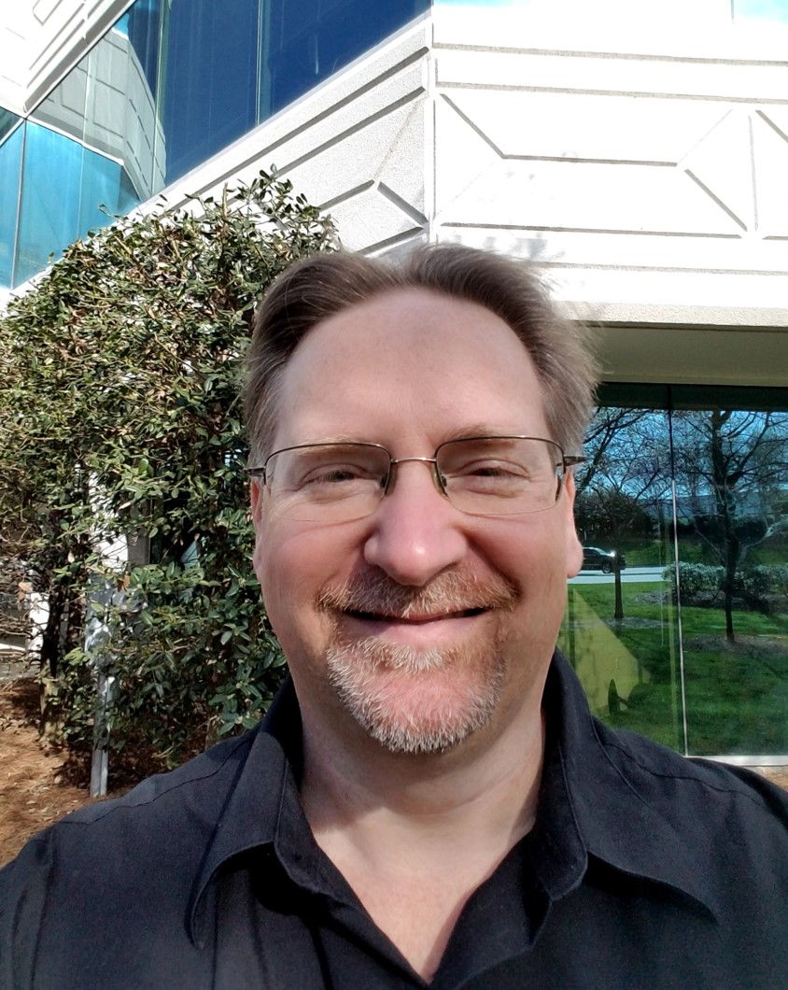
Stephen Ferguson, PhD
Chemist
National Toxicology Program
National Institute of Environmental Health Sciences
Dr. Stephen Ferguson is an Investigator within the National Toxicology Program Division (DNTP) of the National Institute of Environmental Health Sciences (NIEHS). Ferguson serves multiple roles within DNTP that include: 1) leading research efforts to develop, qualify, and apply complex in vitro model systems, 2) integrating informative assay platforms (e.g., high throughput transcriptomics, imaging, cellular health/toxicity), and 3) applying innovative strategies to assess the human toxicity potential of DNTP test chemicals (e.g., PFAS, botanicals, polycyclic aromatic hydrocarbons, and other environmental chemicals). Prior to joining the NTP, Ferguson led the ADME/Tox R&D program of Life Technologies (now Thermo-Fisher) where he and his team developed predictive in vitro liver models and assay approaches for estimation of human drug metabolism, transport, liver toxicity, and drug-drug interactions. Dr. Ferguson received his BS and PhD in chemistry from NC State University with a focus on molecular biology and the roles of transition metals within biological systems, and currently serves as adjunct faculty to the Curriculum in Toxicology at the UNC-CH.
12-1 p.m. EST. Wednesday, November 17, 2021
LEPH 101, 60 College Street
Zoom link: https://yale.zoom.us/j/94199922029

