YALE SCHOOL OF MEDICINE
Department of Pathology

2020-21 Research in Progress Series

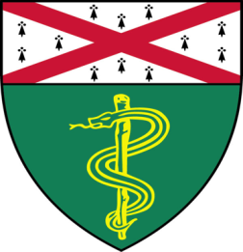
Aesis Luna, (Liu Lab)
Ph.D. Candidate

“Novel Epigenetic Biomarkers for
Hepatocellular Carcinoma”

And

Matt Murray, (Bindra Lab)
Ph.D. Candidate

“Elucidating the Mechanism of PPM1D-Induced Epigenetic Changes and NAMPTi Sensitivity”

Join Zoom Meeting
https://zoom.us/j/95032258483
Passcode: 889918

Tuesday, December 1st, 9:30-10:30 a.m.

"All the contents are proprietary, unauthorized use of the information is prohibited and unethical".

Questions? Wendy Folsom, Pathology: Wendy.Folsom@yale.edu, LH315, 203-785-3478

