YALE SCHOOL OF MEDICINE
Department of Pathology

2019-20 Research in Progress Series

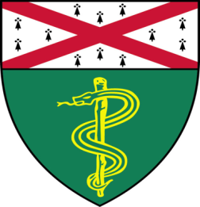

Emily Wingrove (Nguyen Lab)
Ph.D. Student

“Tumor Microenviroment Induced
MYO10 Expression is Required for Brain
Micrometastatic Outgrowth”

And

Robert Means, Ph.D. (Katz Lab)
Associate Research Scientist
“Regulation of Antiviral Responses by
the BCL-2 Family Member BOK”

Tuesday, January 14th, 2020
9:30 to 10:30 a.m.
TAC Auditorium, N-107, 300 Cedar Street

Coffee & refreshments beforehand- TAC Lobby

Questions? Wendy Folsom, Pathology: Wendy.Folsom@yale.edu, LH315, 785-3478

