YALE SCHOOL OF MEDICINE
Department of Pathology

2020-21 Research in Progress Series

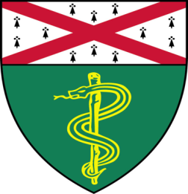

Kingson Lin, (Bindra Lab)
M.D./Ph.D. Candidate

“Synthesis, Characterization, Evaluation of Novel DNA Alkylators for Resistant, Recurrent Brain Cancer”

And

Aileen Fernandez, Ph.D., (Rimm Lab)
Postdoctoral Associate

“Closed System qRT-PCR For Predicting Patient Response to Targeted and Immuno Therapies”

Join Zoom Meeting
https://zoom.us/j/95032258483
Passcode: 889918

Tuesday, April 27th, 9:30-10:30 a.m.
"All the contents are proprietary, unauthorized use of the information is prohibited and unethical".

Questions? Wendy Folsom, Pathology: Wendy.Folsom@yale.edu, LH315, 203-785-3478

