YALE SCHOOL OF MEDICINE
Department of Pathology

2020-21 Research in Progress Series

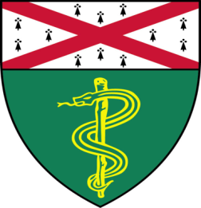

Jai Ansh, (Braddock Lab)
Undergraduate Research Scientist

“Effects of Mutations in the ENPP1 Gene and
Treatment of Associated Morbidities with ENPP1-Fc”

And
Sonali Vishal, Ph.D., (Gopal Lab)
Postdoctoral Associate

“Effect of ALS linked TDP-43 Mutations on Neuronal RNP Granule Function and Pathology”

Join Zoom Meeting
https://zoom.us/j/95032258483
Passcode: 889918

Tuesday, May 25th, 9:30-10:30 a.m.
"All the contents are proprietary, unauthorized use of the information is prohibited and unethical".

Questions? Wendy Folsom, Pathology: Wendy.Folsom@yale.edu, LH315, 203-785-3478

