**YALE SCHOOL OF MEDICINE**

**Department of Pathology**

**2020-21 Research in Progress Series**

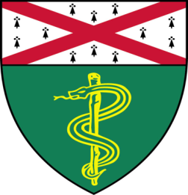

**Ronan Talty, (***Bosenberg Lab)*

*M.D.,/Ph.D. Candidate*

***“*Ibuprofen-Induced Cell Death and**

**Antitumor Immunity”**

***And***

**Yaqing Huang, (***Kyriakides Lab)*

*Graduate Candidate*

**“The Role of Thrombospodin-2 in the Pathophysiology of Diabetic Wounds”**

**Join Zoom Meeting**

<https://zoom.us/j/95032258483>

Passcode: 889918

**Tuesday, April 20th, 9:30-10:30 a.m.**

*"All the contents are proprietary, unauthorized use of the information is prohibited and unethical".*

*Questions? Wendy Folsom, Pathology: Wendy.Folsom@yale.edu, LH315, 203-785-3478*