Presented by: Internal Medicine/Rheumatology, Allergy & Immunology
Hands and Hearts in Systemic Sclerosis
10/6/2021 8:00:00 AM−10/6/2021 9:00:00 AM | Online
Rheumatology Grand Rounds is a conference given every Wednesday morning from September to June for rheumatology faculty and fellows.
Texting code for today’s session: 29471
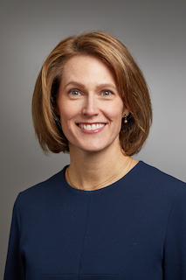
Faculty: Monique Hinchcliff, MD
Director of the Yale Scleroderma Program
Yale School of Medicine, Section of Rheumatology, Allergy & Immunology

Program Goal:
1. Learn to effectively manage threatened digital loss in patients with SSc
2. Learn how Dual-Energy Computed tomography can be used to quantify calcinosis cutis in the hands
3. Gain familiarity with Hyperspectral Imaging of the hands for Raynaud phenomenon quantification
4. Gain familiarity with Rubidium82 PET/CT for microvascular disease quantification in the heart and the hands
5.Understand the concept of echophenomapping
Target Audience: Rheumatology
Financial Disclosure Information: AbbVie-honorarium (consultant), BI-honorarium (consultant), Kadmon Pharmaceuticals-grant support (Principal Investigator).
Accreditation Statement: Yale School of Medicine is accredited by the Accreditation Council for Continuing Medical Education (ACCME) to provide continuing medical education for physicians.
Designation Statement: Yale School of Medicine designates this Live Activity for a maximum of 1.00 AMA PRA Category 1 Credit(s)™. Physicians should only claim credit commensurate with the extent of their participation in the activity.
For questions, email annette.torres@yale.edu.

