Office for Women in Medicine and Science at Yale School of Medicine
is proud to announce the
Beatrix A. McCleary Hamburg, MD Lectureship
Beatrix A. (Betty) Hamburg, MD '48 (1923 – 2018), was an internationally renowned researcher, advocate, and policy maker in the field of adolescent psychiatry, mental health, and violence prevention. In 1948, Dr. Hamburg was the first Black woman to graduate from Yale School of Medicine.

Inaugural Lecture

“Reversing TIME (Tissue/Tumor Immune Microenvironment) in Gastric Cancer”
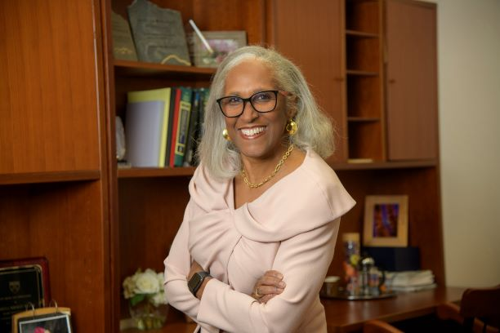
Juanita L Merchant, MD, PhD
Chief of Gastroenterology and Hepatology
Regents Professor of Medicine
University of Arizona, Tucson

Friday, June 3, 2002
12:00 p.m. - 1:00 p.m.
In-person in Harvey Cushing/John Hay Whitney Medical Library, Room 115

The lecture is preceded by an unveiling of the Beatrix McCleary Hamburg, MD, oil portrait from 11:30 a.m. – 12:00 p.m. in the Harvey Cushing/John Hay Whitney Medical Library. Boxed lunches will be served at noon.
Please register for the lecture: https://yalesurvey.ca1.qualtrics.com/jfe/form/SV_4GuxqDkeLuf7InI

