YALE STEM CELL CENTER
Special Seminar Series
“Using supercoiling, sequence, and curvature to create nanoparticle DNAs for gene therapy”

Ellen E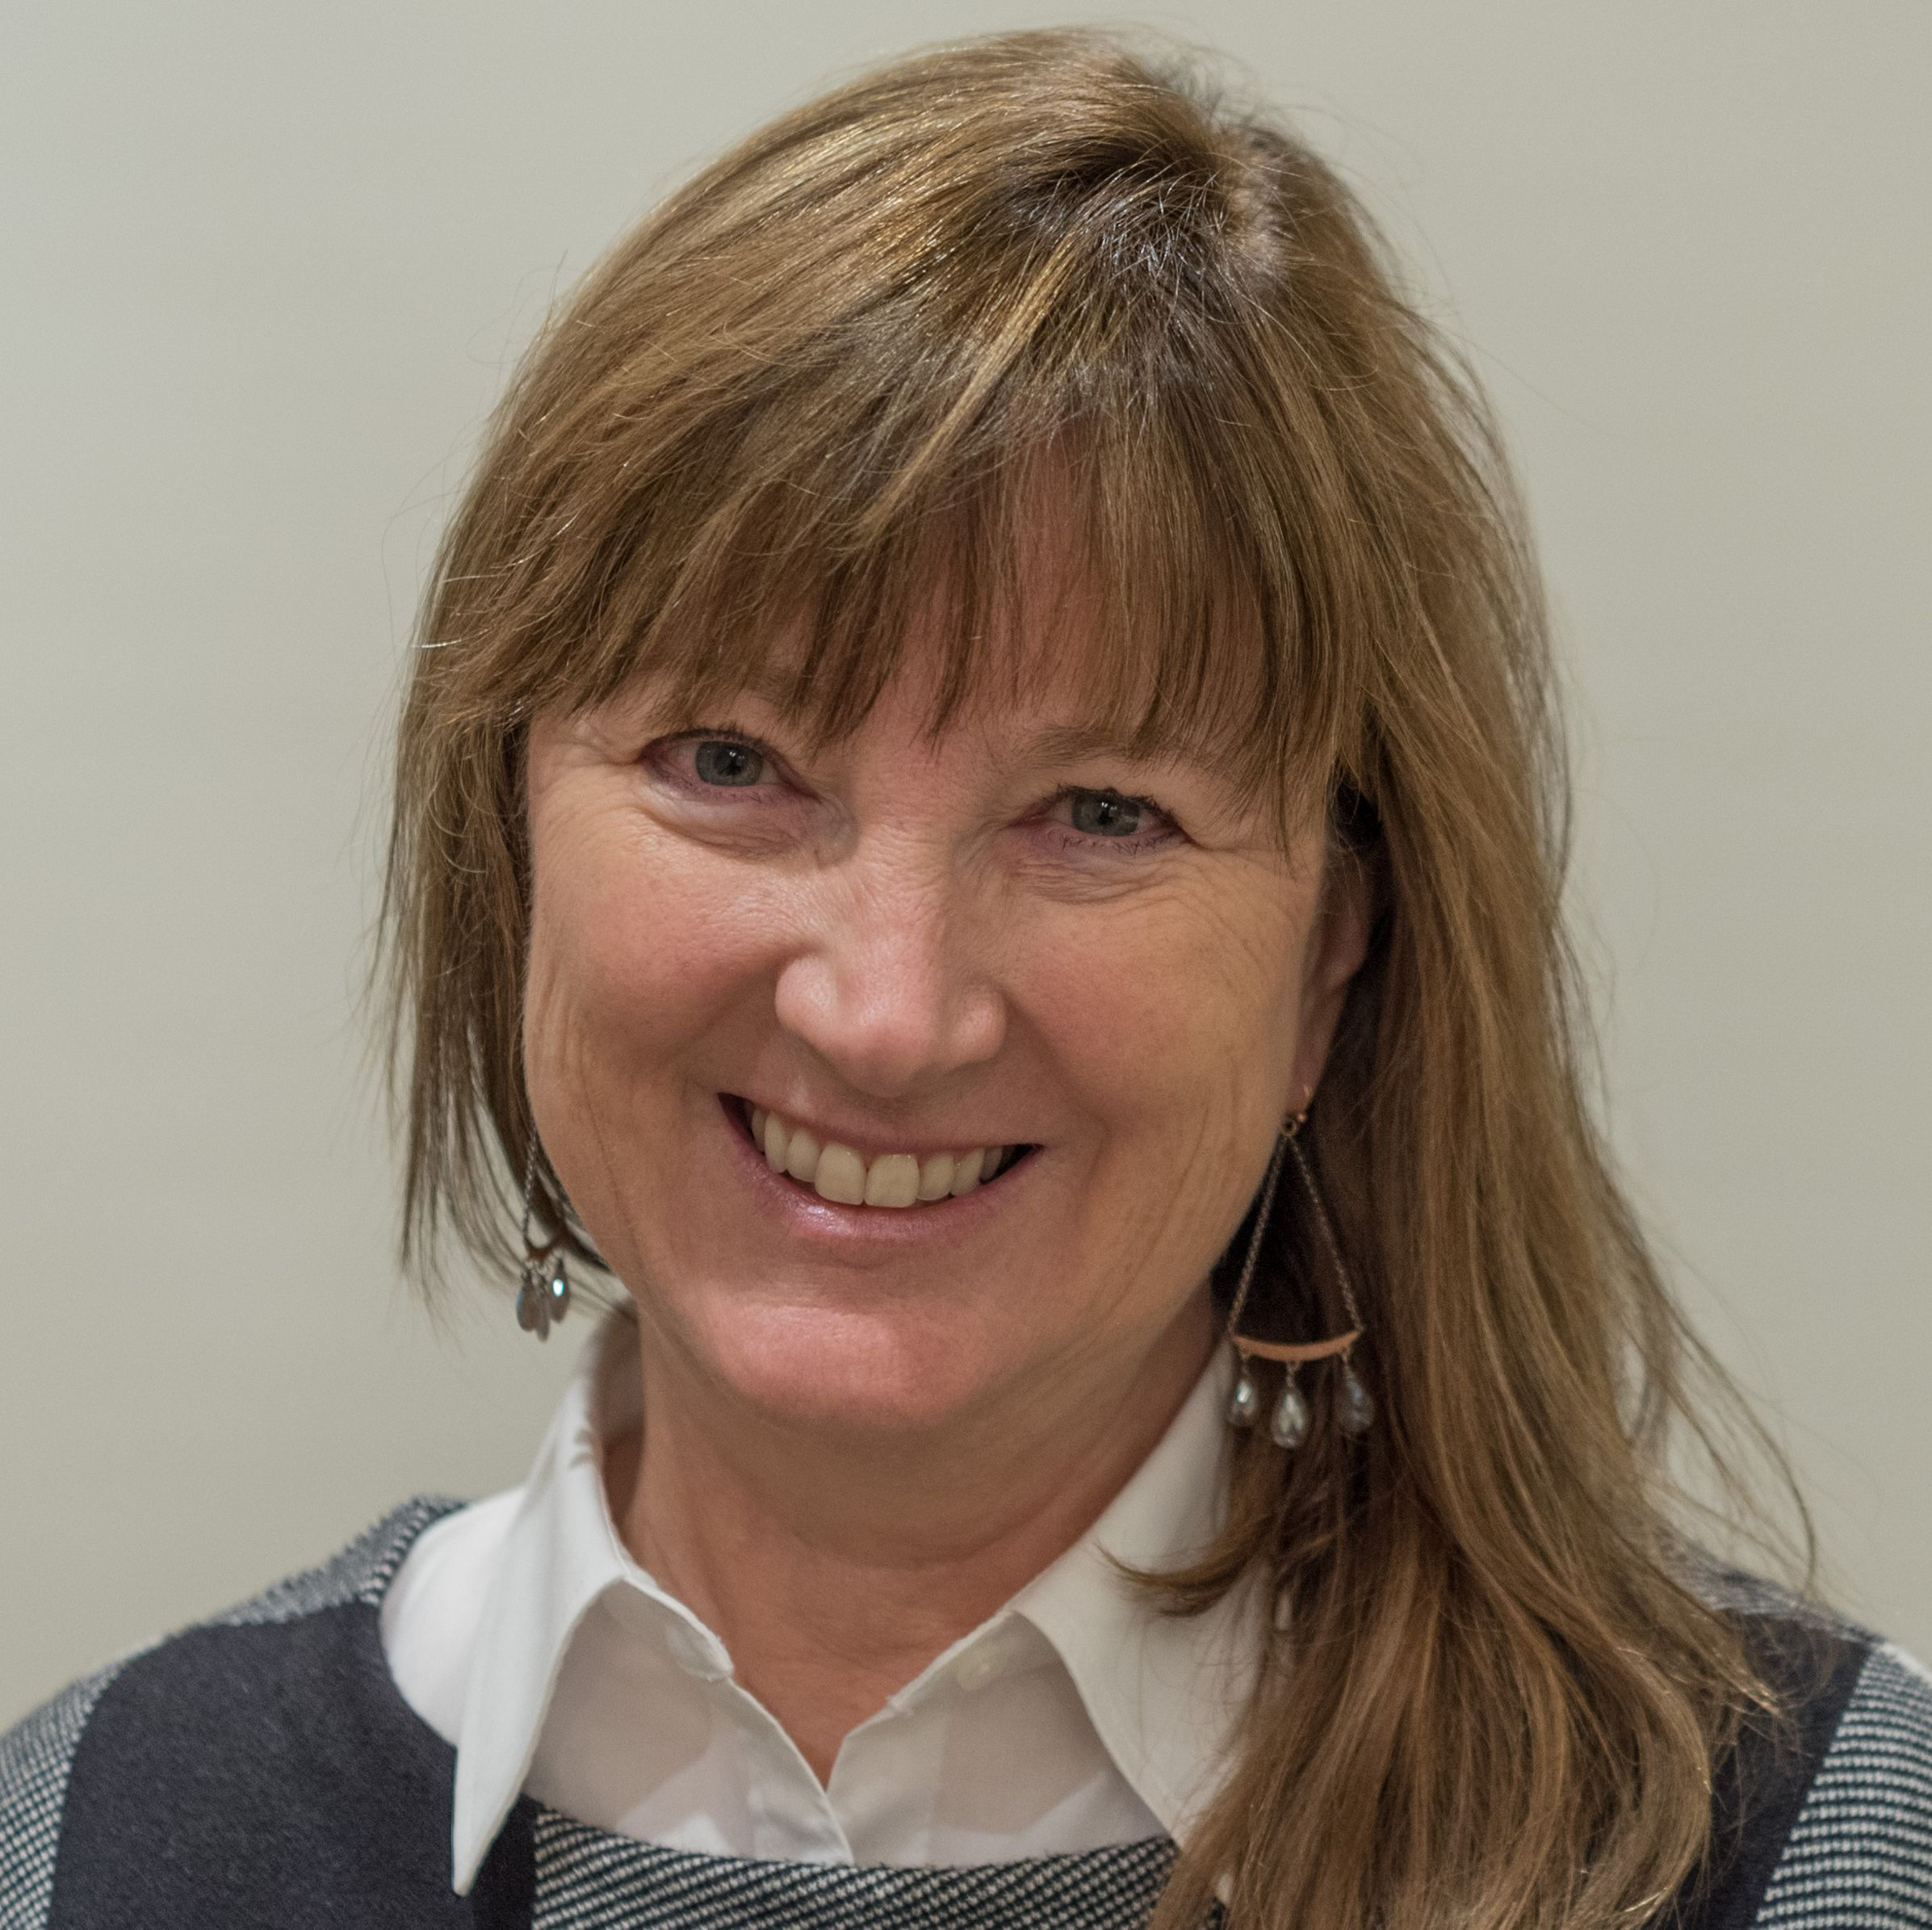ElEllll
Lynn Zechiedrich, PhD
Kyle and Josephine Morrow Chair in Molecular Virology and Microbiology
Professor of Biochemistry, Molecular Biology and Pharmacology
Baylor College of Medicine
Houston, Texas

March 23, 2020
The Amistad Conference Room
Amistad 112
2:00 pm
Host: Haifan Lin, PhD

Refreshments will be provided For additional information please contact Madeline Riccio at 785-6239.

