Presented by: Yale School of Medicine - Department of Pediatrics

Post-Acute Sequelae of COVID-19 (PASC) in Children
10/13/2021 12:00:00 PM−10/13/2021 1:00:00 PM | Medical Campus
The Pediatric Subspecialty Lecture series is a multidisciplinary series. The series includes one hour lectures and case presentations that update our pediatric subspecialist physicians, learners and other healthcare professionals on cutting edge biomedical sciences, clinical and educational practices, presenting this information in an understandable and clinically useful format, that informs the health care delivery and improves outcomes of children and adolescents. Pediatric Subspecialty lecture topics are varied.
Texting code for today’s session: 29695

Faculty:
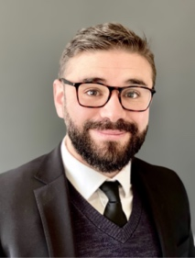
Carlos R. Oliveira, MD, PhD
Assistant Professor of Pediatrics and of Biostatistics, Division of Infectious Diseases & Global Health
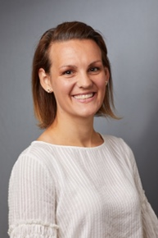
Co-Chair, Yale Pediatric COVID-19 Treatment Team

Cheyenne Beach, MD
Assistant Professor of Pediatrics, Division of Cardiology
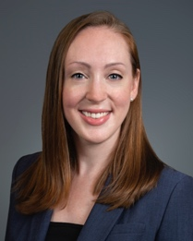
Director, Pediatric Electrophysiology

Erin Faherty, MD
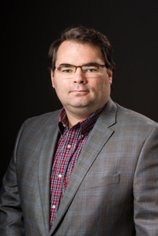
Assistant Professor of Pediatrics, Division of Cardiology

Ian Ferguson, MD
Assistant Professor of Pediatrics, Division of Pediatric Rheumatology

Program Goal:
1 Identify the conditions that can occur after the acute phase of SARS-CoV-2 infection in children and adolescents.
2 To identify patients in whom a cardiology referral is appropriate following a COVID-19 infection.
3 To discuss the clinical phenotype differences in the presentation of MIS-C between young children and adolescents and how it may affect treatment.
Target Audience: Pediatrics

Financial Disclosure Information:
Accreditation Statement: Yale School of Medicine is accredited by the Accreditation Council for Continuing Medical Education (ACCME) to provide continuing medical education for physicians.
Designation Statement: Yale School of Medicine designates this Live Activity for a maximum of 1.00 AMA PRA Category 1 Credit(s)™. Physicians should only claim credit commensurate with the extent of their participation in the activity.
For questions, email andrew.taylor@yale.edu.

