YALE SCHOOL OF MEDICINE
Department of Pathology
2019-20 Research in Progress Series

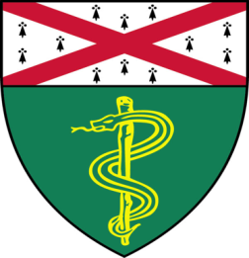
Jialing Zhang, Ph.D., M.D.(Katz Lab)
Postdoctorial Associate

“Transcriptional Modules Revealed By PERTURB-Seq Analysis of Gene Expression
In Myeloid Leukemia”

And

Quan Jiang, (Min Lab)
Postdoctorial Associate

“CCM3 Deficiency Augments Caveolae-Mediated TIE2 Expression and Signaling”

Join Zoom Meeting
https://zoom.us/j/92622241140

Tuesday, May 26th, 9:30-10:30 a.m.

Questions? Wendy Folsom, Pathology: Wendy.Folsom@yale.edu, LH315, 785-3478

