YALE SCHOOL OF MEDICINE
Department of Pathology

2021-22 Research in Progress Series

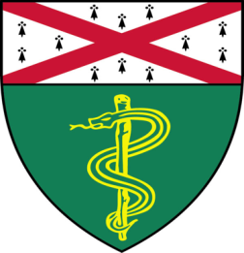
Anton Bennett, Ph.D.
Dorys McConnell Duberg Professor of Pharmacology and Professor of Comparative Medicine; Director, Yale Center for Molecular and Systems Metabolism (YMSM); Director, BBS Minority Affairs"

“Signaling by Protein Tyrosine Phosphatases in Disease – Pathways to Therapeutics”

Join Zoom Meeting
https://zoom.us/j/96247765777
Passcode: 889328
Tuesday, September 21st, 9:30-10:30 a.m.

"All the contents are proprietary, unauthorized use of the information is prohibited and unethical".

Questions? Wendy Folsom, Pathology: Wendy.Folsom@yale.edu, LH315, 203-785-3478

