**YALE SCHOOL OF MEDICINE**

**Department of Pathology**

**2019-20 Research in Progress Series**

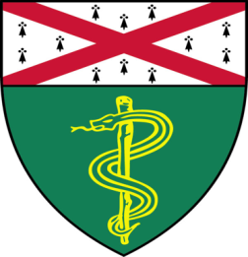

**Fahad Ahmed,** (*Rimm Lab*)

*Postdoctoral Associate*

**“Immune Cells and PD-L1 in the**

**Tumor Microenvironment”**

***And***

**Shruti Desai,** *(Schalper Lab)*

*Associate Research Scientist*

**“Deep Spatial Analysis of Immune Contexture in Lung Tumor Microenvironment and Resistance to Immune Checkpoint Blockade”**

*Tuesday, March 10th, 2020*

*9:30 to 10:30 a.m.*

*TAC Auditorium, N-107, 300 Cedar Street*

*Coffee & refreshments beforehand- TAC Lobby*

*Questions? Wendy Folsom, Pathology: Wendy.Folsom@yale.edu, LH315, 785-3478*