YALE PROGRAM IN NEURODEVELOPMENT
AND REGENERATION

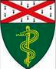
------------------------------------------------------------------------------------------

“Development and arealization of the human cerebral cortex”
Tomasz Nowakowski, PhD
Assistant Professor
University of California San Francisco

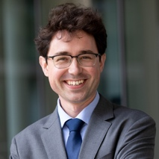

Wednesday, September 29, 2021
2 pm - 3 pm EST
Zoom link to register:
https://zoom.us/meeting/register/tJUrceCvrDovEtx7lH06h775XqVCJo4blDLd

Hosts: Flora Vaccarino, MD and Nenad Sestan, MD, PhD

Please contact monica.mleczek@yale.edu

