# YALE SCHOOL OF MEDICINE

**DEPARTMENT OF PATHOLOGY**

**YALE NEW HAVEN HOSPITAL**

**Special Seminar**

**Friday, August 14, 2020**

**10:00 am – 11:00 am**

**William Damsky, MD, PhD**

Assistant Professor of Dermatology

Yale University School of Medicine

Candidate for BH/SRC position

Pathology, Bridgeport

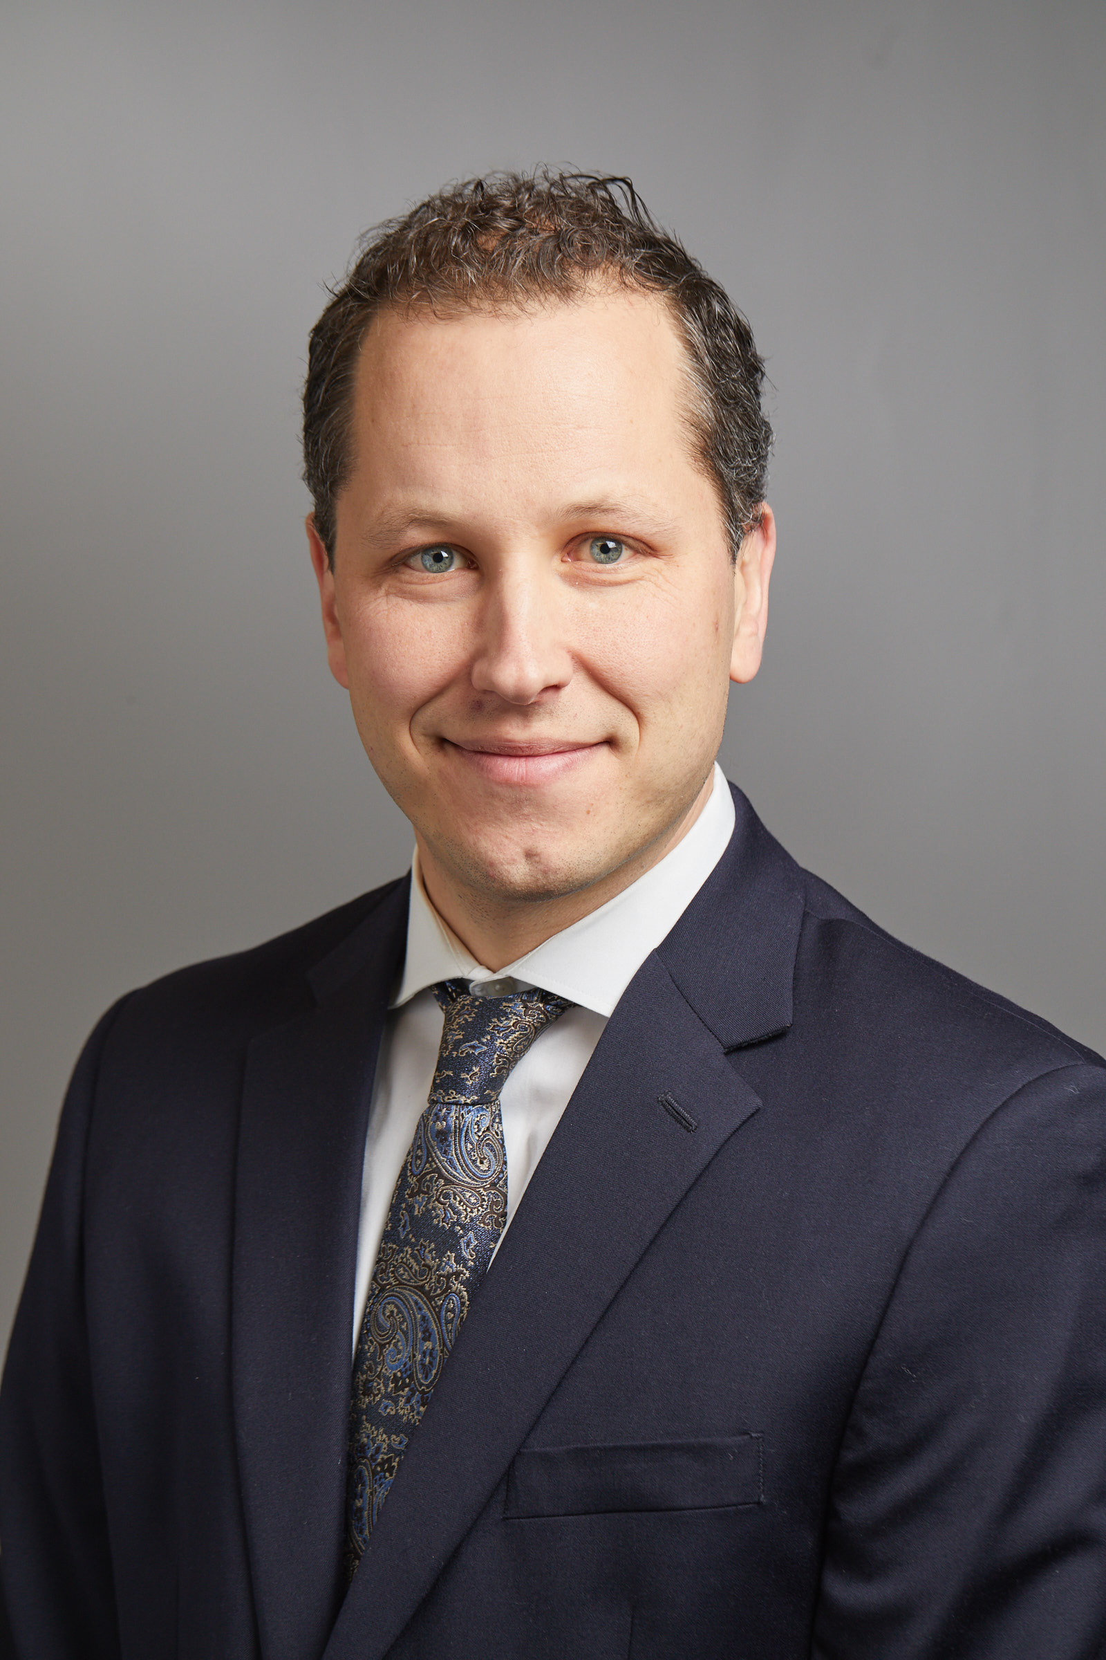

***Secondary Faculty Candidate***

***“*Granulomatous disorders in dermatology: opportunities for unique insight into macrophage biology and developing novel therapeutics”**

Join Zoom Meeting

<https://zoom.us/j/98496351230>

*Hosted by Chen Liu, MD, PhD*

*Chair of Pathology, YSM and Chief of Pathology, YNHH*