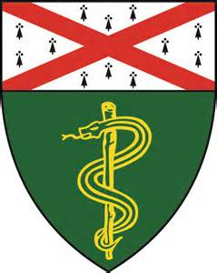
Palliative Care Conference
Tuesday, September 17th @ 4pm
Fitkin (FMP) 6th Floor, Conference Rm 618
(see bottom of flyer for directions)
4-6:00pm

Grand Rounds Presentation

Presenter: Asmita Paudyal, MD
YNHH Hospice & Palliative Medicine Fellow
Title: “Minorities in Palliative Care”

Palliative Case Conference

Presenter: Chris Ahern, DO
YNHH Hospice & Palliative Medicine Fellow
Title: “Breathless and Overwhelmed: Navigating End-stage COPD with a Fatigued Caregiver”

Directions to Fitkin (FMP) Room F-618 Conference Room
Take elevator to 6th floor. Exit elevator and take u-turn to the right. You will see a closed glass door with “Psychological Medicine Service and Interpreter Services” sign. The glass door is unlocked – enter and look for F-618 down hall on the left.

Please contact Lisa.Arnel@yale.edu for additional information

