***Immunobiology Seminar Series***

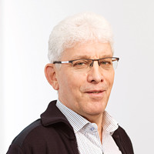

***MEINRAD BUSSLINGER, Ph.D.***

*Senior Scientist/Deputy Director Science,*

*Research Institute of Molecular Pathology (IMP)*

*Vienna Biocenter*

***“***Transcriptional control of B cell development and autoimmunity”

**Thursday, November 30**

**10:30 A.M.**

**TAC N107 Auditorium**

Host: Richard A. Flavell

*For further information, please contact Caroline Lieber at caroline.lieber@yale.edu*