YALE SCHOOL OF MEDICINE
Department of Pathology

2019-20 Research in Progress Series

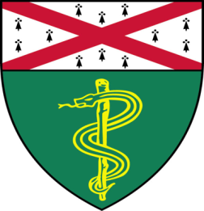

Meiling Zhang, PhD, (Yan Lab)
Postdoctoral Associate

“CECR2 Regulates Breast Cancer Metastasis by Modulating Tumor Associated Macrophage through NFkB Signaling Pathway ”

And

Peter Rabinovich, PhD, (Katz Lab)
Associate Research Scientist
“RNA-Mediated Cell Reprogramming: Can We Prolong the Duration of mRNA Expression?”

Tuesday, November 12th, 2019
9:30 to 10:30 a.m.
TAC Auditorium, N-107, 300 Cedar Street

Coffee & refreshments beforehand- TAC Lobby

Questions? Wendy Folsom, Pathology: Wendy.Folsom@yale.edu, LH315, 785-3478

