YALE SCHOOL OF MEDICINE
Department of Pathology

2019-20 Research in Progress Series

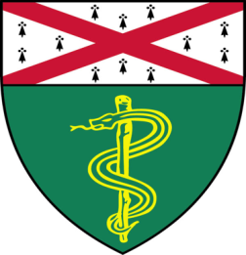

Benjamin Turk, Ph.D.
Associate Professor of Pharmacology
and
David Calderwood, Ph.D.
Associate Professor of Pharmacology and Cell Biology

“Yale Cancer Center
Functional Genomics Core”

Tuesday, October 1st, 2019

9:30 to 10:30 a.m.

TAC Auditorium, N-107, 300 Cedar Street

Coffee & refreshments beforehand- TAC Lobby

Questions? Wendy Folsom, Pathology: Wendy.Folsom@yale.edu, LH315, 785-3478

