YALE SCHOOL OF MEDICINE
Department of Pathology

2019-20 Research in Progress Series

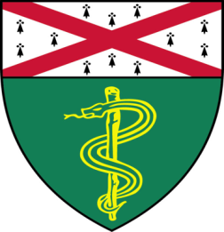

Jacqueline Starrett, (Politi Lab)
Ph.D. Student

“Overcoming Resistance to First-Line Osimertinib in EGFR Mutant Mouse
Models of Lung Adenocarcinoma”

And

Angelo Porciuncula, (Schalper Lab)
Associate Research Scientist

“Exploring the Role of Dendritic Cells in
Non-Small Cell Lung Cancer”

Tuesday, February 25th, 2020
9:30 to 10:30 a.m.
TAC Auditorium, N-107, 300 Cedar Street

Coffee & refreshments beforehand- TAC Lobby

Questions? Wendy Folsom, Pathology: Wendy.Folsom@yale.edu, LH315, 785-3478

