Charles Senteio, PhD, MBA, MSW
charles.senteio@rutgers.edu @CharlesSenteio
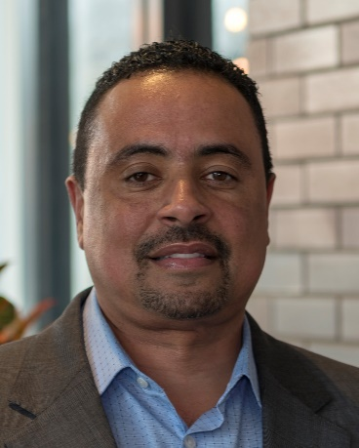
Charles Senteio is a health informatics researcher focused on improving chronic disease outcomes for underserved populations. His is an Assistant Professor at the Rutgers School of Communication and Information in the Department of Library and Information Science. He is a MIT MLK Visiting Scholar for the 2020-2021 academic year.
His community-based research endeavors to address persistent healthcare disparities. His funded investigations of several chronic conditions include: HIV/STIs, diabetes, hypertension, chronic kidney disease, and breast and prostate cancer. He has led research projects based in Flint, Ypsilanti, Detroit, Dallas, and central New Jersey. He is particularly interested in using both existing technology (i.e., smartphones, tablets) and emerging technology (i.e. machine learning) to support underserved patients, which include formerly incarcerated, underrepresented in research, and low-SES urban populations.
He received a PhD in health informatics from the School of Information at the University of Michigan where he also completed a Master’s in Social Work (MSW). He began his IT strategy consulting career in the high-tech industry with Booz Allen Hamilton, then Accenture, after receiving an MBA from the Ross School of Business at Michigan. He started a consulting practice in 2002 in Dallas to concentrate exclusively on healthcare. During that time, he supervised and trained Community Health Workers in his work with Project Access in Dallas and with Baylor University Hospital in Dallas. He is a licensed clinical social worker (LCSW), certified health education specialist (CHES) and certified community health worker instructor (CHW-I #115).

