YALE SCHOOL OF MEDICINE
Department of Pathology

2020-21 Research in Progress Series

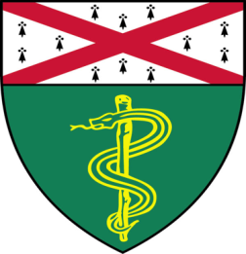

Carrie Lucas, Ph.D.
Assistant Professor of Immunobiology

“Novel Molecular Regulators of Mucosal Inflammation Elucidated by Gene
Defects in Humans and Mice”

Join Zoom Meeting
https://zoom.us/j/95032258483
Passcode: 889918

Tuesday, September 22nd, 9:30-10:30 a.m.

"All the contents are proprietary, unauthorized use of the information is prohibited and unethical".

Questions? Wendy Folsom, Pathology: Wendy.Folsom@yale.edu, LH315, 203-785-3478

