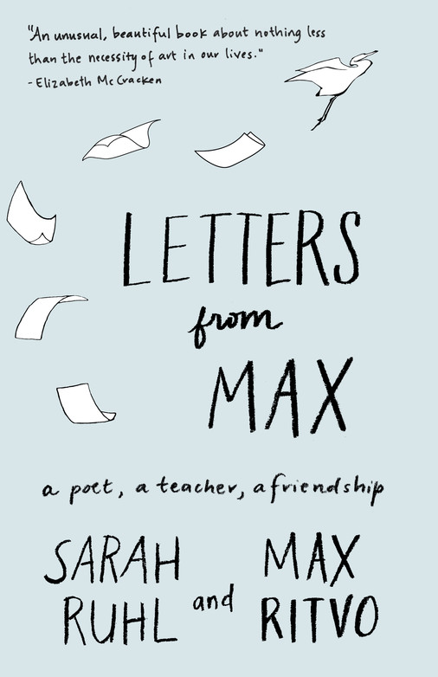

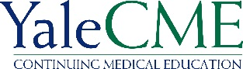

This program is accredited by the Accreditation Council for Continuing Medical Education to sponsor continuing Medical Education for physicians.

CHILD STUDY CENTER

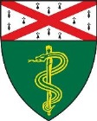

The Second Annual
Max Ritvo ‘13 and Alan B. Slifka ‘51
Memorial Lecture

Sarah Ruhl

Letters to Max

Tuesday, June 11th, 2021
1:00PM
Via Zoom

The Max Ritvo ‘13 and Alan B. Slifka ‘51 Program for the Medical Humanities at the Yale Child Study Center

The Max Ritvo ’13 and Alan Slifka ’51 Program for the Medical Humanities at the Yale Child Study Center brings an artist to campus annually as a guest speaker and visiting scholar to explore and support the experience of psychiatric and medical illness in youth.
The Program also works to support artists and creative arts therapists who help patients and their families with the artistic expression of their struggles with illness in a variety of clinical settings.
The Program was endowed in 2018 by Dr. Riva Ariella Ritvo-Slifka and the Alan B. Slifka Foundation, in loving memory. ז״ל

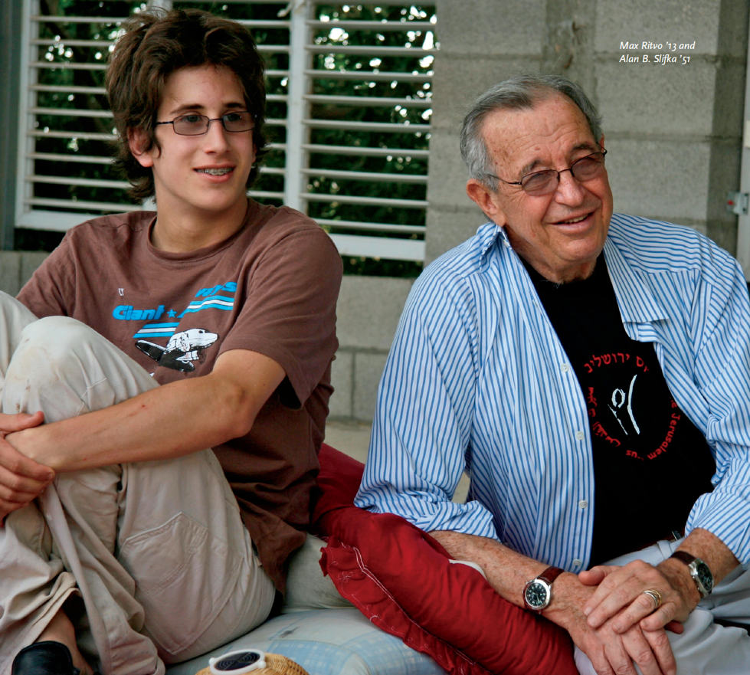

www.maxritvo.com

Sarah Ruhl is an award-winning American playwright, author, essayist, and professor. Originally from Chicago, Ms. Ruhl received her M.F.A. from Brown University where she studied with Paula Vogel. An alum of 13P and of New Dramatists, she won a MacArthur Fellowship in 2006 and the Steinberg Distinguished Playwright Award in 2016. She was the recipient of the PEN Center Award for a mid-career playwright, the Whiting Writers award, the Feminist Press’ Forty under Forty award, and a Lilly Award. She proudly served on the executive council of the Dramatist’s Guild for three years, and she is currently on the faculty at Yale School of Drama. Her book of essays on the theater and motherhood, 100 Essays I Don’t Have Time to Write, was a Times Notable Book of the Year. Her plays have been produced regionally all over the country, with premieres often at Yale Repertory Theater, the Goodman Theater, Berkeley Repertory Theater, and the Piven Theatre Workshop in Chicago. Her plays have also been produced internationally and have been translated into over twelve languages. Her newest book, Smile: The Story of a Face will be published by Simon and Schuster in October. Ms. Ruhl lives in Brooklyn with her family.
https://www.sarahruhlplaywright.com/

LETTERS FROM MAX - A KIRKUS BEST BOOK OF 2018
In 2012, Sarah Ruhl was a distinguished author and playwright, twice a finalist for the Pulitzer Prize. Max Ritvo, a student in her playwriting class at Yale University, was an exuberant, opinionated, and highly gifted poet. He was also in remission from pediatric cancer.
Over the next four years—in which Ritvo’s illness returned and his health declined, even as his productivity bloomed—the two exchanged letters that spark with urgency, humor, and the desire for connection. Reincarnation, books, the afterlife as an Amtrak quiet car, good soup: in Ruhl and Ritvo’s correspondence, all ideas are fair, nourishing game, shared and debated in a spirit of generosity and love. “We’ll always know one another forever, however long ever is,” Ritvo writes. “And that’s all I want—is to know you forever.”
Studded with poems and songs, Letters from Max is a deeply moving portrait of a friendship, and a shimmering exploration of love, art, mortality, and the afterlife.

We are honored to welcome Sarah Ruhl as the 2021 Second Annual Max Ritvo ‘13 and Alan B. Slifka ’51 Speaker

