YALE SCHOOL OF MEDICINE
Department of Pathology

2020-21 Research in Progress Series

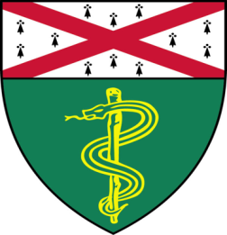

Sateja Paradkar, (Bindra Lab)
Graduate Student

“Investigating the Mechanism and Therapeutic Potential of PARG Inhibitors in DNA
Repair-Deficient Cancers”

And

Thazin Nwe Aung, Ph.D., (Rimm Lab)
Postdoctoral Associate

“Assessing Tumor Infiltrating Lymphocytes
with Automated Image Analysis as a Prognostic Variable in Melanoma”

Join Zoom Meeting
https://zoom.us/j/95032258483
Passcode: 889918
Tuesday, March 9th, 9:30-10:30 a.m.

"All the contents are proprietary, unauthorized use of the information is prohibited and unethical".

Questions? Wendy Folsom, Pathology: Wendy.Folsom@yale.edu, LH315, 203-785-3478

