YALE SCHOOL OF MEDICINE
Department of Pathology

2020-21 Research in Progress Series

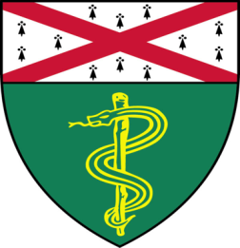
Jonathan Sun, (Fernandez-Hernando Lab)
Ph.D. Candidate

“Delineating Hepatocyte Metabolic Transitions in Obesity-Induced Hepatocellular Carcinoma”

And

Saba Shafi, MBBS, M.D. (Rimm Lab)
Postdoctoral Associate

“Building a Companion Diagnostic
Test for Siglec-15”

Join Zoom Meeting
https://zoom.us/j/95032258483
Passcode: 889918

Tuesday, October 27th, 9:30-10:30 a.m.
"All the contents are proprietary, unauthorized use of the information is prohibited and unethical".

Questions? Wendy Folsom, Pathology: Wendy.Folsom@yale.edu, LH315, 203-785-3478

