VIRTUAL SEMINAR
The Liver Exposome: Environmental exposures and Liver Disease
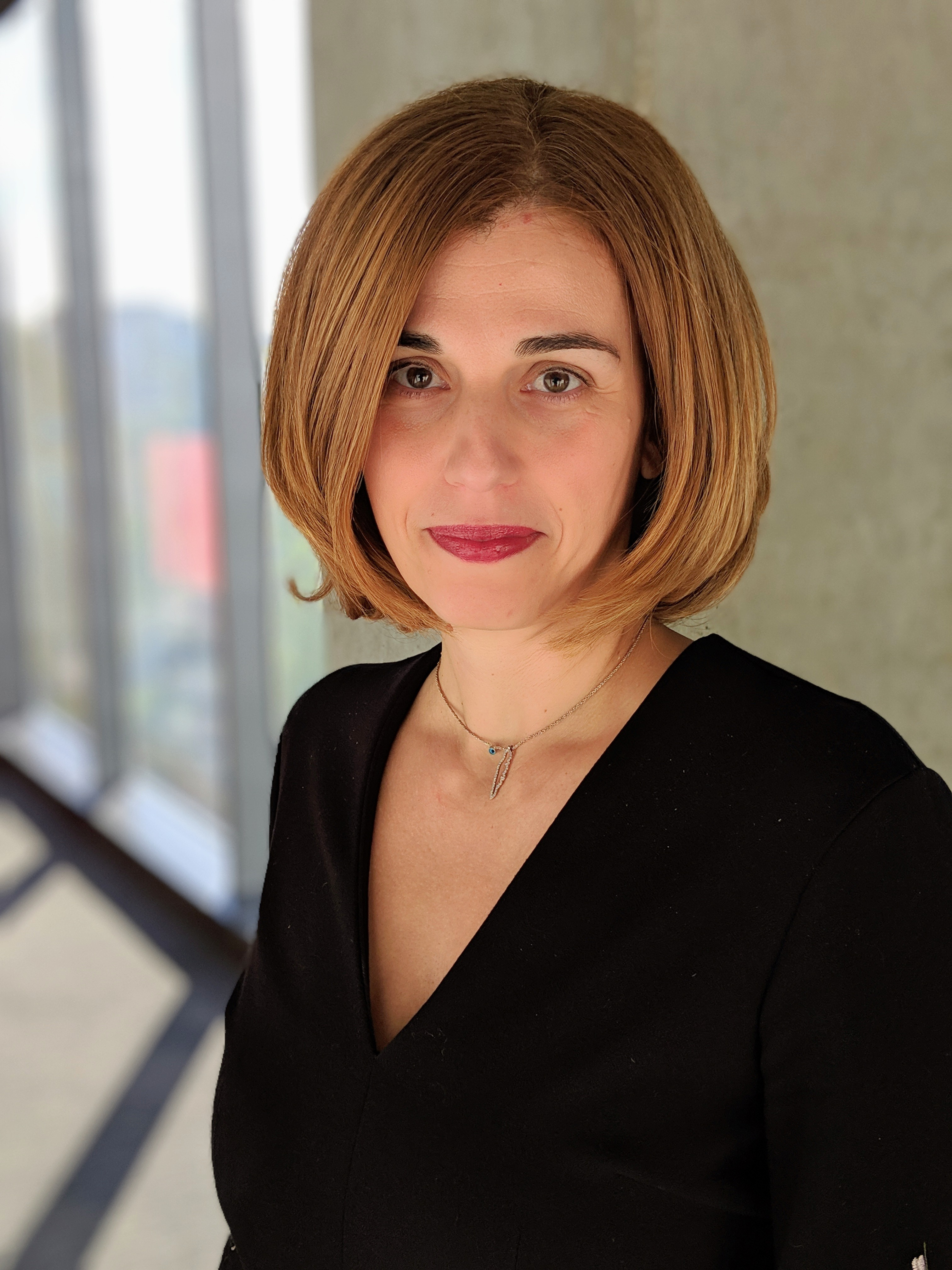
Vaia Lida Chatzi, MD, PhD
Professor, Preventive Medicine
Keck School of Medicine, University of Southern California
As a physician, epidemiologist and public health researcher, Dr. Chatzi leads an interdisciplinary program of research focused on advancing our understanding of how exposure to environmental chemicals affect metabolic health. Overall, her investigations have focused on the health effects of environmental toxicants classified as endocrine disruptors, including perfluoroalkyl substances, organochlorine pesticides, phenols, phthalates, and metals, on long-term youth health, especially, obesity, type 2 diabetes, and fatty liver disease. In support of this work, Dr. Chatzi currently leads multi-center, multi-disciplinary studies measuring the impact of these chemicals on longitudinal changes in insulin sensitivity, beta-cell function, and fatty liver disease in cohorts in Southern California and on the trajectory of metabolic improvement after bariatric surgery. She has catalyzed and led several transatlantic research initiatives leveraging intellectual resources and cohorts in Europe and the United States. Dr. Chatzi is the PI in several EU and NIH/NIEHS research grants. She also serves as Director of the USC Center for Translational Research on Environmental Health (USC-R-TEN), which conducts translational research on the influence of environmental pollutants on health outcomes by integrating human population-data and laboratory methods to develop comprehensive understanding of exposure risk and disease development.

12-1 p.m. EST. Wednesday, March 2, 2022
LEPH 101, 60 College Street
Zoom link: https://yale.zoom.us/j/92965470385

