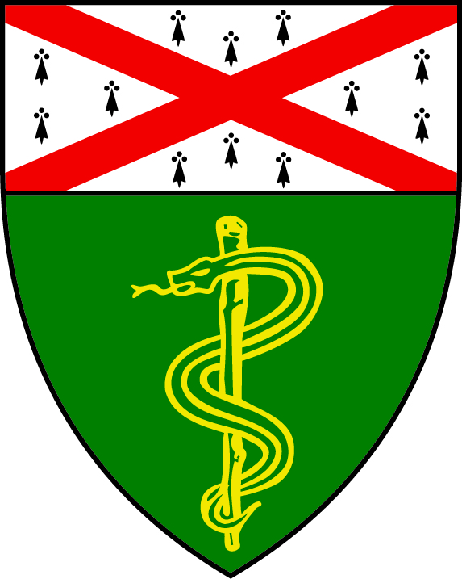

Yale School of Medicine

Yogesh Khanal, M.D. Global Health Resource Fund

Thank you for your commitment to Yogesh Khanal, M.D. Global Health Resource Fund. To convey your gift or state your gift intention, please complete and mail this form in the enclosed envelope. Gift intentions may be fulfilled over a five-year period.

I hereby commit $______________ to Yogesh Khanal, M.D. Global Health Resource Fund.
Please make checks payable to Yale University

Yale’s Federal Tax
Identification
Number: 06-0646973

For gifts of securities or
mutual fund shares, contact
Yale at 203-432-4107

$____________ Enclosed
$ ______________ Expected Corporate Match

Card # __ __ __ __ __ __ __ __ __ __ __ __ __ __ __ __
Expiration Date___________ □ Visa □ MasterCard □ American Express

If fulfilling your commitment in future installments, please complete the following:
Corporate Matching Gift
Month Day Year Amounts (if applicable)

$___________ by ______ _____ _____ $______________ $___________ by ______ _____ _____ $______________
$___________ by ______ _____ _____ $______________
$___________ by ______ _____ _____ $______________
$___________ by ______ _____ _____ $______________

$___________ by ______ _____ _____ $______________
Total Total Matching Gift

Comments, special instructions______________________________________________________________

□ My gift intention includes the possibility of my making recommendations to a private or community foundation for distributions to Yale.

Name______________________________________________Class/School/Affiliation_______________________

Street, City, State, Zip__________________________________________________________________________________________________

Telephone (H)_________________________(B)__________________________Email

Address_______________________________________

Employer____________________________________________________________________________________________________

Signature__________________________________________________________Date______________________________________

YALE UNIVERSITY SCHOOL OF MEDICINE ♦ OFFICE OF DEVELOPMENT
P.O. BOX 7611 ♦ NEW HAVEN, CT 06519-0611 ♦ PHONE (203) 436-8529 ♦ FAX (203) 436-8500 ♦ EMAIL erin.shreve@yale.edu

