Yale GIM's Research in Progress Meeting
Presented by
Yale School of Medicine’s Department of Internal Medicine
Section of General Internal Medicine

“Embedding Equity in Health Systems and Managing Resistance
to Change”

Consuelo Hopkins Wilkins, MD, MSCI
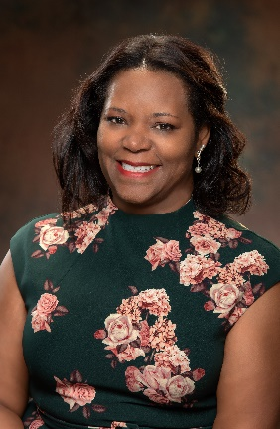

Senior Vice President & Senior Associate Dean for Health Equity and Inclusive Excellence

Professor of Medicine

Vanderbilt University Medical Center
Date: October 6, 2022 12:00pm – 1:00pm

Zoom: https://yale.zoom.us/j/95746029979

Texting code for today’s session: TBA

Course Director/Host: Patrick G. O’Connor, MD, MPH, 203-688-6532
There is no corporate or commercial support for this activity
Program Goal:
1. Describe the importance of systematic data collection and disaggregation to enhance health equity
2. Identify measures of health equity that can be used to monitor systems change
3. Discuss strategies to enable implementation of health equity initiatives and mitigate resistance to change.
Target Audience: Medical Professionals

Financial Disclosure Information: Consuelo Hopkins Wilkins has no relevant financial relationship(s) with ineligible companies to disclose.

Dr. O’Connor, course director and faculty member for the Yale General Internal Medicine Faculty Meetings, has no relevant financial relationship(s) with ineligible companies to disclose.

Patti Cavaliere, Vivian DuBrava, Michele Manganello, and Toni Boulay, coordinators/planners for the Yale General Internal Medicine Faculty Meetings, have no relevant financial relationship(s) with ineligible companies to disclose

Accreditation Statement: Yale School of Medicine is accredited by the Accreditation Council for Continuing Medical Education (ACCME) to provide continuing medical education for physicians.

Designation Statement: Yale School of Medicine designates this Live Activity for a maximum of 1.00 AMA PRA Category 1 Credit(s)™. Physicians should only claim credit commensurate with the extent of their participation in the activity.

