Presented by: Internal Medicine/Rheumatology
Lupus Nephritis: End of the Beginning
9/15/2021 8:00:00 AM−9/15/2021 9:00:00 AM | Online
Rheumatology Grand Rounds is a conference given every Wednesday morning from September to June for rheumatology faculty and fellows.
Texting code for today’s session: 29468
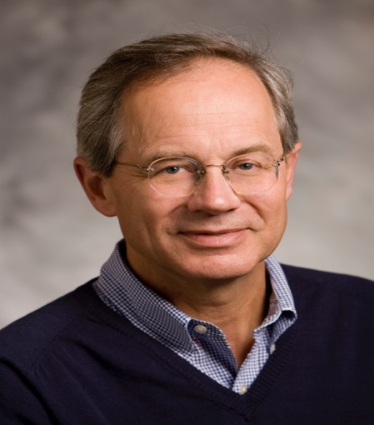
Faculty:
Joseph Craft, MD
Paul B. Beeson Professor of Medicine and Professor of Immunobiology
Yale School of Medicine

Program Goal:
1 Understand stepwise progression of SLE with development of tissue injury.
2 Understand biology of tissue injury in the nephritic kidney.
3 Understand associated therapeutic implications.
Target Audience: Rheumatology
Financial Disclosure Information: Joseph Craft has no financial disclosures.
Accreditation Statement: Yale School of Medicine is accredited by the Accreditation Council for Continuing Medical Education (ACCME) to provide continuing medical education for physicians.
Designation Statement: Yale School of Medicine designates this Live Activity for a maximum of 1.00 AMA PRA Category 1 Credit(s)™. Physicians should only claim credit commensurate with the extent of their participation in the activity.
For questions, email annette.torres@yale.edu.

