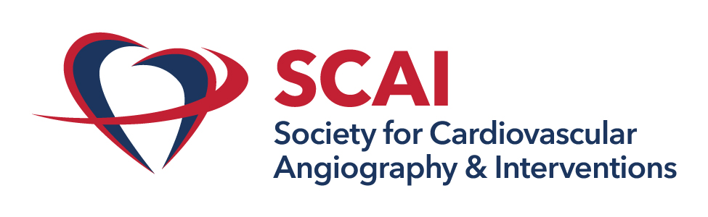

SCAI Vascular Disease Council Case Exchange
Webinar length: 85 minutes

Learning Goal:
Join the SCAI Vascular Disease Council for a case-based discussion on complex peripheral revascularization challenges.
Case: Balloon Pulmonary Angioplasty in Distal CTEPH
Panel Discussion, Audience Q&A
Case: Critical Limb Ischemia
Panel Discussion, Audience Q&A

Invited Faculty
- Moderators:
  - Subhash Banerjee, MD, FSCAI
  - Herbert Aronow, MD, MPH, FSCAI
- Case Presenters:
  - Vikas Aggarwal, MBBS, MPH, FSCAI
  - Abdullah M. Abdullah, MD
- Case Commentators:
  - Jay Giri, MD, MPH, FSCAI
  - Mitul Patel, MD, FSCAI
- Panelists:

  - Beau Hawkins, MD, FSCAI
  - Drew Klein, MD, FSCAI
  - Prakash Kirshnan, MD
  - Ehtisham Mahmud, MD, FSCAI
  - Carlos Mena-Hurtado, MD, FSCAI
  - Binita Shah, MD, FSCAI
  - Medhi Shishehbor, DO, MPH, PhD, FSCAI
  - Madham Shanmugasundaram, MD, FSCAI
  - Maja Zaric, MD, FSCAI

Agenda:
Agenda is in eastern daylight time.
6:00 – 6:05 pm Welcome and introductions. (Participants enter webinar.) Dr. Grines, Banerjee, Aronow
6:05 – 6:15 pm Balloon Pulmonary Angioplasty in Distal CTEPH Dr. Aggarwal
6:15 – 6:20 pm Commentary on Case Dr. Giri
6:20 – 6:35 pm Panel Discussion for Balloon Pulmonary Angioplasty in Distal CTEPH
Drs. Mahmud, Giri, Zaric, Sundaram, and Klein
6:35 – 6:40 pm Audience Q&A
6:40 – 6:45 pm Introduction to Case 2 and panelists Drs. Banerjee and Aronow
6:45 – 6:55 pm Case: Critical Limb Ischemia Dr. Abdullah
6:55 – 7:00 pm Commentary for CLI Dr. Patel
7:00 – 7:15 pm Panel Discussion for CLI
Drs. Shishebor, Mena, Shah, Krishnan, and Hawkins
7:15 – 7:20 pm Audience Q&A, Case 2
7:20 – 7:25 pm Moderator Conclusion

Accreditation Statement

The Society for Cardiovascular Angiography and Interventions is accredited by the Accreditation Council for Continuing Medical Education (ACCME) to provide continuing medical education for physicians.

Credit Designation

The Society for Cardiovascular Angiography and Interventions designates this enduring activity for a maximum of 1.5 AMA PRA Category 1 CreditTM. Physicians should claim only the credit commensurate with the extent of their participation in the activity.

ABIM MOC

Successful completion of this CME activity, which includes participation in the evaluation component, enables the participant to earn up to 1.5 medical knowledge MOC points in the American Board of Internal Medicine’s (ABIM) Maintenance of Certification (MOC) program. Participants will earn MOC points equivalent to the amount of CME credits claimed for the activity. It is the CME activity provider’s responsibility to submit participant completion information to ACCME for the purpose of granting ABIM MOC credit.

